OXFORD UNIVERSITY ARCTIC EXPEDITION, 1924
notes by C.S. ElTon.

7 July 1924 – 5 September 1924

Leader: George Binney
This was the largest and most complex of the three expeditions, with 2 ships, a seaplane (taken up in bits and assembled on open tundra), three sledge-parties on N.-E. Land, and a base-camp with scientific work. It took many risks part had no accidental casualties though there were some close shaves. And it had luck with the ice-pack movements.
For additional data, see WEATHER and CLIMATE, and GEOLOGY

Editor’s notes:
The manuscript was assembled in the 1970s from diaries, field notes and photographs, and typed on unnumbered sheets of loose-leaf quarto. Page numbers are added for ease of reference. Pages that begin or end in mid-sentence are shown as such. Photographic prints, drawings (and early Xeroxes of other documents) are scanned in situ (i.e. with photograph corners and other mounting showing), but to high resolution, so they are shown larger on the page than they were in the original text thus resolving more detail. Those taken by the author are identified e.g.: ‘(Photo C.S.E. 1924: No. 137)’. Most of their negatives are still held by Elton’s family to whom application can be made for reproduction.
Species names appear in italics, but other underlining is shown as such. Handwritten additions and corrections are not distinguished from typing. Scored out material is omitted entirely. Abbreviations are shown in full where the meaning is clear. Incomplete or ungrammatical sentences and inconsistent use of upper/lower case, number format, inverted commas etc. are unaltered and only blatant spelling errors are corrected. Editor’s notes and explanations are shown in {}.
D.S.O. = Distinguished Service Order; M.C. = Military Cross; M/S = Motor Ship; N.-E.Land = Nordaustlandet; R.A.F. Res. = Royal Air Force Reserve; R.E. = Royal Engineers; R.N. = Royal Navy; /- = shilling (£0.05)

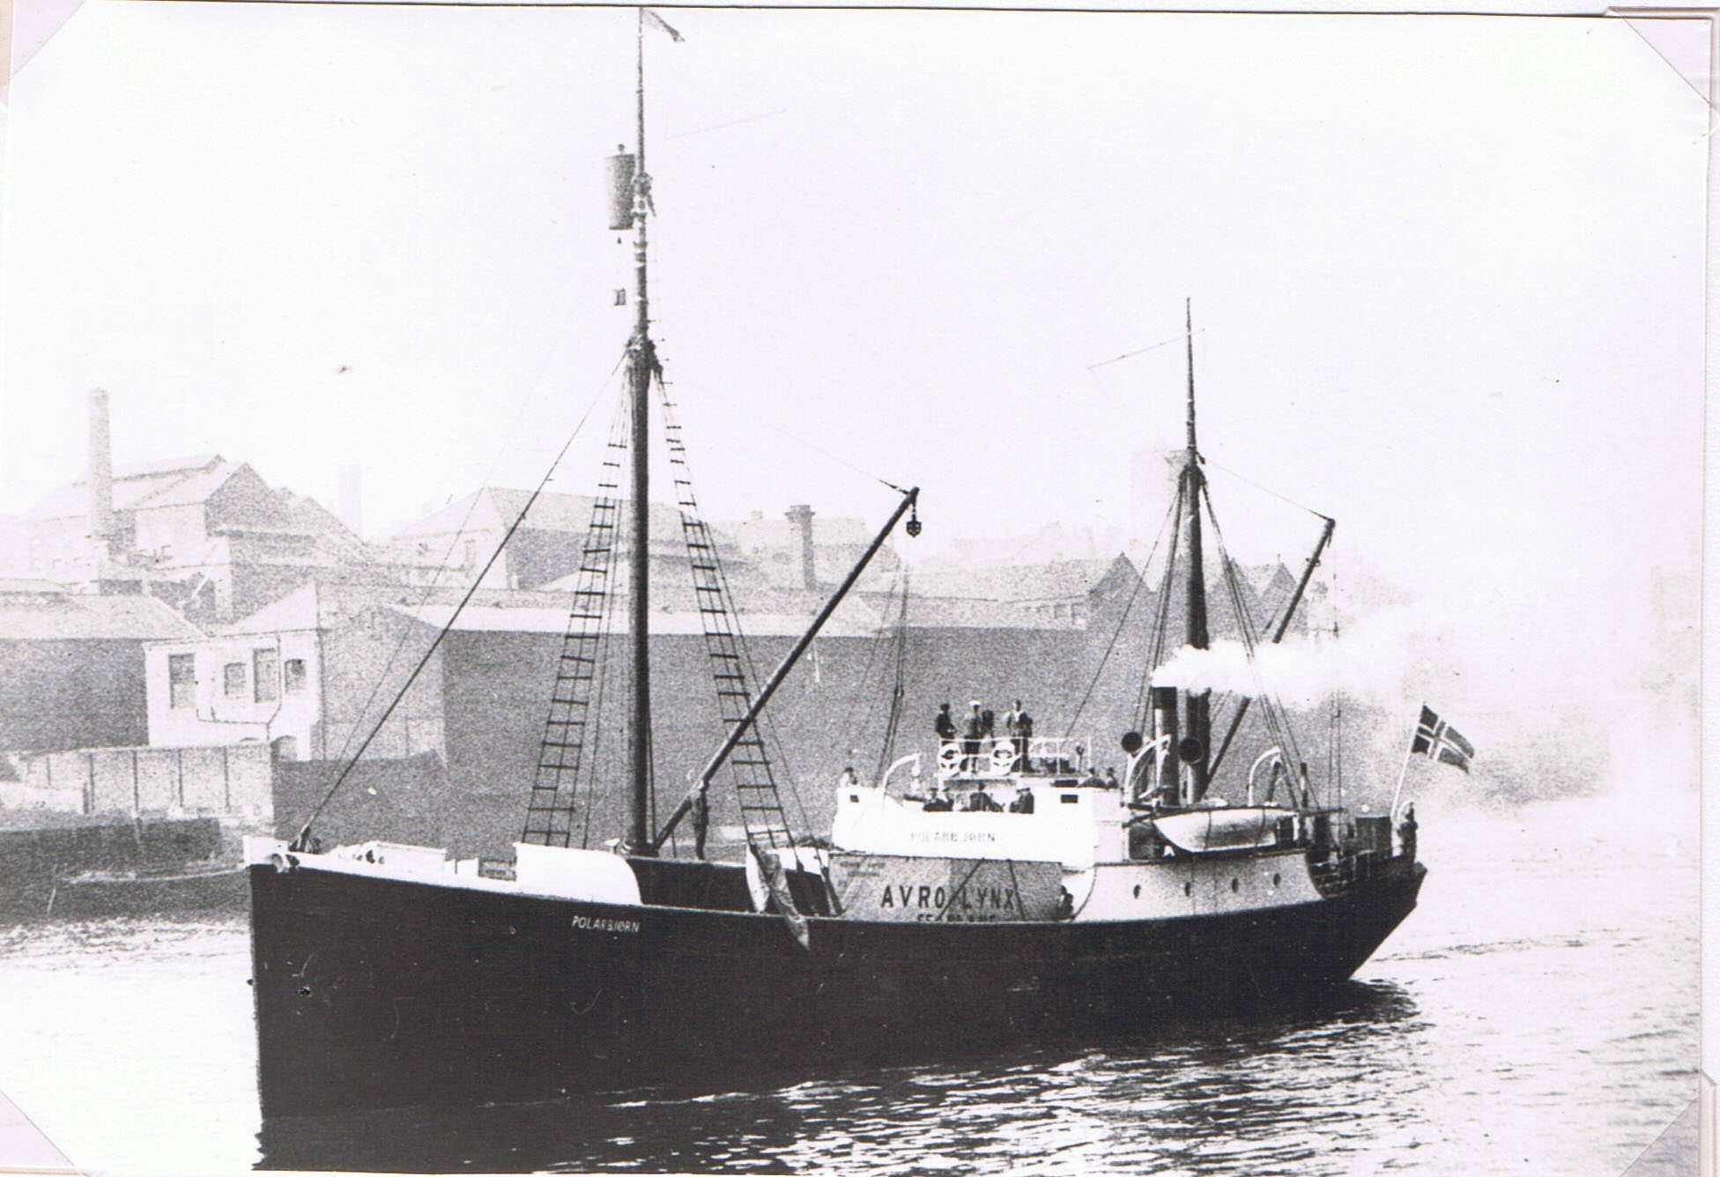
The “Polarbjørn” going down the Tyne, under Norwegian flag. A big sea-plane case on deck. Barrel as crow’s-nest for ice-spotting. (Press photo).

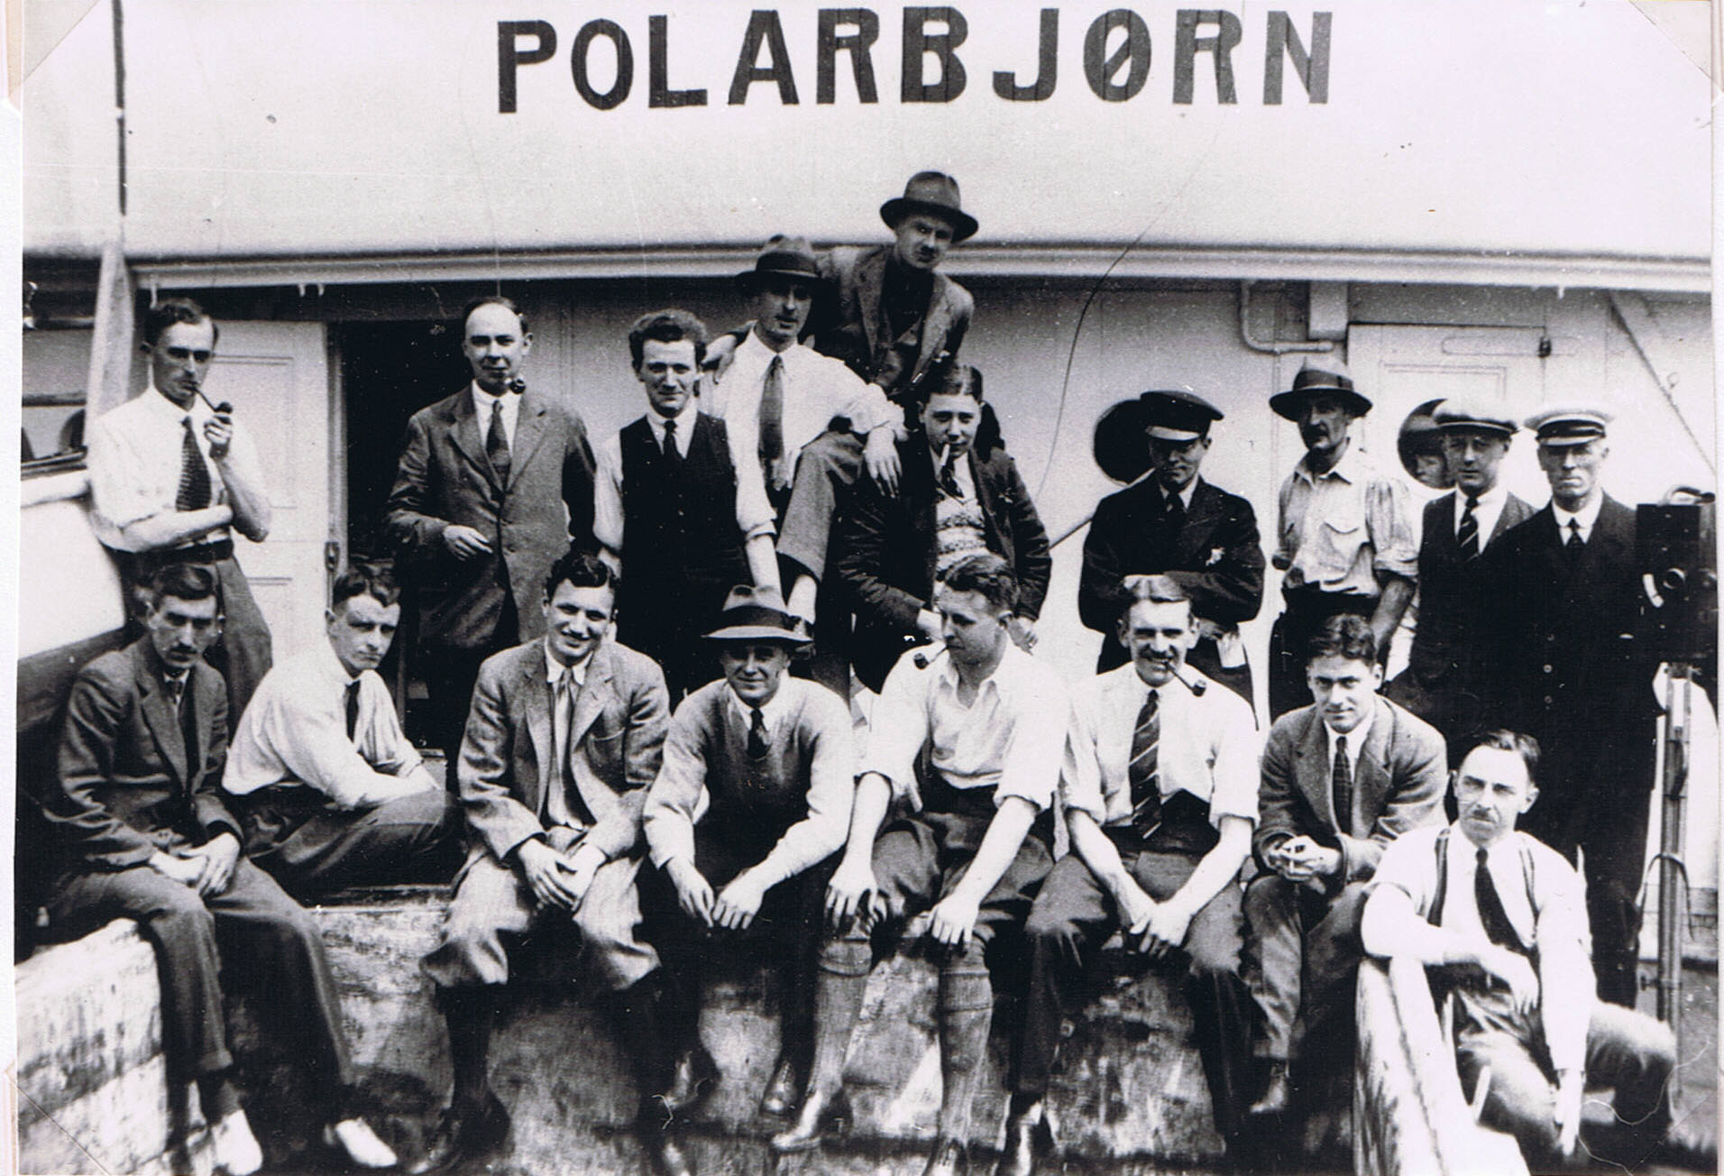
Lower row, left to right: R.A. Frazer; C.S.E.; T. Stonborough; Lt. H. Baker, R.N.; Lt. J.R.T. Aldous, R.E.; Capt. J.C. Taylor (R.A.F. Res.); Dr. H.W. Florey; Capt. F. Tymms, Air Ministry. Top row: K.S. Sandford; E.R. Relf; E. Law; H.M. Clutterbuck; (at top, 1st pilot, who returned ill from Norway and was replaced by A.G.B. Ellis, ex-R.A.F.); F.G. Binney (Leader); Col. J.E.Tennant; Lt.-Col. Sir Ian Colquhoun; A.N.T. Rankin; J.C. (“Bee”) Mason.
F.A. Montague, R. Thorneycroft {sic} & W.B. Carslake, not in this photo, joined us in Norway, also 2 Norwegians, Capt. H. Hanssen (of Amundsen’s expeditions); and 2 Norwegian dog-drivers, G. Lindquist & H. Schmidt.

List of Members of the Oxford University
Arctic Expedition, 1924.

Mr. G. Binney (Merton College, Oxford). Leader and organizer of the expedition; No. 3 Sledging Party.
Lieut. J.R.T. Aldous, M.C., R.E. Surveyor; Leader No. 3 Sledging Party.
Lieut. H. Baker, R.N. (Ret.) (Cambridge). In charge of M/S Oïland; Surveyor.
Mr. W.B. Carslake (Cambridge). Mountaineer; No. 1 Sledging Party.
Mr. H.M. Clutterbuck (University College, Oxford). Assistant organizer; No. 2 Sledging Party.
Lieut.-Col. Sir Ian Colquhoun, D.S.O. No. 3 Sledging Party.
Mr. A.G.B. Ellis, ex-R.A.F. Sea-plane Pilot.
Mr. C.S. Elton (New College, Oxford). Chief Scientist; Ecologist.
Mr. H.W. Florey (Magdalen College, Oxford). Medical Officer.
Mr. R.A. Frazer (National Physical Laboratory). Surveyor; Leader No. 1 Sledging Party.
Mr. E. Law. Wireless Operator.
Mr. J.C.B. Mason. Cinematographer.
Mr. F.A. Montague (Balliol College, Oxford). Ornithologist; No. 1 Sledging Party.
Mr. A.N.T. Rankin (Christ Church, Oxford). Bird Photographer.
Mr. E.R. Relf (National Physical Laboratory). Physicist; Surveyor; Assistant Wireless Operator.
Mr. K.S. Sandford (University College, Oxford). Geologist and Glaciologist; No. 2 Sledging Party.
Mr. T. Stonborough (Cambridge). Reserve Sledger.
Capt. J.C. Taylor, R.A.F. Reserve. Ground Engineer of the sea-plane.
Capt. J.E. Tennant, D.S.O. Surveyor; 2nd in command of M/S Polar Bjørn.
Mr. R. Thornycroft (Balliol College, Oxford). In charge of motor boat; Mechanic.
Capt. F. Tymms, M.C. (Air Ministry). Sea-plane Observer, Aerial Photographer and Navigator; Meteorologist.

Norwegian Members.
Capt. H. Hanssen (Amundsen South Pole Expedition). In charge of dogs; No. 3 Sledging Party.
Mr. A. Eilertsen. Interpreter; Navigator; No. 3 Sledging Party.
Mr. G. Lindquist. Dog Driver; No. 1 Sledging Party.
Mr. H. Schmidt. Dog Driver; No. 2 Sledging Party.

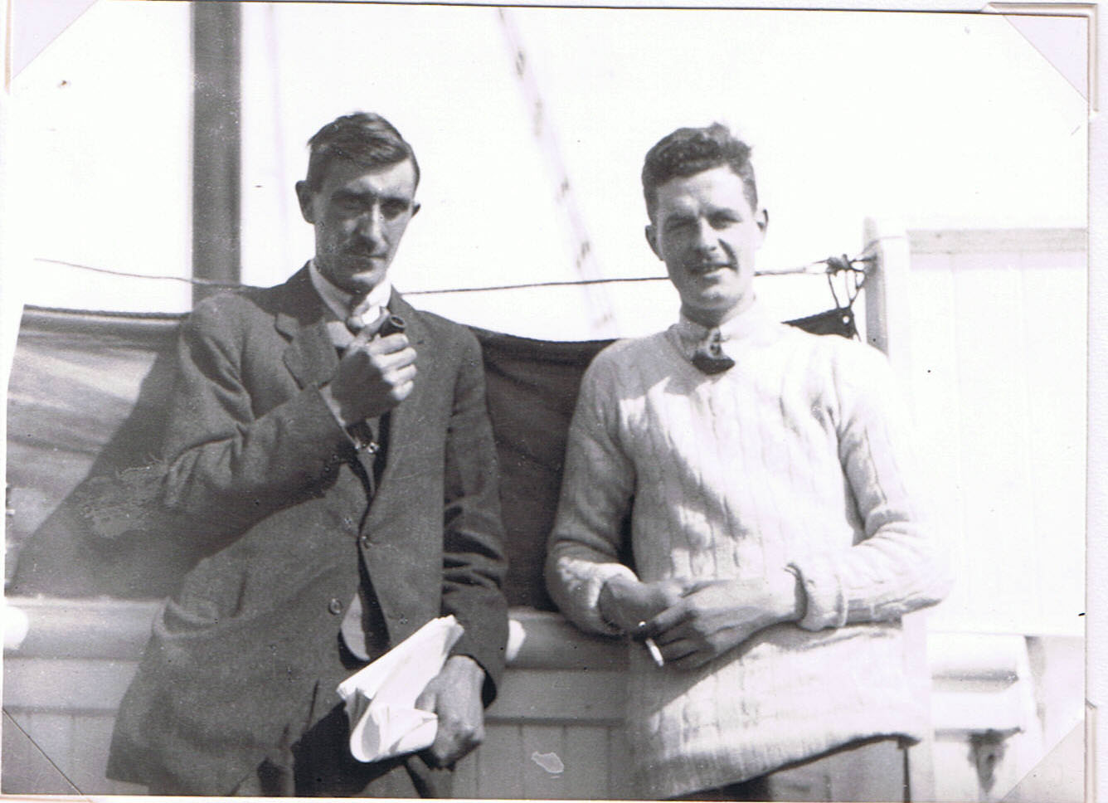
Frazer & Clutterbuck. The former, Binney & C. S.E. were the only ones who went on all 3 Expeditions. The latter was on the 1923 “Terningen” and helped me by having a very good eye for collecting plants. (He was a considerable benefactor to the 1924 Expedition). Taken on the way up the Norwegian coast, June 1924. (Photo C.S.E. 1924: No. 137).

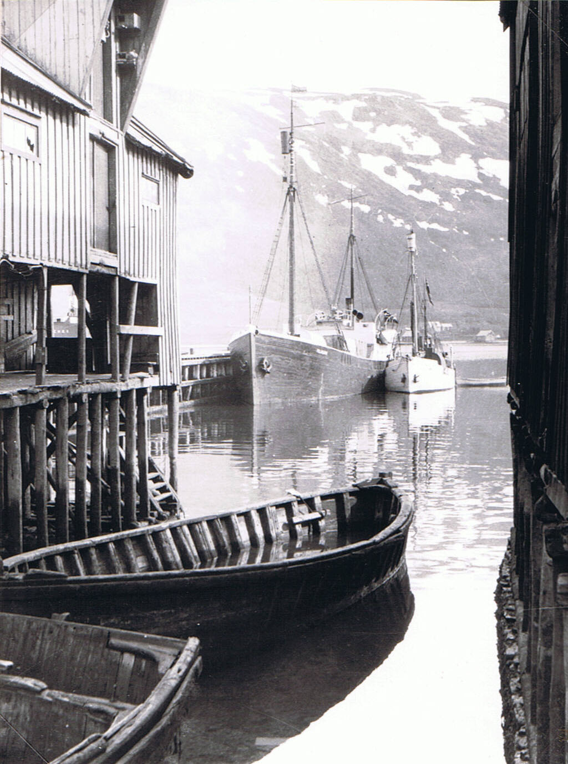
Polar Bjørn and Oïland in Tromsø Harbour, c. 28 June 1924. (Photo C.S.E. 1924: No. 134). Barrel crows-nests for ice-spotting.
7 July 1924. Deer Bay Island, King’s Bay, North-West Spitsbergen.
[After landing and assembling our sea-plane at Green Harbour, in Icefjord, where Kenneth Sandford and I did quite a lot of work on the melting spring tundra and shore, we went on in the Polar Bjørn to King’s Bay – see map earlier, 1921 Expedition].
Arrived at King’s Bay coal mine station early this morning, and awoke 8 a.m. to find a beautiful clear sunny day, and a bay gleaming with glaciers. A party of us was formed and went up to Deer Bay Island in the motor-boat to look for Sabine’s gulls (which here have one of their very few nesting stations in Spitsbergen). We got there about 11.30 and returned at 4 p.m. The motor-boat stopped on the way back and we drifted for about half an hour, while the engine was being put to rights.
The island is a marvellous place, especially on a day like this. In the distance it appears as a low green rocky piece of land, and as one approaches one sees two huge glaciers flanking it, while the mainland itself is rather barren looking, and has brown and grey low cliffs like Walrus Bay on Bear Island. They are in fact the same Hekla Hoek metamorphosed limestone. There seemed to be singularly little plant-life on the mainland and I can’t make out why it is named Blomstrand. Perhaps he was a bloke, & not a compliment (Yes!). Deer Bay itself is a curious mistake in name, since it is a corruption of Dyr Bay, which means Brute or Beast Bay. The Norwegian map calls the island Gjerd Øy, which is evidently the name of a girl. I prefer Deer Bay Island as being more descriptive.
As we got nearer the shore, we were met by a concourse of screaming terns which came circling and diving over our heads in dozens. In the sea round about the island and in the fjord there were fulmars – a few and solitary, while two puffins, and a few single Brünnich’s guillemots, Mandt’s guillemots ditto, small parties of little auks, one or two glaucous gulls but no kittiwakes, ♂ and ♀ eiders and one or two red-throated divers. A glaucous gull was seen to swoop and catch a little auk on its feet, out at sea.
The whole biology of the island is very interesting; I think it is probably one of the warmest and richest spots in Spitsbergen. The rock is Hekla Hoek schist, covered in places with boulder clay, but it is only exposed on the coast, in low cliffs…. The height is about 60 feet. Everywhere there is a thick mat of vegetation, often with over 6 in. of peaty soil. The dominant plants by a long way are mosses, which form in places an

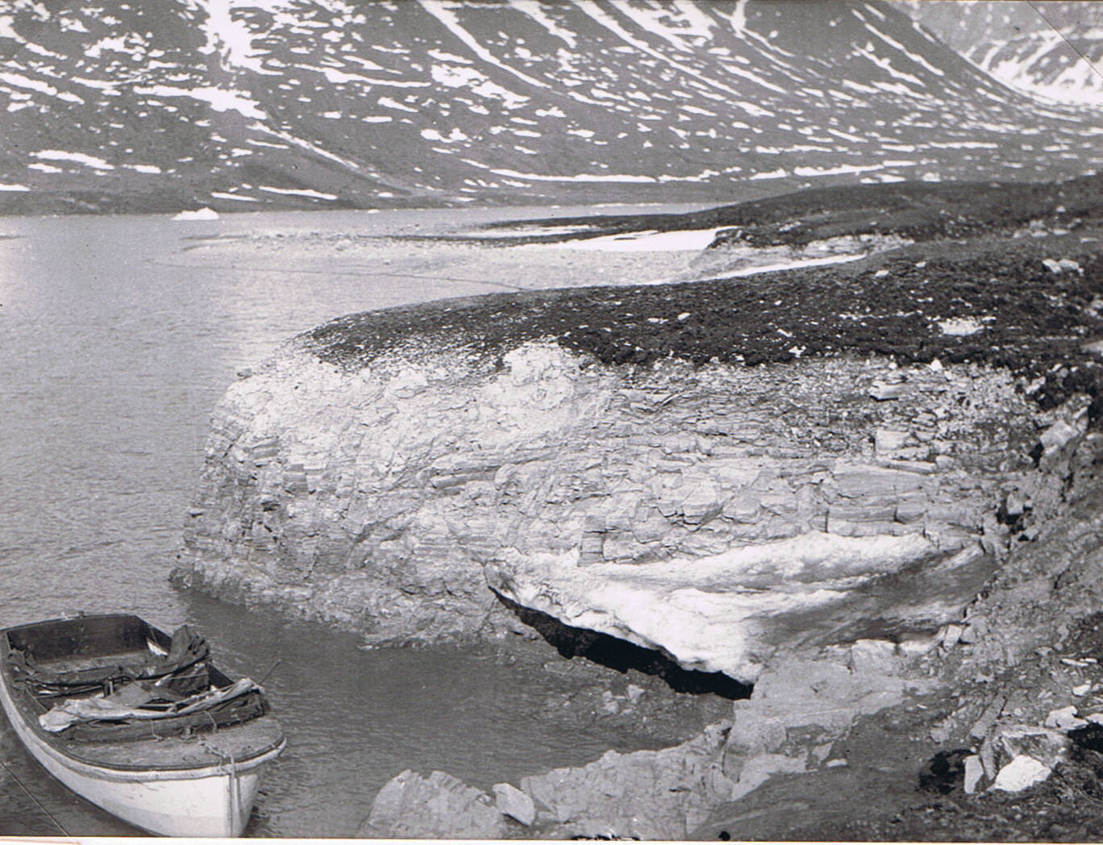
Nesting ground of the rare Sabine’s gull on Deer Bay Island, King’s Bay, with mossy tundra; and remains of winter “ice-foot”. 7 July 1924 (Photo C.S.E. 1924: No. 38).
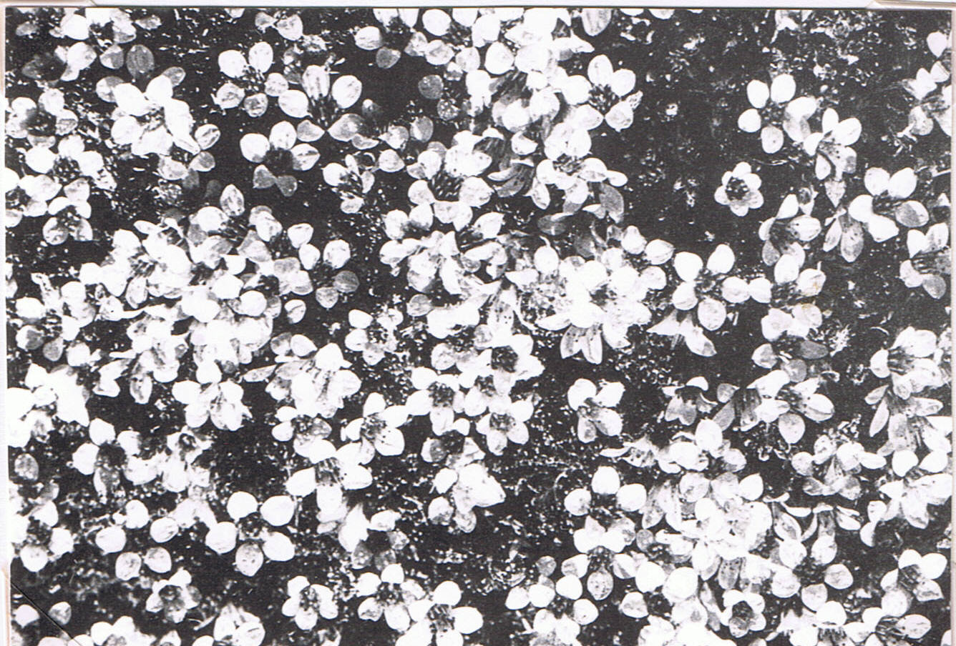
Luxuriant cushion of purple saxifrage (Saxifrager oppositifolia) on Deer Bay Island. (1924: No. 34) (published by V.S.S. & C.S.E. in J. Ecol., Vol. 16, 1928).
7 July 1924. Deer Bay Island, King’s Bay, North-West Spitsbergen….
almost pure moss associations. There are no ponds on the island and therefore no divers etc. nesting. The birds sum up as: 3 Sabine’s Gulls, many Arctic terns; 2 Arctic (Richardson’s) skuas; a few grey phalaropes on shore waters, and purple sandpipers on the shore; a few pink-foot geese, many eiders, and a few snow buntings of both sexes.
The Sabine’s gulls were nesting on boggy ground near the shore. Three birds were seen altogether, one sitting on the nest and the other two were hanging about, sitting on stones. They are very beautiful birds and resemble black-headed gulls rather in size, but with greyer heads and black primary wing feathers. Montague says the Sabines boss the terns completely i.e. the terns always sheer off without attacking. There are a great many terns about, and I saw them chasing an Arctic skua round, several times. They probably protect their own nests & eggs from the skua, but certainly do not always do the same for the eider. I saw a skua, which had been mobbed by terns shortly before, sitting by the edge of an eider’s nest, calmly sipping out of the eggs, just as a hen drinks water.
The small bog pools had many blue-black springtails (Collembola) floating on the surface of the water. Pairs were apparently copulating (or courting!).
The damp moss (-willow) hummocky ground is a most curious formation. I do not remember seeing anything quite like it anywhere else in Spitsbergen. The moss covers the ground in thick lumpy sheets (I collected 10 species of moss and 1 liverwort). A few flowering plants occur, mostly dwarf willow (Salix polaris). Numbers of small flies were walking and flying about and there were also many small black spiders running about on the surface of the moss; there were many strands of web from tuft to tuft, but no regular webs of any sort, and no flies caught in the strands…. All the common Spitsbergen spiders feigned dead when touched.
In one area this ground was thrown into rut-marks (polygons), which were in a fairly advanced state of plant colonisation. Here and there are fine isolated mud patches with plant rings were shown, the whole thing usually about 4 or 5 feet across. Frazer and I excavated and measured one:
(see below)
The ridge of frozen ground running round under the plants were flat, not channelled, and with no stones visible (the vegetation had delayed melting by insulating the ice). The mud was dry on top, but heavy, clayey, and water-logged below.
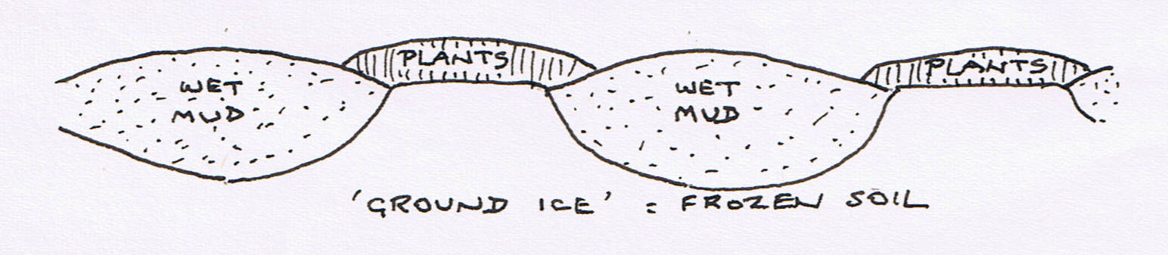

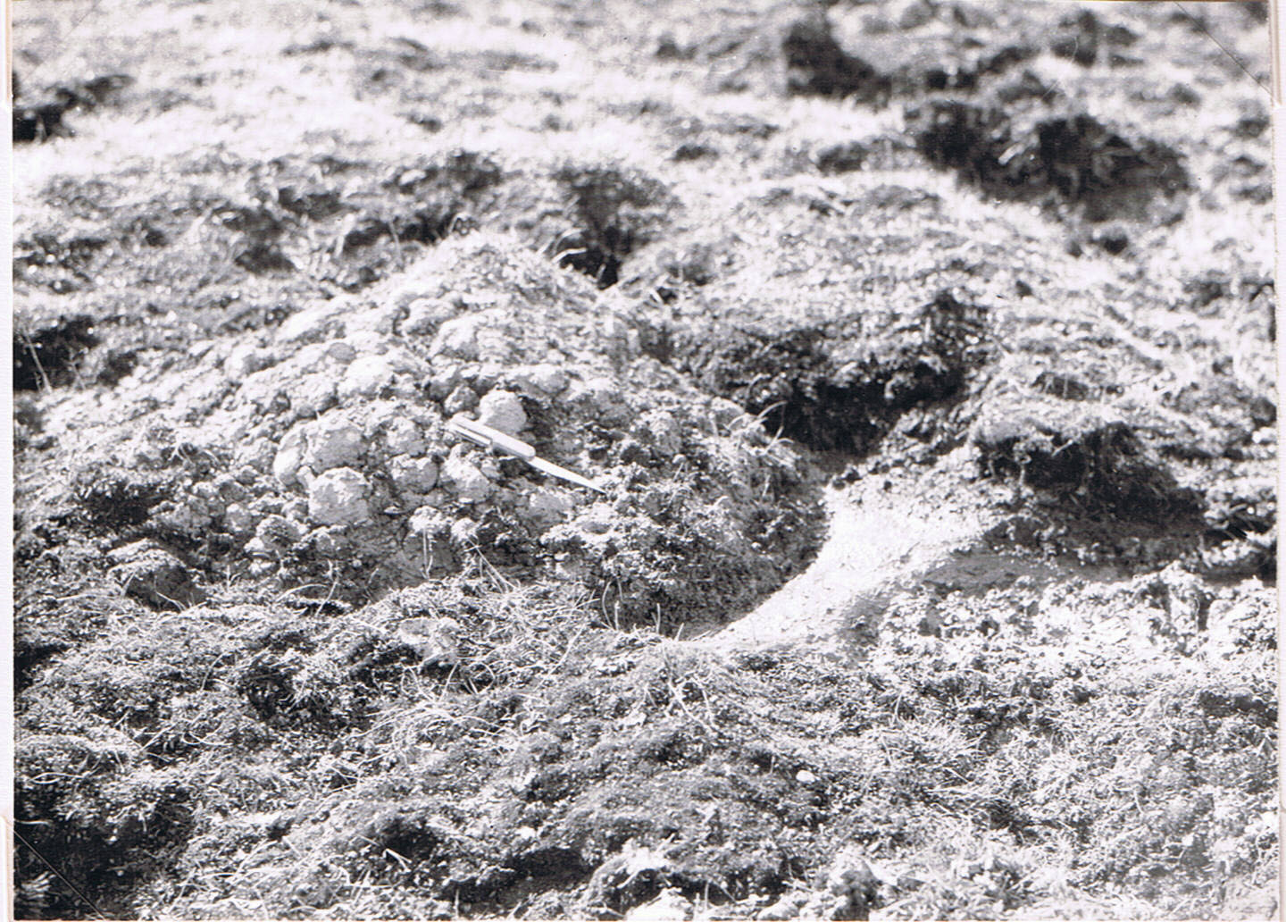
Mud “polygon”, 4-5 ft. diameter; cleared part of edge shows still frozen ground where plants insulated it, centre being bare and unfrozen. Deer Bay Island, King’s Bay, 7 July 1924. (Photo C.S.E. 1924: No. 35). (Published by C.E. in Q. J. Geol. Soc. 1927, vol 83).
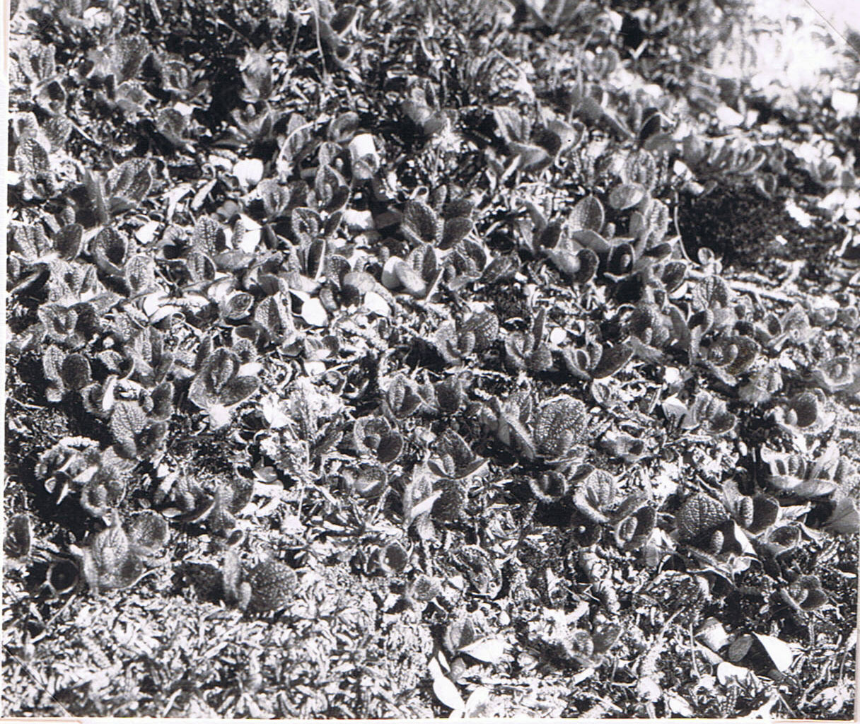
Salix reticulata, a creeping willow found only in warmer parts; Deer Bay Island, King’s Bay, 7 July 1924 where I found among it the very local leaf-mining weevil that lives on it. (Photo C.S.E. 1924: No. 33) Published by C.S.E.; 1928, J. Ecol. Vol. 16, plate 23).
7 July 1924. Deer Bay Island, King’s Bay, North-West Spitsbergen….
It supported little plant life.
On rocky slope the moss grades into a mixed flowering plant association. There was Salix reticulata in patches, in flower bud, and it had a very interesting fauna including a black weevil (Tachyerges saliceti) and an aphis. The weevils were abundant, and both sexes were present, some pairing. They are black and about 1/10 in. long. When touched or alarmed the jump about an inch on the ground, at the end of which they sometimes, though not always, feigned dead. They always seem to alight the right way up, unlike click-beetles. They can also run about actively. (This weevil has been found in a few warmer spots in West Spitsbergen, and a Norwegian entomologist has studied it on the Norwegian mountains, and proved that its larvae grow in leaf-mines on Salix reticulata, itself a plant not found in the bleaker parts of Spitsbergen).
A hawk-fly (Syrphus tarsatus) was flying near, and evidently its larvae feed on the aphis. (This pair do not live in the barren regions either).
On a rocky hill-pop there was a pure open formation of mountain avens (Dryas). These grew in isolated clumps, and showed a wave-like formation as at Klaas Billen Bay. The stems were up to a foot long, the wind-blown end of the plant being towards the south-west. Therefore the prevailing wind here is North East.
There was a rich orange lichen where terns had been sitting and manuring the rocks.
It was remarkably hot on the island today, and one had to discard clothes a good deal. I think the factors causing the richness of Deer Bay Island are (a) being in an inner fjord i.e. much sunshine (because föhn winds down the glaciers warm the air as the pressure increases during their descent) (b) a complete ring of sheltering mountains (c) reflection of heat and light from 7 surrounding glaciers (d) manuring by terns and eiders (e) being open to the south.
Bed 2 a.m.

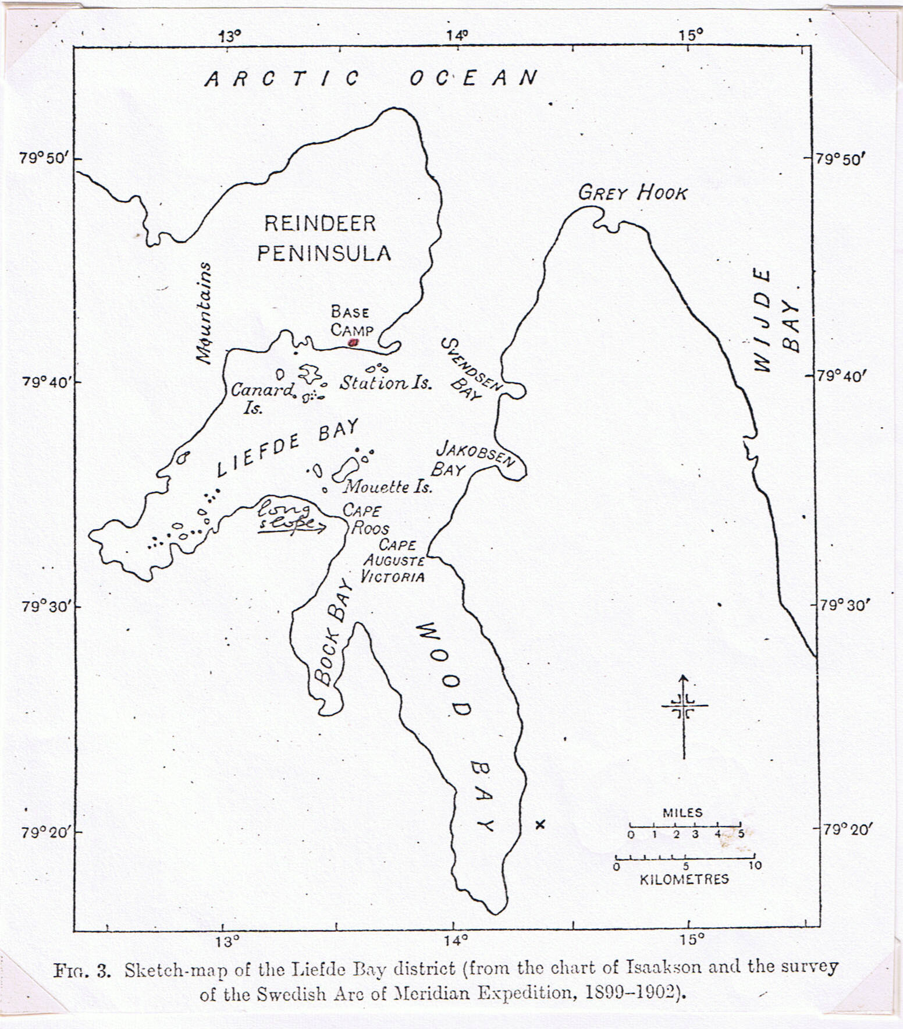
(V.S.S. & C.S.E. 1928, page 200. Cross shows approximate position of Mount Scott-Keltie)

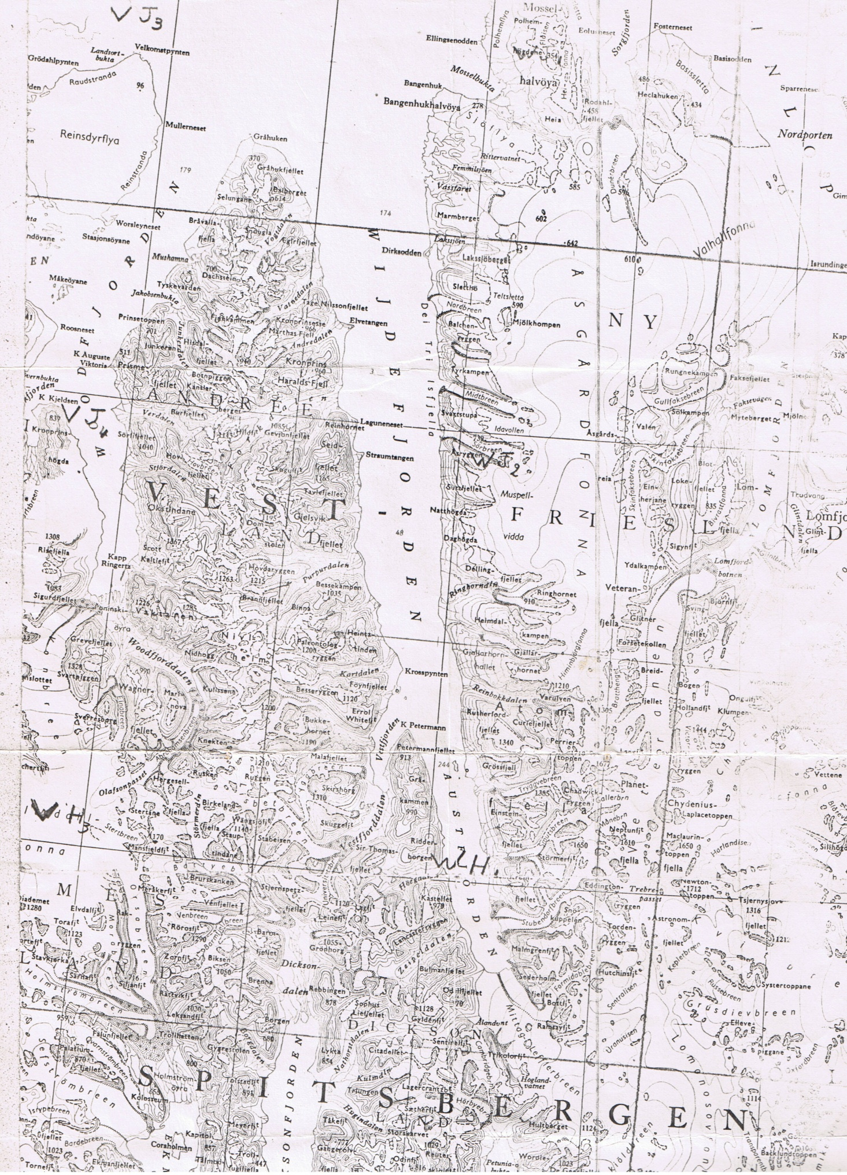
{Loose map inserted here; Mt. Scott-Keltie & site of Base Camp (see p. 11) ringed in red, left.}
10-14 July 1924. Camping on Reindeer Peninsula, North Spitsbergen.
10 July. Up 8.15 a.m. Working party on shore 9 a.m. to 1.30 p.m. (we were still living on the Polar Bjørn), and 2.30 p.m. to 5 p.m. We floated the three sea-plane cases ashore on rafts composed of barrels and planks (the latter from the old American balloon place on Dane’s Island), and hauled them are up the slipway onto the shore. From there they were hauled by block-and-tackle and much sweating of ourselves, onto a flat place about 10 feet above the shore; the three cases (now huts) look quite imposing. I made a well and dammed up a place for a pond of water, and there is a wireless aerial up. Altogether it is a good piece of work. Hard work though: nearly all day we have been having a tug-of-war with these cases, moving them foot by foot by means of rollers (of drift wood).
Saw a turnstone chasing away a skua single-handed. 1 reindeer was shot at the grass lagoons near the shore. Bed at 12.30 a.m.
11 July. Up 8 a.m. Worked 9-1 and 2-6 on the shore, on more sea-plane stuff. Thank goodness the job is almost finished. We towed ashore and rolled up 15 barrels of petrol – steel barrels, and did various other things, such as levelling shingle places for running up the machine. I made an elegant camp fire-place with stones, turf, and 5 lengths of brass curtain rod (brought by me for this purpose).
Took a slack evening. Bed 12 o’clock.
12 July. Up to 10 a.m. Everyone rather late today, after the strenuous work of the last week. I went ashore in the morning and did some digging up of rut-marks (polygonal soils), but soon tired of this! Determined the general fact that the core of the peninsula is formed by fine red sandstone, and this crops out in many places, often in curved terraces along hill-slopes. But there is a great deal of boulder-clay, forming a deposit of varying thickness over much of the rock. It contains rounded stones and shells and is very sticky and soggy. Roughly speaking, the bare rocky areas, which weather into gravel, are covered with Dryas (mountain avens), and the boulder-clay areas with dwarf willow-moss-lichen. The Dryas is only in open association, or else occurs in the borders of rut-marks which have red muddy centres mostly. The boulder-clay is also thrown into rut-marks in most places.
The temperature of the air was 10 ºC. at noon, 7º in the evening. An utterly still day, with the fjord like a pond. Not a ripple. A mist lying low over the water, but not very thick, and clearing up at times so that the day was sometimes merely overcast. Mirages. Dense silence when

10-14 July 1924. Camping on Reindeer Peninsula, North Spitsbergen…
12 July… was sitting away up on the tundra. The only noise one could get within sound of at times was that of running water. When one was over a mile from the shore there was absolutely no life about except the occasional purple sandpiper, with his curlew note, and very occasionally reindeer. While I was sitting on a huge block of transported granite on top of a hill, with wide stretches of reindeer pasture all round, two purple sandpipers flew up and settled on the ground a few feet away and ran about chattering. They ran round for 5 minutes giving out a curious chattering-piping cry, all on the same note. Then they flew off, one doing the curlew note. Saw one fly up like a lark, doing its curlew note and then drop down head first like a plummet, turning a few feet from the ground and dashing away along the side of the hill.
3 small reindeer were grazing over it gently sloping gravelly alluvial ground. Not very frightened, until I moved, and even then they seem torn between curiosity and fear, galloping round me several times, in wide circles. I watch them grazing over the dry tundra and saw one eat flowering purple saxifrage, and another a clump of dwarf willow. They move along slowly, with a quick nibbling motion of their jaws, just skimming the tops of the tundra plants, apparently indiscriminately (like mowing-machines). They were shedding their long white winter coats, and showing black marks where the hair had already come off. They have black faces with a fringe of white hair like whiskers, just now. These Spitsbergen reindeer are very small animals, 4 or 5 feet long, but stockily built. They can run about as fast as a man doing the 100 yards. 1 ♀ and 2 ♂♂.
There is great destruction by streams here, in spite of the comparatively gentle slopes. The spring floods from snow-melting, of course, do all the damage, and one may see now the beds of the rushing torrents of the early part of the summer (a few weeks ago). The present streams are quite small and shrunken, while the beds of the snow-melting streams contain relics of plants almost torn from their roots. The snow has mostly gone now.
I watched three red-throated divers on the calm fjord. By the rocky shore terns were fishing. The bird does roughly 3-4 strokes a second, for 15-20 strokes while hovering. On the shore Fucomyia parvula (a sea-weed fly) was frequent under stones, and there were 5 species of mite.

Traced from sketches in my diary, Reindeer Peninsula Base camp.
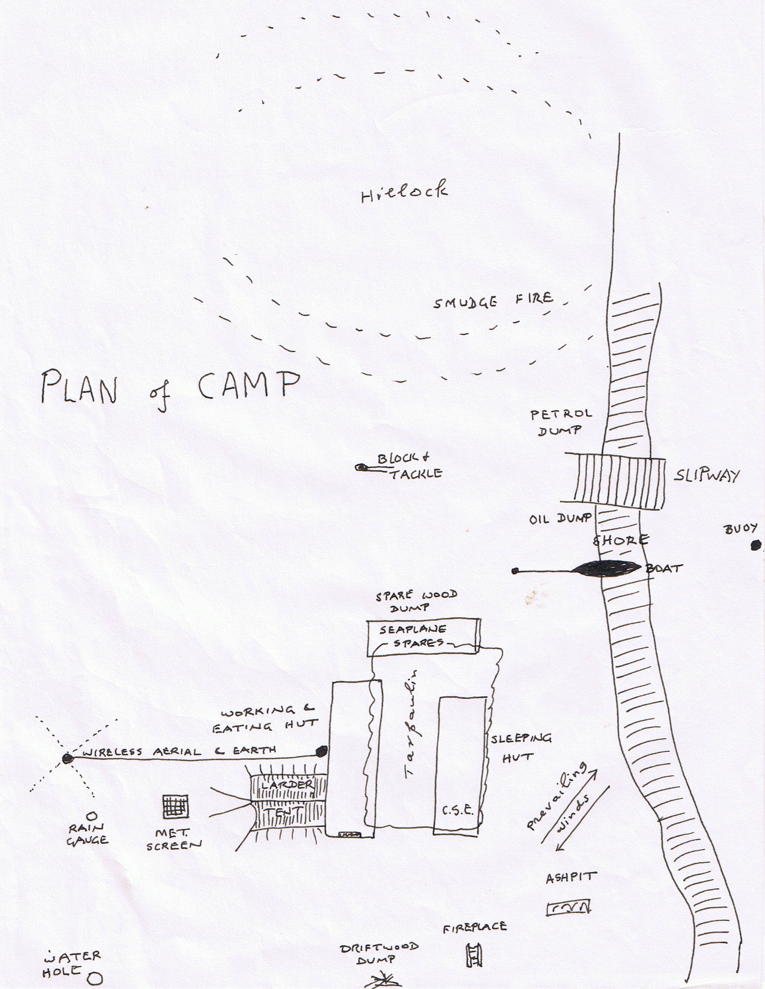

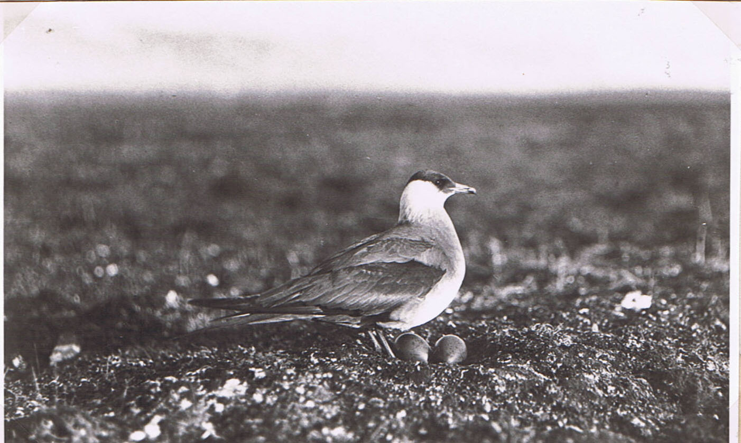
Richardson’s skua on Reindeer Peninsula, c. 13 July 1924. (Photo A.N.T. Rankin).

10-14 July 1924. Camping on Reindeer Peninsula, North Spitsbergen…
12 July… and some young spiders.
In the evening, found a real sanderling on its nest, with four eggs. It was a cup full of dead willow leaves, situated in the centre of a clump of purple saxifrage on the alluvial dwarf-willow ground near Lagoon II. The bird is rather smaller than the purple sandpiper, has a fawn side to its throat, and shows much white especially on the tail. It shuffled about trying to lead us away. A purple sandpiper with four eggs, on similar ground. Bed 12.30 a.m.
13 July. Up at 11.30 a.m.! Feel correspondingly fresh. Went ashore in the morning. There was quite a sea running, owing to a south-west wind which rose in the night and set the waves running right down the length of Liefde Bay towards our ship. The crew are not very good; they mostly seem to be dead from the neck up, including the Captain. It was lucky that I noticed that there were no spare oars in the boat the landing, for on the way back someone smashed an oar in the heavy waves, and the weather was not conducive to rowing gondola-fashioned.
Montague and I walked out towards the base of Reindeer Peninsula in the teeth of a strong exhilarating wind. We raised the sanderling from her nest, and she led us away, scuttling along looking like a rat or a lemming, for about 500 yards, before she flew back to her nest. The country had an air of interesting bleakness. Further on two skuas rose, and began flopping about pretending to have broken wings and hopping like large frogs. After some search we found the nest, which was a scrape in the willow-lichen tundra of a stream valley, and contained two eggs. The nest site was very similar to that of the skuas in Skua Valley, Bear Island, but there was no skua hummock, or any particular signs of rich vegetation. Further on there were two purple sandpipers running about together, and apparently not concerned with nesting. They had the occupied air of an engaged couple. There were two pairs of turnstones nearby, and we found 2 downy young ones hiding among the Dryas. The parents were very fierce and came quite close in their anxiety.
Visited the nearest Canard Island (west of the camp), at 10 in the evening, going over a choppy sea in the motor-boat. The island is similar to the Station Island I visited, in geological structure and vegetation. There were a few eider nesting, terns frequent (?nesting), 2 brent geese, 2 ice duck (= long-tailed duck), red-throated divers (1e nest with 2 eggs),

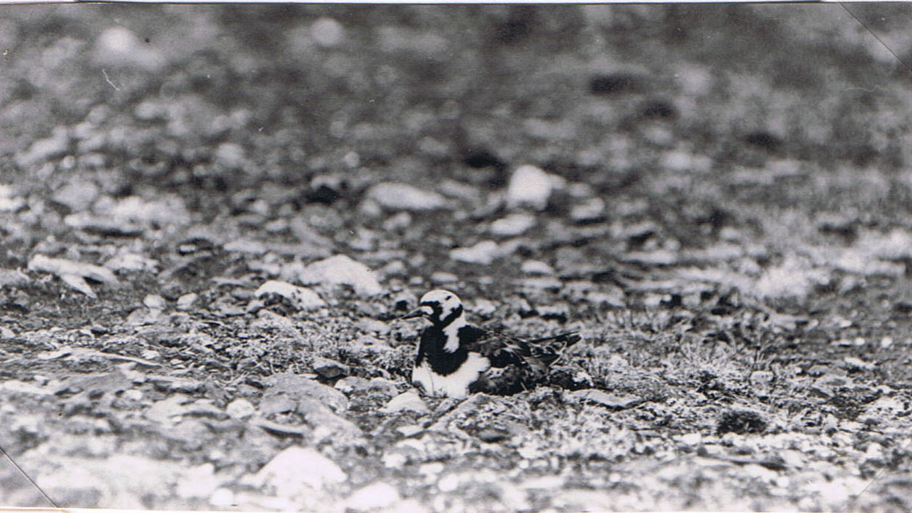
Turnstone on nest, on fjaeldmark. (Photo Seton Gordon, 1921, almost certainly on Station Island, Liefde Bay).

10-14 July 1924. Camping on Reindeer Peninsula, North Spitsbergen…
13 July… 1 cock snow bunting; and purple sandpipers feeding on the ice-foot (the remnant of winter freezing still stuck to the shore). An astonishing result came from examining the ice-foot where the purple sandpipers were feeding. The snow was in a crystalline mushy state and about 2 inches down occurred enormous numbers of Lumbricillus aegialites (small white Enchytraeid worms) moving about and lying in bunches in the snow, with an inch or two of between them {sic} and the dead seaweed below, which also contained a good many worms. (This is a sea-shore worm that I partly found in seaweed in other Spitsbergen localities; Dr Stephenson described it as a new species; and I brought some home alive from the Canard Islands, which stayed alive in the tin I gave him, all winter).
Bed 2.30 a.m.
14 July. Up at 10 a.m. General excitement, as the sea-plane was reported to have started from Green Harbour. They said it was to be expected in about ¾ of an hour. Tymms was very anxious, because the aeroplane party had decided to fly across the mountains by the Monaco Glacier, instead of going round by sea, and we could see from here that there were big patches of cloud over it. T. said they were “damned fools” to try it. The sea-plane contained Binney and Ellis. After a hurried breakfast, Montague and I went ashore. The sea was still rough. We went up to the hill behind the camp, and lit a fire of driftwood and stood by to throw on seaweed in order to make a smoke for the sea-plane. By this means they can see the direction of the wind. We waited for about two hours and were then recalled to the ship and found everyone anxious. The sea-plane had apparently vanished from all knowledge. Relf fell into the sea, when getting into the motor-boat (when noone was on deck: he hung on by his hands to the bottom gangway step in the cold water, but could not pull himself up, shouted for 20 minutes, and was providentially heard when almost done).
We waited until four-thirty in the afternoon, and then the Polar Bjørn left hurriedly for the south. The news up to the last moment was that neither King’s Bay nor Green Harbour had heard or seen the sea-plane. Something has happened to it, and it may be trifling, serious, or fatal – probably serious. We are in the dark. The Oïland has also left from Green Harbour with the speed of light. The two boats will probably have to search for the air party.
Meanwhile Relf, Montague, Sandford and myself have been left here at Liefde Bay in case the sea-plane turns up and to carry on with our work. We have a small wireless sending and receiving set worked by Relf. We have

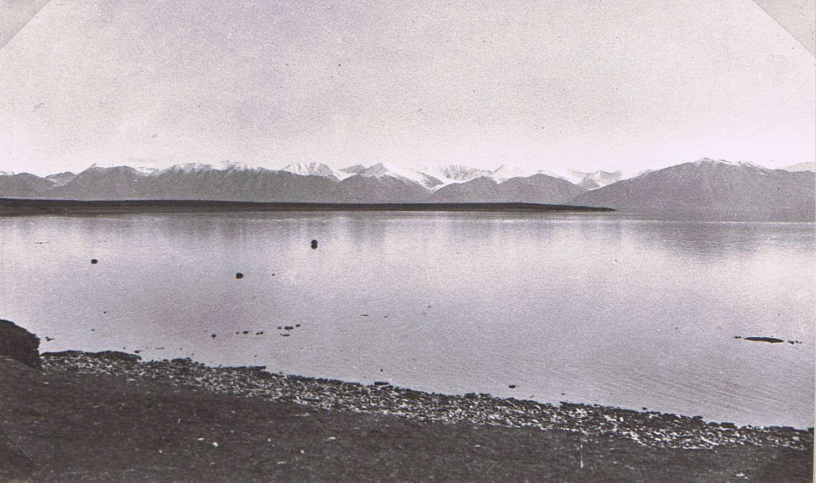
Liefde Bay, from our base camp on Reindeer Peninsula. Entrance behind long point, left; Mountains on east side of Wood Bay; Cape Roos 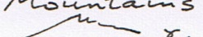right. (Photo A.N.T.Rankin, 1924).

{Photograph missing}

2 other volumes have print
Base camp, cooking in the open on driftwood fire; petrol tin made into a kettle. Meteorological screen left: tent meat-larder; large sea-plane-parts hut-eating room left, my bedroom right – feet outwards! July 1924. (Photo A.N.T.Rankin, 1924)

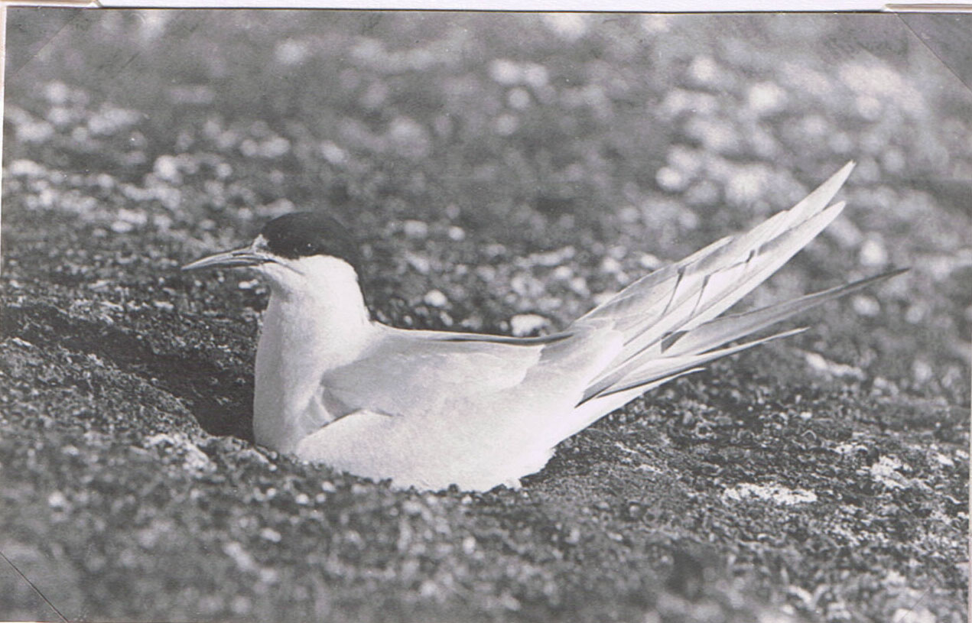
Arctic Tern on nest (as below). But they nested mainly on lichen crust, never on the turf their manuring was helping to make.
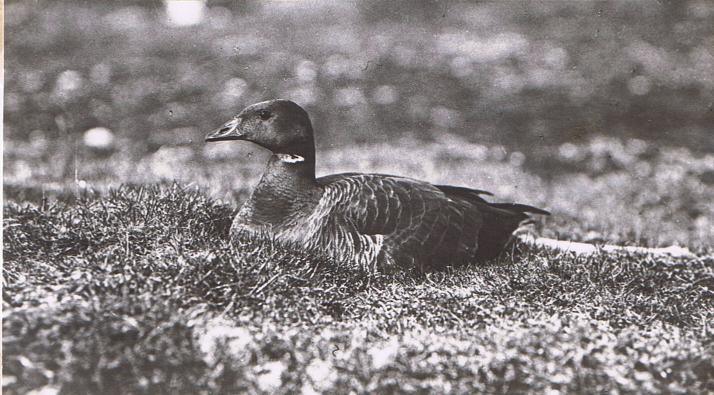
Brent goose on its nest, Station Island, Liefde Bay, end of July 1924. They were nesting only on turf, this developed by bird manure.
(Photos A.N.T. Rankin)
(Both photos published by V.S.S. & C.S.E. 1928, J. Ecol. Vol. 16, plates 20 & 21).
10-14 July 1924. Camping on Reindeer Peninsula, North Spitsbergen…
14 July… fixed up very comfortable quarters in the “Avro” cases.
We got away at short notice, collecting all gear and food and camping outfit in an hour and getting it ashore in twenty minutes. I am in charge of the practical side of the party – such as boating, food, and general camp routine. Bed 12.30 a.m.
(The sea-plane story does not belong to my own experience, and is well told by Binney in “With Seaplane and Sledge in the Arctic”. Just after leaving Green Harbour they came down in the sea because a piston shattered. They floated for some 12 hours in increasingly rough weather and waves, and were on their way to death in the Greenland Sea, when a young Norwegian meteorologist went out from his hut late at night and spotted them on the ocean far out. He and his brother and their cook went out in a small motor-boat and with great danger and difficulty towed the plane back into King’s Bay and their hut on Quade Hook. Later the plane was hoisted onto the Polar Bjørn and brought up to our camp on Reindeer Peninsula).

10-19 August 1924. Tundra weather in North Spitsbergen.
(I was at the Base Camp on Reindeer Peninsula, in charge, but with only one companion. First A.N.T. Rankin the young bird photographer; then H.W. Florey = “Doc.” The ships, seaplane and three sledging parties were “in the field”. I was left in charge of the meteorological recording).
10 August. Up 12 o’clock again. The rest is certainly refreshing, but I must wake earlier tomorrow. It is delightful to be able to get on quietly with my own work, without interruption from the seaplane. It snowed and sleeted and was very cold and damp all day. Stayed in mostly and worked. Went out in the evening right to the end of the spit south of Seal Lagoon. It consists mainly of boulder clay up to 5 or 6 feet thick overlying the red shale. There is a dwarf willow flora in the channels of the polygons, which are fissure polygons with many stones lying in the bare centres. In some places purple saxifrage dominates.
There were many eider families along the shore, and old nests in the willow-channel association. Much seaweed in thick drifted mats at high-tide mark… And small lagoons in red mud, containing the (relict brackish) copepod Eurytemora.
At 11.30 p.m. the earth temperature at one foot in mud-gravel willow alluvium by the huts = 39.8 ºF., while the air temperature = 33 ºF. This settles the (supposed) “alternate thawing and freezing of the polar summer.” At 8 a.m. next morning the air temperature was 32 ºF. and temperature 39.2 ºF. The air temperature had not been lower during the night.
11 August. Up 8 a.m. (woke successfully at seven minutes to 8). I tried the Coué idea of imagining, instead of willing, to wake up at the right time, and it certainly worked this time. Last night it snowed quite heavily, and although none lay on our ground, the mountains were clothed with white down to a certain level. There was a striking gradient from the mouth of the fjord towards the inner regions. This gradient may have been an accident or it may mean that the climate is warm as one goes in, as one would expect.
A bitter cold morning, with the thermometer at 33 ºF. and a wind from the north-west. It cleared up to comparative calm later on. As far as I can make out, the weather events of the last week are as follows: a big depression has moved across from the west and it brought, firstly, two days of south-west winds. Then we “ran into” the centre of it and had the curious calm hazy day on a Friday, with a few hours of E.N.E. wind. Then there were two or three days of N.W. winds, as we caught the other corner of the cyclone. The S.W. winds brought rain, while the N.W. winds brought sleet and snow (“off the ice-pack”). The thermograph curve has been an exact inverse of the barograph one, but the former is now steady while the latter is still going up.

10-19 August 1924. Tundra weather in North Spitsbergen…
11 August… In the evening I dug up a purple saxifrage stone polygon by Lagoon 1…. Bed 12 o’clock.
12 August. Up 11 a.m. it has snowed hard all day and we have stayed in and worked. Jolly cold when one sat still for long, as we have not a stove or anything. Alleviate this by shadow-fighting and skipping in the work-shop (an open-sided place between huts, with a tarpaulin over). A sealing sloop came in last night and three of the men called on us on the way to their reindeer hunting. She left this morning.
I do wish the fine weather would come again, especially for the sake of the sea-plane, which must have been tied down all the time to the ground owing to the clouds, mist and snow. I wish also that I knew what had happened to the old Polar Bjørn, which is a week late. She might have been trapped in by the ice which must have been brought down by the recent northwest winds. Then this foggy weather and snow must prevent her moving, since all sailing is done by sight in this region. Everyone is shooting about in different directions now, and noone knows where anyone else is! This is due to the breakdown of the wireless communications, from the following causes:
Polar Bjørn: Generator out of action. Can receive but not send. (Unknown to me the generator had been repaired). Oïland: Can send but not receive, since accumulators have run out. Base Camp: could receive if anyone here knew how, but they don’t. Could not send, since the valves are burnt out. Sledgers: have probably given up listening and thrown away their gear, (yes) owing to the Polar Bjørn’s failure. Seaplane: Has thrown out both sending and receiving sets, at the call of weight considerations of absolute urgency.
The various units of the Expedition are like the molecules of a gas, they bumping into one another, and bouncing off in different directions. All this being so, I am going to fill up the motor-boat with all the petrol she will hold, tomorrow, and then shoot another seal. We shall then be prepared for any emergency, as far as is in our power. (We could have made our way over 100 miles to the nearest coal settlement).
By weather and other calculations I reckon that the P.B. got round the east coast of N.E. Land and landed its sledging party there, afterwards going to Cape Leigh Smith and on round the north coast. At this time it was probably shut in comfortably by mist and the pack, inevitably brought down by the N.W. wind. This wind has persisted for the last four days. They will therefore take a day to get out, if the wind changes tonight, as it shows signs of doing. But they have to be at Hyperite Island on the 14th (to pick up the other 2 sledging parties), so will not be here until the 15th

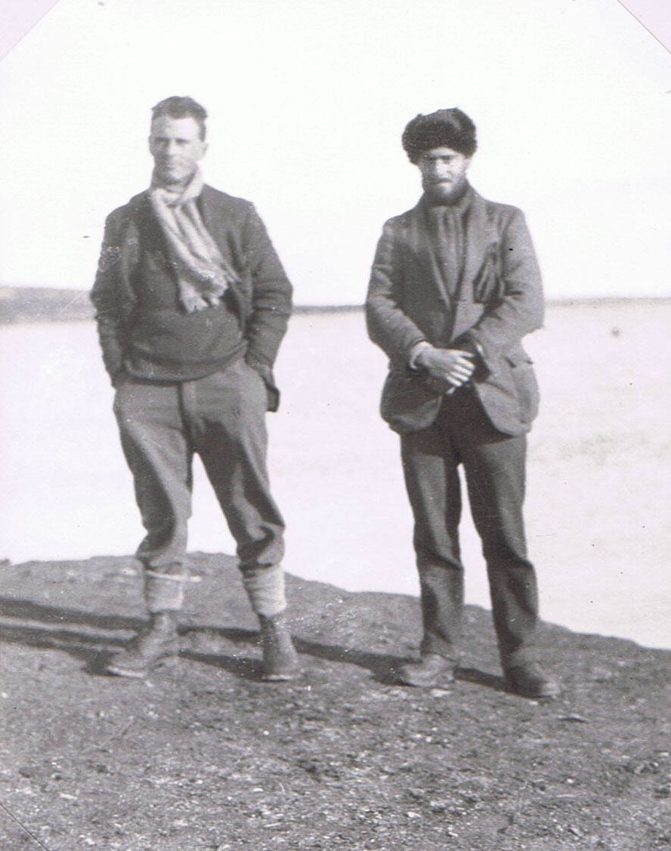
C.S.E. & Florey at camp, Reindeer Peninsula. 30 August. (Photo C.S.E. 1924: No. 12).

10-19 August 1924. Tundra weather in North Spitsbergen…
at earliest. The Oïland will be back here on the 14th or 15th, I think. Bed in 11 p.m.
13 August. Up at 8.30 a.m. The storm has passed all right. We have had a windy and rather cold day, but the sun has been out part of the time, and lit up the snow-covered hills, making an amazing sight of the tangled peaks between Wood Bay and Wijde Bay. Also high up, there has been a delicate mackerel sky. In the morning I filled 11 cans with petrol, according to plan, but it was too windy to get any seals.
Went out and dug rutmarks (polygonal soil structures) in the afternoon, and found the solution of the problem. There was a place by a tarn, which I must describe in detail later, since I had forgotten my notebook (follows much technical description).
Kittiwakes were taking advantage of west wind producing upward current against cliffs to soar along easily, following the tortuous coast-line:
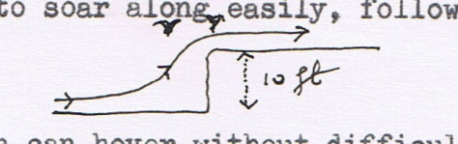
An Arctic tern can hover without difficulty without flapping, against a 6 m.p.h. wind.
Bed 11.30 p.m. But the Polar Bjørn steamed in about 12.30 and we rowed out to see them and hear the news. They had got round as far as “Isis Point”, halfway up the east coast of N.E.Land, and landed the sledge party (Binney, Colquhoun, Eilertsen, Hansen). Then they went on north, but soon had to turn back because of ice. The delay in returning here was caused by various mild adventures and long waits caused by ice, wind and mist… The sea-plane passed over them in Hinlopen Strait and dropped a message.
Ultimately bed again 2.30 a.m.
14 August. Up 11.30 a.m. Did little today in way of scientific work, but replenished our stores and visited the P.B. Rankin has now gone into the ship, while the Doc. is going to keep me company on shore.
Bed 11.30 p.m.
15 August. Up 11.30 a.m. I suppose this long sleeping in spite of efforts to wake up early is a sign that I need it. It is a great relief to be camping with someone who does things to help without being told to. We went out after brunch, in the boat, to look for little auks and seals. They were flying out in parties towards the sea, but there was also a big social gathering several miles beyond the Station Islands. No seals about. A flock of 15

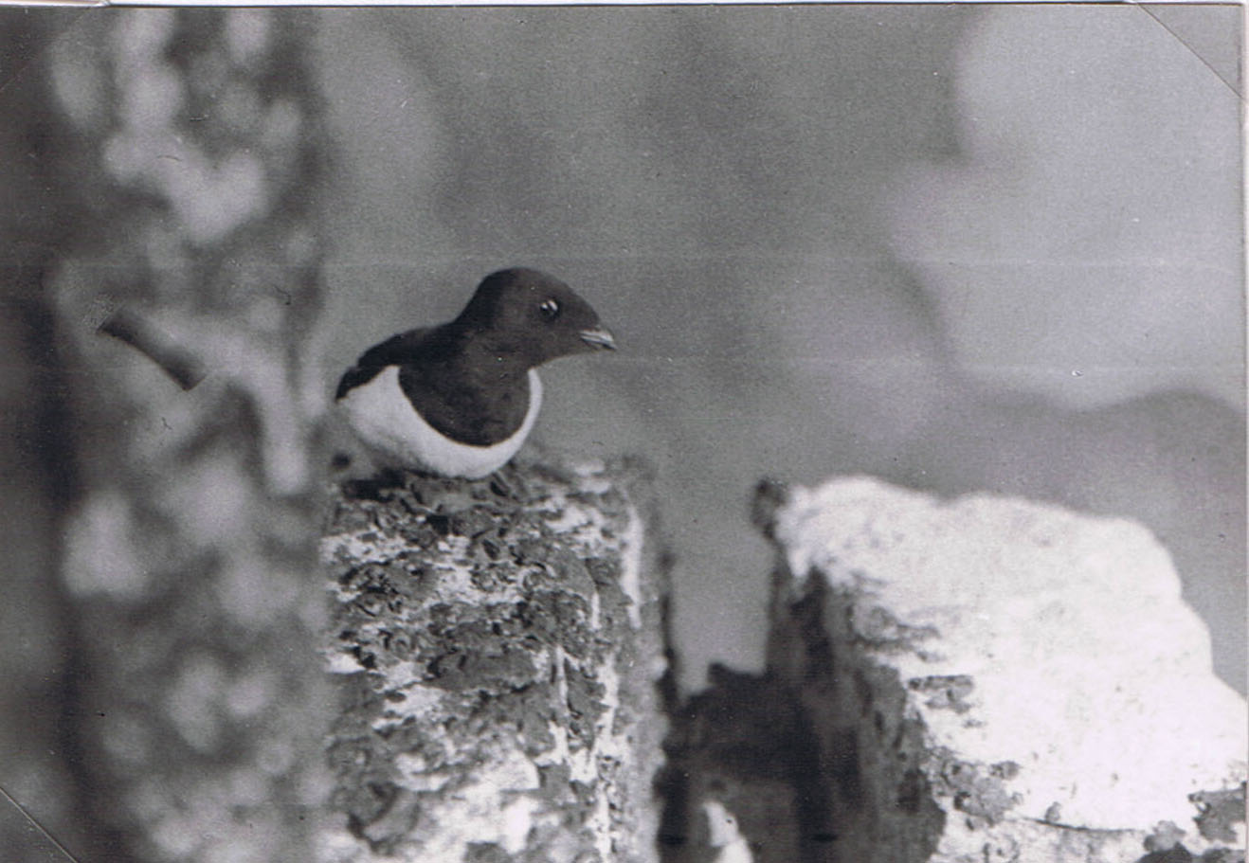
Little Auk outside its nesting place in a crevice. Dane’s Gat, July 1924. (Photo A.N.T. Rankin).

10-19 August 1924. Tundra weather in North Spitsbergen…
brent geese on the Station Island; many eiders with families; Mandt’s guillemots with young; and tern young from downy to flying stages. A puffin flew round close to us. Flocks of kittiwakes were sitting about on the rocks, and in the water. The sea calmed down much about four o’clock; big banks of cumulus rolled away from the north, and we had calm sunny weather once more. This is the first day one could take photos or dry anything for about 10 days. But our water supply has run out again. After various expedients had been tried, we ended up by carrying water from the tarn on the hill above. The trouble is that there is plenty of water near at hand if one digs, but it is full of very fine red mud in suspension, and which is impossible to filter decently. I hope the sun may melt the ground-ice and fill our well again. There is a fine mackerel sky now, which ought to mean fine weather. But the wind has got up again (that beastly cold north wind, that walks down your neck and through anything but mackintosh). We are sitting in the hut, using candle-light, with the door shut. Bed 11.30 p.m. (Today I got, on the Station Island, three species of lichen from a reindeer horn; nine species of moss and a grass; and in the moss and turf 4 species of small white enchytaeid worms and 4 species of springtails).
16 August. Up 12 o’clock again. Slept solidly until then. A fine day with blue sky and hardly a cloud except mackerels here and there. But a number 7 wind all day (classified in the books as “umbrella is used with difficulty”). This made walking and working out of doors a curse. Sun and wind together made it very hard to see clearly while walking, and in consequence we both got headaches by evening. Doc. and I went over in the direction of Welcome Point, he with rifle, and I with camera, rucksack and entrenching tools. I found several interesting rutmark areas and dug them. The Doc. went lame on return, and we did not get in until 8.30 p.m. There is a sort of upland plateau at about 200 feet, which consists mainly of rock and its weathering products, together with many boulders, large and small, of glacial origin. There is very little animal life up here except an occasional purple sandpiper, skua or reindeer. Tracks of the last are very numerous and they appear to cover very big stretches of country in their grazing. This area is rather distinct from the lower parts round our camp, since it is not very well drained, and there is

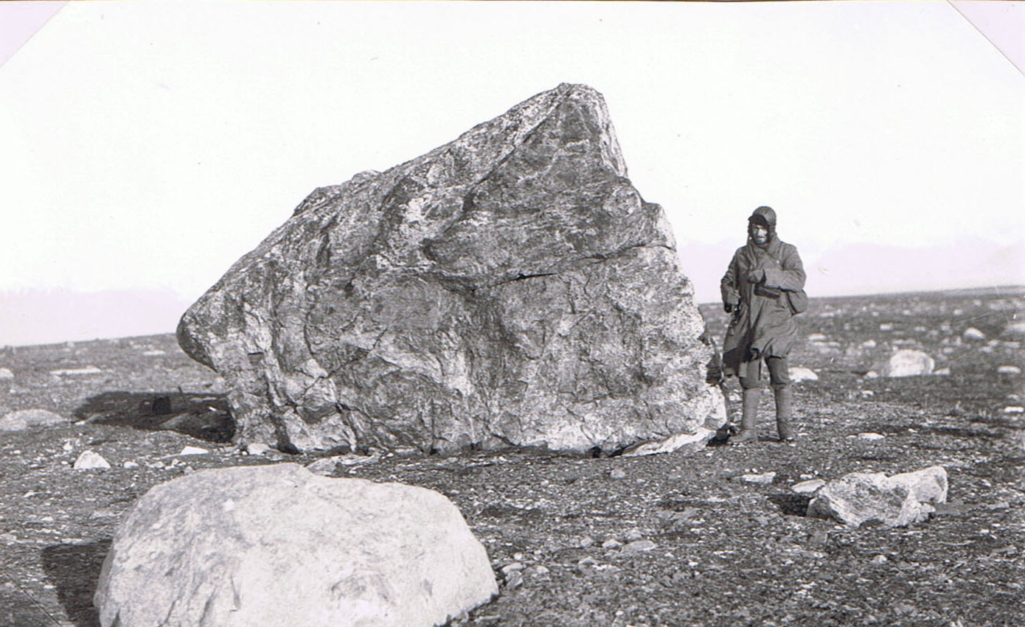
Florey by glacier-transported gneiss boulder on upper part of Reindeer Peninsula. The gneiss rock had a different moss (Rhacomitrium) from the general flora (see Wijde Bay 1923. (Photo C.S.E. 1924, No. 123), 16 August. (Published by V.S.S & C.S.E. in J. Ecology vol 16, plate 16).
{Lower half of page cut away with scissors.}
10-19 August 1924. Tundra weather in North Spitsbergen…
hardly any boulder-clay.
Stone polygons are numerous and many of them are almost completely plant-covered:
The plants are as follows: Alpine mouse-ear chickweed, another chickweed; yellow poppy; Oxyria (arctic sorrel); small wood-brush (Luzula); four kinds of saxifrage – purple, white cernua, also caespitosa and nivalis; a good many mosses and lichens.
The wind has a peculiar rattling whistle up here, which I found to be caused by the enormous number of seeds of Alpine chickweed (Cerastium alpinum) rattling inside their pods.
In one place stone polygons were being formed from the living rock. They were 18 inches – 2 feet wide, and the centres about 4½ feet apart i.e. they had not yet formed a continuous network… The appearance was a thick ring of shale stones set on edge, with a small mud centre which had several plants on it…
Bed 11.30 p.m.
17 August. Up 12 o’clock. Found a full gale blowing from the north-west, with beautiful sun and blue sky. Our tent was nearly blown away, and the tarpaulin doing its best to lift the huts (aeroplane cases) up. Stayed in and did worm collecting from moss. It snowed hard in the evening; we made a big cheerful fire and cooked an eider duck in the snow storm. There was some snow on the ground and the whole scene looked like England in winter.
Bed 11 p.m.
18 August. Woke at 7 and then at 12, and got up, just in time to change the thermograph and barograph. The latter goes up while the former goes down. Tonight is one degree below freezing (F°). The night temperature is much lower than the day, contrasting with the irregularity in this respect early on in the summer. But the terns go on fishing. And we go on working. It was calm this afternoon, and sunny; and now, although the air is really cold and the sun is hidden by clouds, we feel warm. It is the wind that makes it so cold. Now I can think and work peacefully for the first time for a fortnight. As a matter of fact, having gone up to my knees in an icy wet bog this evening, I am now sitting in my pyjamas, working, at 30°-31 °F.! The way to keep warm is by hard intermittent shadow-fighting.
We visited the Station Island again to retrieve my notebook which we left behind the other day, and made improved notes (on vegetation zones etc.)

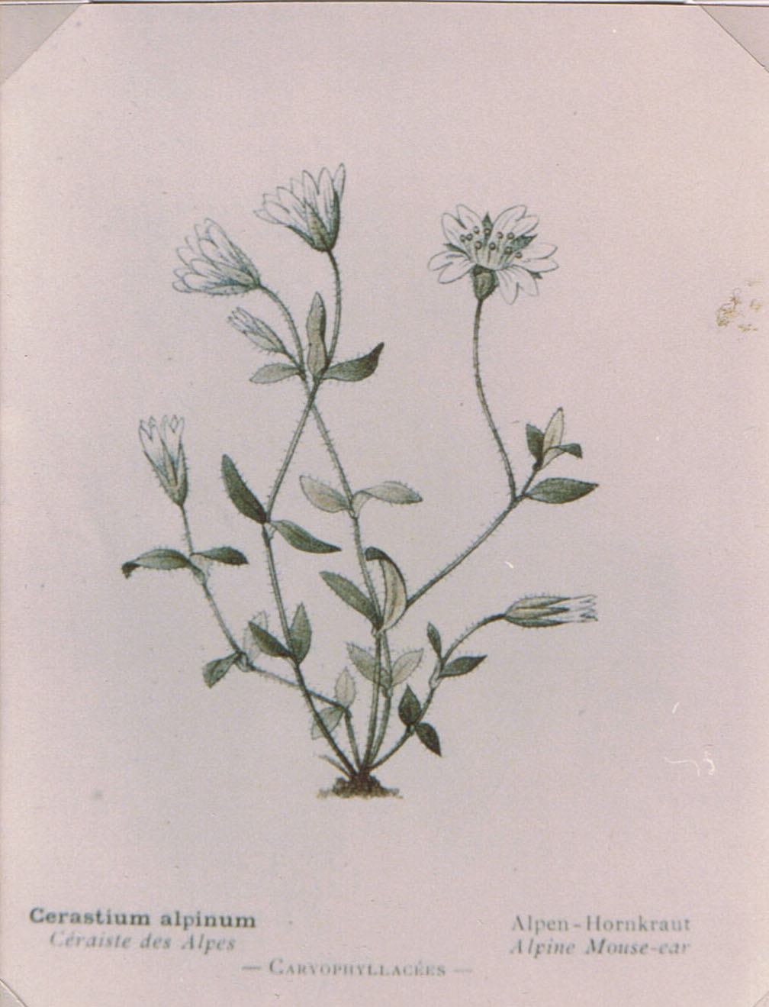
Photocopy by C.S.E. from C. Flahault 1908, ‘Nouvelle Flore coloriée de poche des Alpes et des Pyrénées.’ (Paris) (Green shown in rather bluer than in reality).

10-19 August 1924. Tundra weather in North Spitsbergen…
18 August… Terns were fledging their young, which were mostly at the large, running, globular stage. Kittiwakes were flocking on the Islands and on Lagoon I shingle. There were brent and pinkfoot geese about, and the tarn above the camp had its grass eaten by geese. The lower of these two tarns is drying up now; terns were fishing and catching Lepidurus (a smallish king-crab-shaped crustacean allied to Apus) (half-size ones) in the upper part of the tarns. Young purple sandpipers feeding along the shore.
Bed 1.30 a.m.
19 August. At 3.30 a.m. the Polar Bjørn rolled in, and we were woken up by Clutterbuck coming in. He told us that all three sledging parties had arrived simultaneously, and that the seaplane had crashed but no one was hurt. So everything is all right so far...
There was one most extraordinary discovery. One day, while the big depression was coming up, and strong south-westerly winds were blowing, there was a large deposit of huge Syrphus hover-flies and black “mosquitoes” on the snow. In the case of Frazer’s party there were many of these, and I have narrowed down the times pretty well. The other two parties (on N.E.Land ice-cap) also met the flies after this storm. They are not Spitsbergen species, at any rate the yellow and black Syrphus, and must have been blown right over from Europe. Went to sleep again at 6 and got up at 10 a.m.
(This wind-borne invasion of insects over a distance of at least 800 miles, perhaps from the Kola Peninsula, remained for some years one of the longest known of its kind. I wrote a paper about it. The hover-fly was Syrphus ribesii (common in England) and the black insect was a large aphid, Dilachnus piceae or (as more recent study has suggested) an allied form. Captain Parry found at the latter on the sea-ice off the west coast of N.E.Land, 97 years earlier, while trying to sledge to the North Pole! It seems certain that both were from conifer, probably Norway spruce, forest in north Europe. The larvae of hover-flies eat aphids.)
(See earlier under Weather)

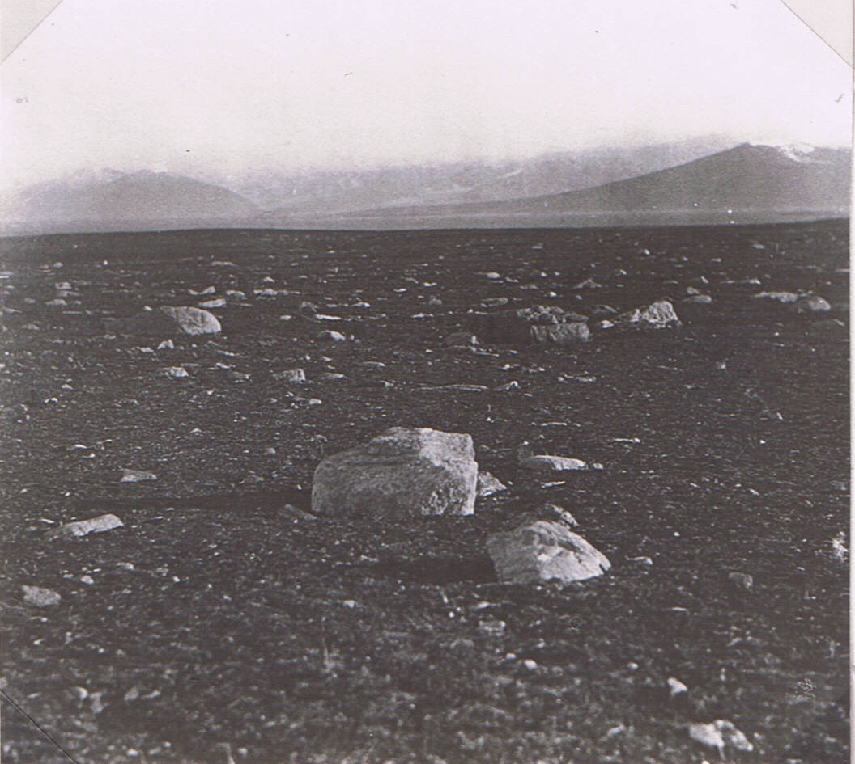
The bleak fjaeldmark tundra of Reindeer Peninsula, looking towards the entrance of Wood Bay and the long-sloping mountain above Cape Roos. Erratic boulders of harder rocks. 16 August 1924. (Photo C.S.E. 1924: No. 22). (Published in V.S.S. & C.S.E. (1928), J. Ecol. 16 plate 30).
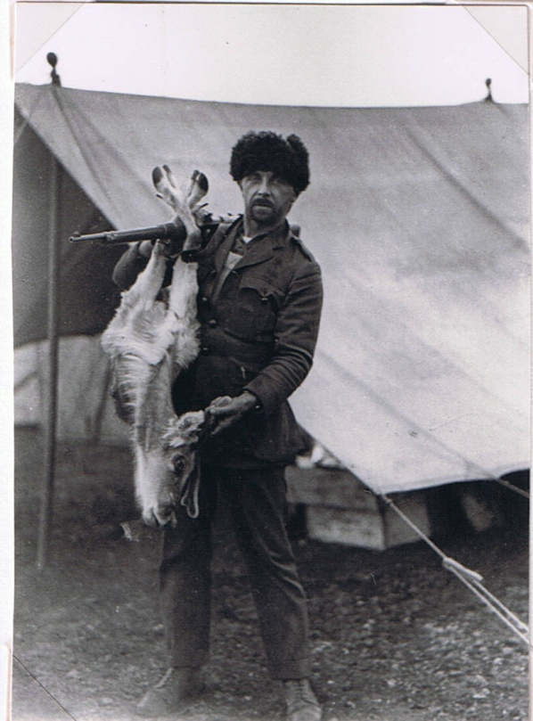
Tymms + reindeer shot for food. Reindeer Peninsula 21 July. (Photo C.S.E. 1924: No. 76).
20-23 August 1924. A mountain in Wood Bay, West Spitsbergen.
(Because of one thing and another and the continuous daylight, our times of activity and sleeping have got rather irregular.)
20 August. Base Camp, Reindeer Peninsula, Liefde Bay. Up to 4 p.m. Mostly routine work. Bed 1 a.m.
21 August. Wood Bay. Up 11 a.m. After the seaplane had been hoisted overboard from the Polar Bjørn, with its new under-carriage and floats, and towed ashore and run up on its trolley, we left the three aeroplanists to their work, and the Polar Bjørn went down Wood Bay to explore. As a matter of fact it has already been surveyed, and so on, but the biology and geology wanted attending to. [I had been at Reindeer Peninsula since 9 July, doing steady work on tundra ecology when not attending to camp chores – which were heavy. Hugh Clutterbuck was temporarily in charge of the ship party while Binney had gone elsewhere, and came to me, to say that as a change for me he would take the ship anywhere I liked within the Liefde Bay area. I had gazed daily (when the weather allowed) at the tremendous mountain country south, but had made only brief visits to Cape Roos, Bock Bay and the Mouette Islands. I chose Wood Bay – = Woodfjorden of the modern map, which runs deep into West Spitsbergen, and we aimed at the spot about 30 miles from the Base Camp].
The ship anchored half-way down and we went the rest of the way by motor-boat. Hugh, Montague and I were landed first, and we started at 9.45 p.m. to climb up Mount Scott Keltie, which is a high mountain of Old Red Sandstone (Devonian), capped with a thousand feet of dolerite (basalt-type). The first three thousand feet were mainly steep screes of mixed material, mostly of sandstone of course. These we sweated up. Then came the dolerite, which looked fairly simple from below. In the lower part up to 200 feet there was a fan of boulders from a colossal gully. Plants growing here included open scattered dwarf willow, purple saxifrage, Dryas (mountain avens), alpine mouse-ear chickweed, cinquefoil and a thin sedge, and a few mosses. One boulder had snow-bunting dung and orange lichen. An interesting result of spring run-off on snow surface: several boulders three feet high had a little stone perched on the top.
The steep red shale-sandstone-mud scree up to 800 feet or more had sorrel (Oxyria), a dandelion with ripe seed, poppies, a spiky purple grass (a Poa species), etc. and some mosses and lichens, but all very scattered. Purple saxifrage is the first coloniser in bad places. (Higher

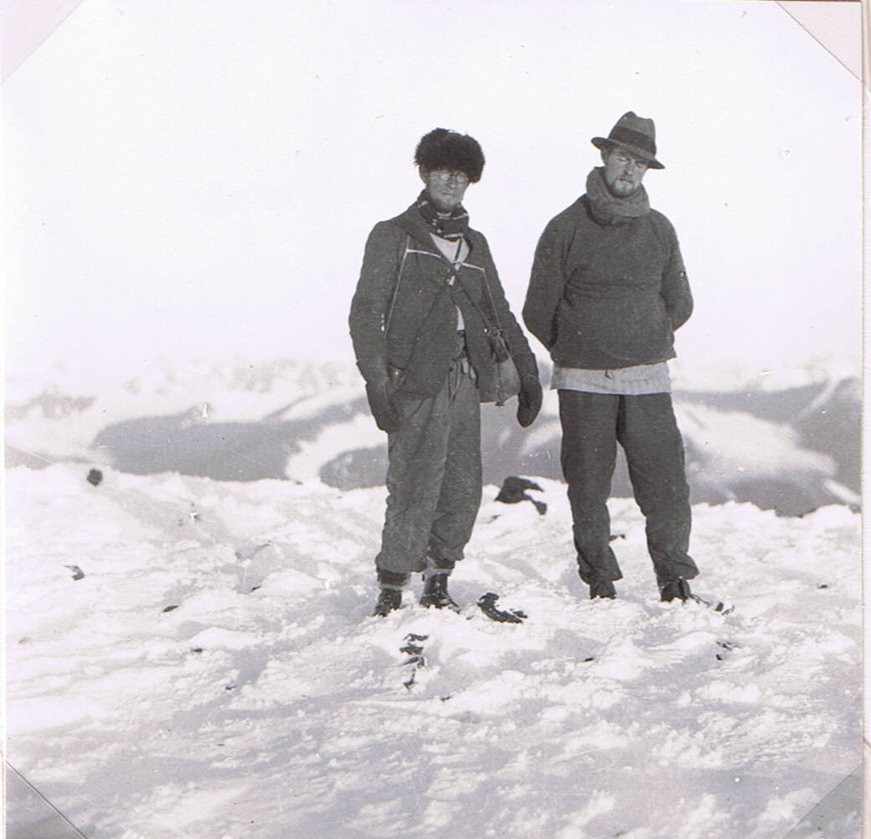
Montague & Clutterbuck on top of Mount Scott-Keltie, Wood Bay, 4440 ft. 21 August 1924 (Photo C.S.E. 1924: No. 94).
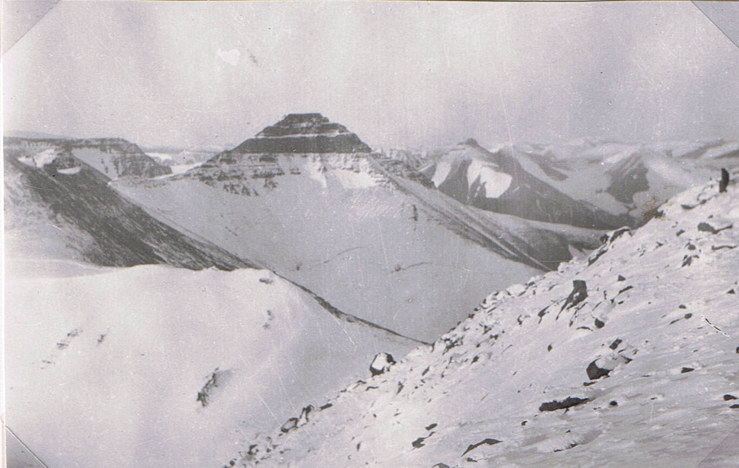
View North-East (from above) across what is now Andrée Land. Dolerite cap very clear. 21 August 1924. (Photo C.S.E. 1924: No. 95).
21 August 1924. Wood Bay, West Spitsbergen….
up on these screes, where snow and ice were still lying in gullies and patches, the conditions knocked out even the purple saxifrage). Here we met a ptarmigan, which was very tame. It flew away like a grouse, soaring at intervals on its white wings. Red feet, grey body, no red on the head. Hard to see. It had been eating seeds of Oxyria, a mouse-ear chickweed, Polygonum viviparum, a small crucifer Draba alpina, poppy heads and dead grass heads. The gully streams have a long hair-like brown filamentous alga growing on the stones, and blue fat Collembola (springtails) on the edge. Frozen in places.
(At the base of the dolerite) I left the others and went up a different way, in order to get to the only patch of plants up there – the result of fulmars nesting above. (We had seen their cliff from lower down the scree, and the sun was then on it; when the sun left it, evidently the air cooled suddenly and flowed down the gully, before a tiny horizontal cloud suddenly formed just where we were standing). With some difficulty I got there and was interested to find all the mosses frozen solid – it was midnight and out of the sun, and some 4000 feet up. Below the fulmar colony was a rich plant association (closed vegetation) and 4000 feet, one fulmar being seen. It had mouse-ear chickweed white Saxifraga cernua, and grass (Catabrosa algida), all luxuriant, and much moss and lichen, and a green alga (Prasiola crispa) (that is found both in Antarctic penguin colonies, and on English cottage roofs!). Ptarmigan dung, but no plants visibly eaten. On the rocks that were not manured, the grass was tiny (see photo).
From here on I got into a “bad plaas”, as our Norwegian trapper-sledger Lindquist would have said. There was first a slope of big blocks of dolerite, tumbled about, and half covered with snow. These I negotiated; but having taken too big a step, found myself in such a position that I could not get back, only forward. The reason for this was that the blocks were lying on a steep rock-face slope, and although some were frozen in, the rest were loose. If you put your foot on a loose one, it slid down swiftly and plunged over a young precipice of seventy feet, down below. I spent half an hour trying to get across this place, and several times the stones slipped and I was left holding on by my hands, with fingers dug into the rock crevices under the snow. However, finally got across, and onto a moderately safe place on solid rock. Luckily the cramp, which had been threatening my legs, came on now and not before. Sat and recovered. The next bit was

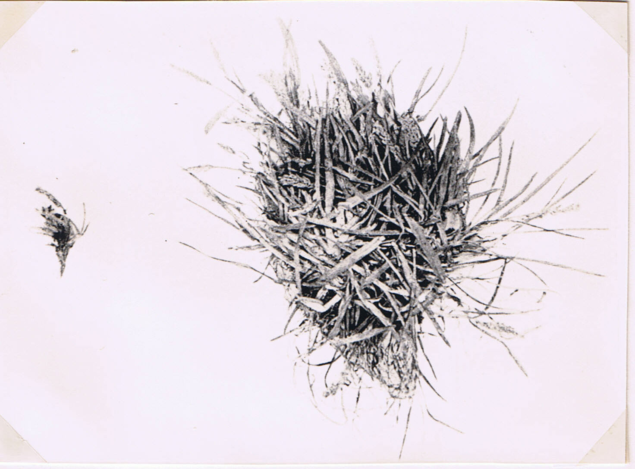
Grass, Catabrosa algida, on right grew under the nesting colony of fulmar petrels on the dolerite of Mt. Scott Keltie. The left-hand plant is from the same rocks but unmanured by birds. (Photo C.S.E. & published with V.S.S. in J. Ecology, 1928, 16, page 241).
21 August 1924. Wood Bay, West Spitsbergen….
merely hard rock climbing – not easy with a heavy pack on. Below the top of the cliff I sat down to rest, feeling relieved, but immediately cascaded down the snow, which was overlying a smooth surface of ice, as it turned out, and brought up abruptly against a rock outcrop 10 feet below!
On the top, I found Hugh and Montague who had also found some difficulty in getting up. There was permanent snow mixed with tumbled blocks of dolerite. From here we got a marvellous view. There was a far prospect of spiky peaks in all directions save the north. Over Reindeer Peninsula and Liefde Bay was the umbrella of clouds under which we have so often sat. We were in bright sun, and sat out of the breeze in comfort, although wet through with cold and perspiration. I made the height 4425 feet by anaeroid. This agrees well enough with the 4440 on the mat. Took photos.
We found an easier way down and got back to the shore about 6 o’clock in the morning. Bed 7.30 a.m.
22 August. Reindeer Peninsula. Woke up in the afternoon at 3 p.m. – as a matter of fact the Oïland (our small ship) arrived at that time, with Binney on board. It was not surprising that I awoke, since the Captain of the Oïland, having recently recovered from drinking too much methylated spirit, and possessing, in any case, only one eye, practically rammed the Polar Bjørn! His ship bumped into us and the bowsprit nearly came in at my cabin porthole! Got up feeling like a dead rabbit, after it had been mauled by dogs. Got two letters from home, dated July 6th and 20th. This was very pleasing; hearing about sweet-smelling pine-forests made my mouth water. I have solved the main problems of the tundra and shall now move on to woods and forests.
The Polar Bjørn left at 2 a.m. next morning, for Hinlopen Strait. She is going to try and survey Wahlenberg Bay. The Oïland is also leaving, to explore in that direction. The three airmen, the doctor, and I, remain here on shore. Bed 1.30 a.m.
Idem. 23 August. Up 9.30 a.m. Still feeling extremely tired. Shaved for the first time in 3 weeks. Saw my shirt again which had been concealed under my waistcoat for 3 weeks also…

25-26 August 1924. A visit to the Mouette Island, Liefde Bay.
Up 10 a.m. By one a.m. the Doc (Florey) and eyes started to row to the Mouette Islands about 8 miles away, taking with us four days food supply and a tent in case we were delayed by the weather. We had dull calm weather on the way over and the rowing was not too strenuous, as we took it in turns a mile or two at a shift.
The Mouettes consist of several small islands and one big one. We landed on the latter. It shows a certain well-marked differences from the Station Islands or Canard Island – this must be the fjord climate, as the rock and soil are similar:
- White bell-heather (Cassiope) is locally dominant, (though absent from Reindeer Peninsula), and there is much Dryas.
- Cotton-grass (Eriophorum scheuzeri) & luxuriant reed-swamp grass (Arctophila fulva) occur.
- Rich moss growth.
There is a fine series of lagoons from marine to relict (fresh-water). Many birds about, especially waterfowl. Seven long-tailed ducks on one lagoon, and five dead ducklings of the same size, picked up by the edge. A sixth ditto, gnawn. Killed by cold? Twenty adults on one fresh-water lagoon – with many young. Very hard to make them fly, even by shooting (over). There were many eider ducks at sea (families) but none seen on fresh-water. One or two brent geese flying, and a flock of a dozen pinkfoot goose flying. A pair of red-throated divers on each large fresh-water lagoon, each with one big swimming downy (like a young penguin – jaeger suiting), which dived when one came nearer, while the two old ones flew off. Several kittiwakes were flying, one sitting on the water of a fresh-water lagoon; many on a rock at sea. A few terns, mostly with flying or nearly flying young. No diving in fresh-water, therefore no Lepidurus (these relatively large Crustacea might not get to the islands, or they might have been cleaned out by terns fishing). Many were feeding right out in the field, in definite areas, diving “under”. There were large numbers of planktonic crustaceans which had got above the surface and could not get under again (N.B. Tymms saw a small dust-devil pass through our camp today – could small water-spouts raised these animals above the surface film?).
We failed to shoot a tern (to find food eaten), but got a (ring-) seal.
By the edge of lagoons, in bogs etc. were purple sandpipers. A pair of skuas, chased by terns. Reindeer tracks (fresh), dung & horn.

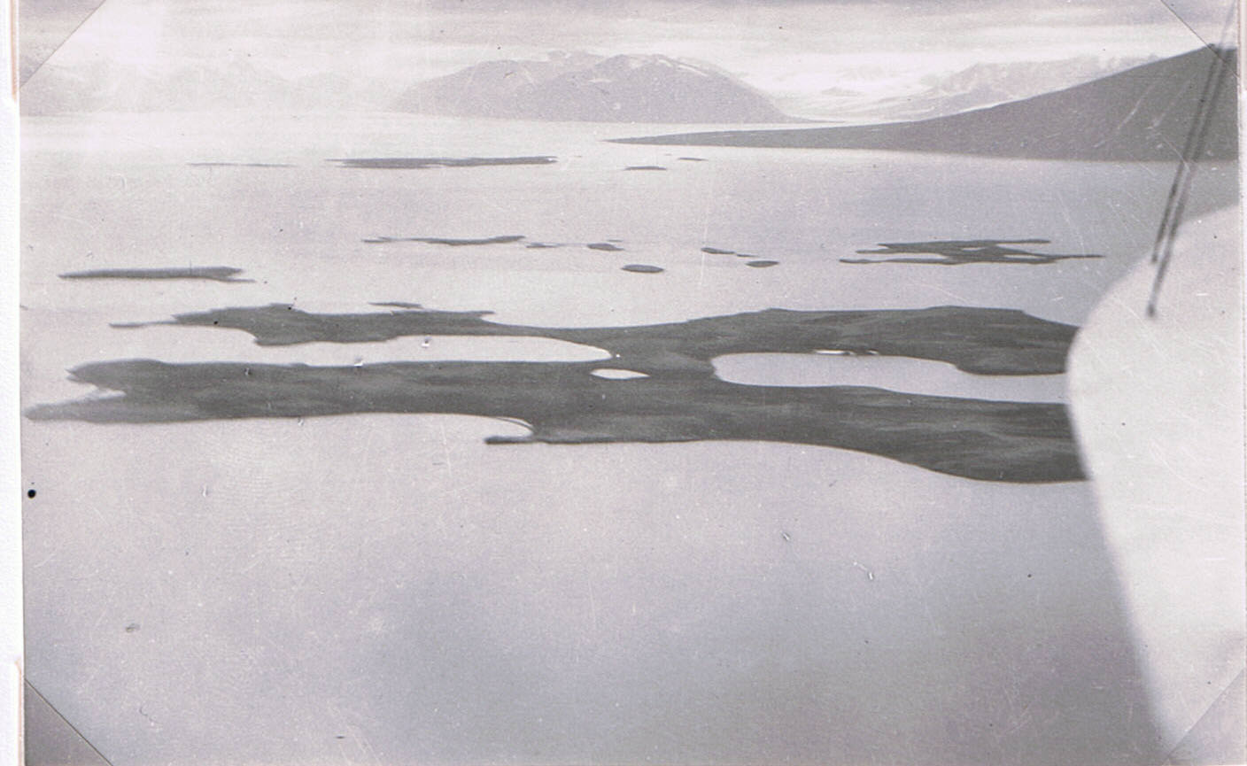
The Canard Islands, and (in distance) the Mouette Islands and Cape Roos, Liefde Bay, 2 August 1924. (C.S.E. 1924: No. 62). One of the first air photos taken, from c. 2000 ft. from a seaplane assembled in Spitzbergen.
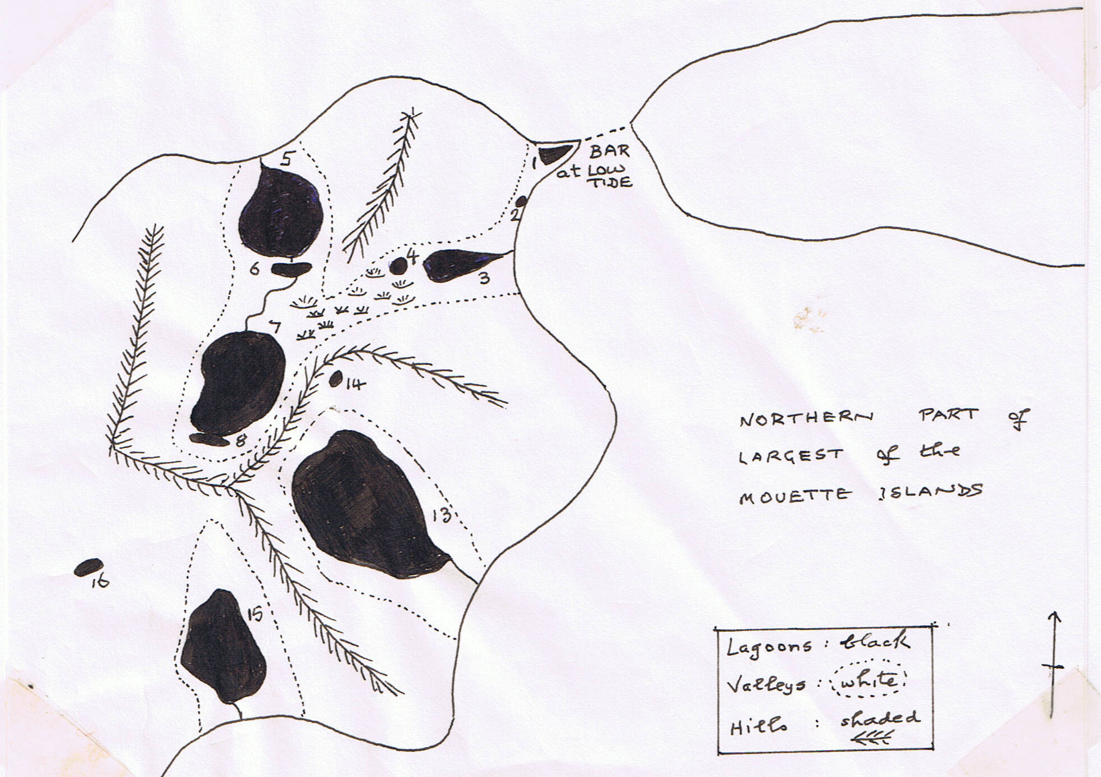
Taken from a sketch-map in my diary.
25-26 August 1924. A visit to the Mouette Island, Liefde Bay…
Lagoon 1. A brackish lagoon formed by currents meeting and forming a pointed shingle spit between two islands. Although it was nearly low tide the water tasted brackish. There was no entrance, and only a little trickle of bog stream coming in, so seepage through the shingle must be sufficient. There was a zone of green alga round the mud-over-shingle edge. It was full of Eurytemora raboti (see August 1921 notes), but no Gammarus or Mysis were visible. Purple sandpiper feeding by the edge. Lagoon 2 was a storm-beach pool with nothing in, tasting fresh. At this point the shingle was covered with a foot or two of unfrozen snow-ice. This was owing to two inches of drifted seaweed acting as an insulating. Lagoon 3 was about a foot above high tide, and fresh-water. Eurytemora and water-fleas (Daphnia) were abundant. The thick mossy edge contained two kinds of small white worm and two of springtails. Purple sandpiper feeding. Lagoon 4 was a pool in a moss-cotton grass bog higher up. Lagoon 5 was a big shallow lake about 1-2 feet above high tide. It was full of Daphnia and (brackish-relict) Eurytemora, and chironomid fly larvae. The rich moss blog round the edge had Ranunculus hyperboreus (a small species), golden saxifrage (Chrysosplenium, not seen on R.P. {= Reindeer Peninsula}), with a red mossy zone of Mnium affine. There was much bird dung round the banks on moss, and responsible for its richness (I collected six species of moss). Of the other lagoons, Lagoon 7 was another shallow one, about 10-15 feet above No. 5, and connected to it by a winding stream. It was surrounded by stones of moss bog and had R. hyperboreus, Daphnia and Eurytemora. No Lepidurus. (I collected 10 moss species here). In another boggy Lagoon, not relict, at 30-40 feet up, there was luxuriant reed-swamp grass, much eaten but with some flowers, and with a reindeer track right across but not stopping. There were goose tracks, and some small horsetail grew at the edge.
It was very cold working all this time. When we had fed, we rowed back. It was at first dead calm, but later a breeze sprang up; there was a wonderful “eider-down” sky (pink, as I remember). We decided that
“The eider-ducks of heaven
Were laying the golden eggs of dawn”.
Back midnight. Skinned the seal. Bed 2 a.m.
26 August. Up 11 a.m. Spent the day putting away stuff and in collecting routine. Very cold, though calm. Bed 12 o’clock.

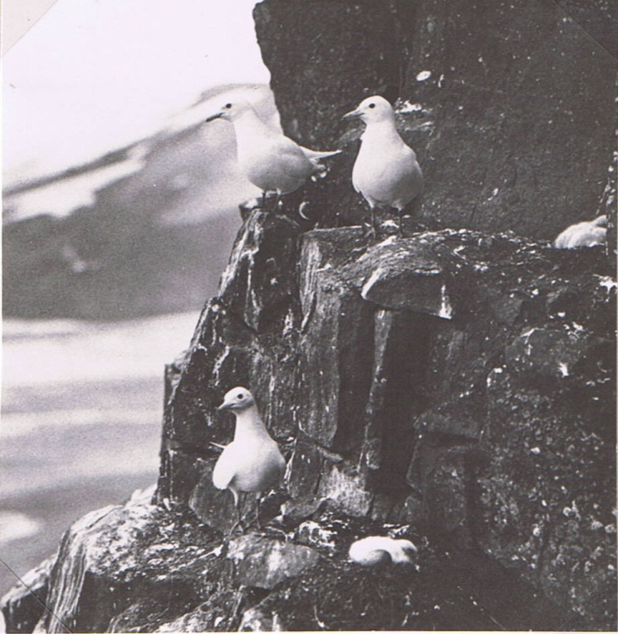
Ivory gulls nesting on cliffs on south side of Wahlenberg Bay, North-East Land, August 1924. (= on the West end of the Clarendon Cliffs, named after the Oxford hotel. (Photo A.N.T. Rankin). Dolerite cliffs at c. 1000 ft.
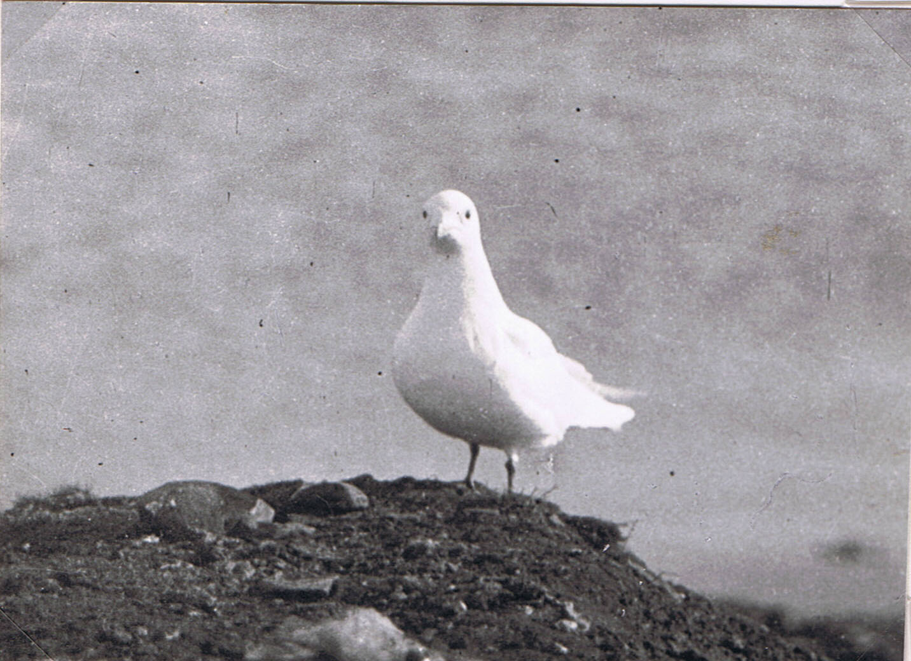
Ivory gull that used to visit our Base Camp on Reindeer Peninsula; 30 August 1924. (Photo C.S.E. 1924: No. 7).
25-26 August 1924. Reindeer Peninsula A visit to the Mouette Island, Liefde Bay…..
Up at 9.30 a.m. Heavy snow, up to 1 inch. Spent a day on routine and keeping warm. I saw an ivory gull chasing a skua away.
10.30 p.m. The temperature is down to 30 ºF. & there is an inch of snow on the ground. I have bet Florey a 5/- dinner that this is going to stay there until next spring. I think it has come to stay. If so, my work is more or less finished. This evening the place is almost completely white, & {sic} and there is a grey grim sky.
Four ivories turned up today, and a white gull with black-edged wings (possibly a Sabine’s). Did routine work putting away collections, etc., and kept warm by chopping wood and by shadow-fighting. We had a cheerful evening, under the influence of a large meal. I made a roaring fire with part of the broken sea-plane floats, and Ellis (pilot) cooked the dinner in a driving snowstorm. Put a snowball in my stewed apples & {sic} and it made a wonderful iced pudding.

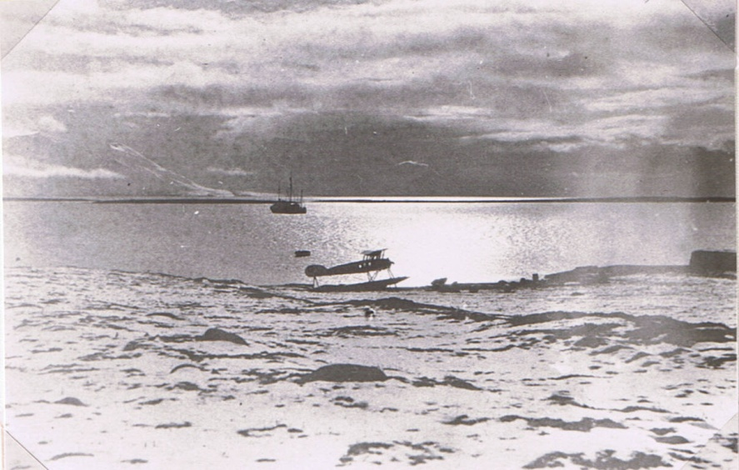
The end of Arctic summer, base camp at Liefde Bay, 30 August 1924. (Photo C.E. 1924, No. 44).

28 August-5 September 1924. The end of an Expedition to Spitsbergen.
(Up at our Base Camp on Reindeer Peninsular the Polar Bjørn had just rolled in after making immense discoveries in the huge Wahlenberg Bay fjord that runs far into the south side of North-East Land. There was a quite fertile place, that they called Oxford Peninsula, at the head. We did not then realise that and un-ice-covered valley runs right through to the desolate north coast we went past in 1923 in our unsuccessful attempt to circumnavigate N.-E.Land. My notes are full of what they found, and the maps of Oxford names – Clarendon Cliffs, Bodley Bay, also the Eton Glacier. Also the Elton Glacier!! (This went with three others in a row down the North side of the Bay from the ice-In this order from west to east, the modern Norwegian names running: Frazerbreen, Aldousbreen, Eltonbreen, and Bodleybreen). Unfortunately Eltonbreen appeared (in 1970) to be in full retreat and may still vanish, though the others still reach the sea.)
(Then the Oïland came in after exciting times in the south of Hinlopen Strait).
29 August. Reindeer Peninsula. Up noon. Spent the day packing up collections. I leave on the Polar Bjørn with others, on or before Wednesday. The sea-plane survey of the rest of N.-E.Land being now abandoned owing to ice conditions. Bed 1 a.m.
30 August. At 930 a.m. Spent the morning taking photos and helping to launch the sea-plane. The snow has nearly vanished from the lower land e.g. round camp, but is still fairly solid on the upper parts. The snow-covered mountains with mist on their tops look rather unreal, and I don’t like the wintry suggestion. Hanssen (Capt. Helmar Hanssen, one of our dog experts – he has been with Amundsen to the South Pole, through the North-East Passage and the North-West Passage!) says that the ice-pack is apt to come down on the Verlagen Hoek and on Danes Island, thus shutting in Liefde Bay by an arc of pack.
Ellis went up & stunted in his machine. He then went up with Hanssen, successfully. But on his third attempt, the machine ran against something quite small (a bottle?) floating in the sea, & this knocked a hole in one float. She taxied back to shore in a lop-sided way. That’s that. No more flying for her. And just as well that no more lives should be risked under existing conditions of ice and weather.
I packed up camp stores and my stuff in the afternoon. I have come on board the P.B. for good now. Ditto the airmen. We may have to push off

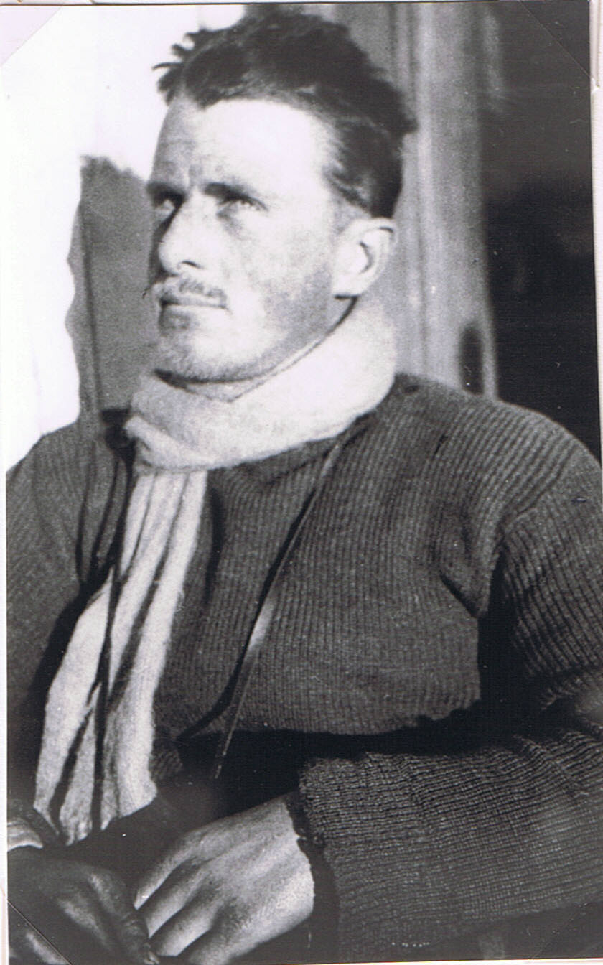
C.S.E., hairy, late August 1924. (Photo H.W. Florey).

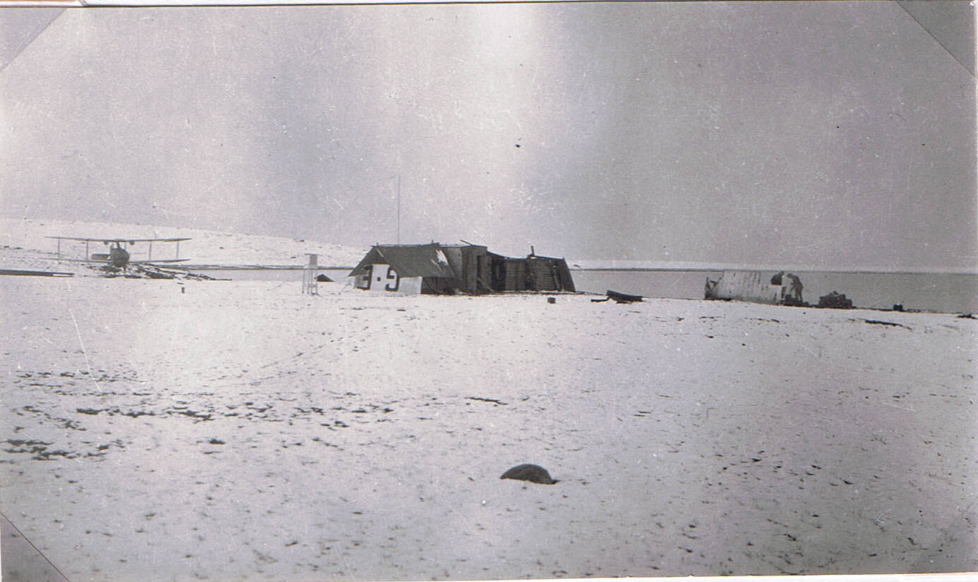
Base camp, Reindeer Peninsula, 30 August 1924 – cooking meal on right! (Photo C.S.E. 1924 No. 50).
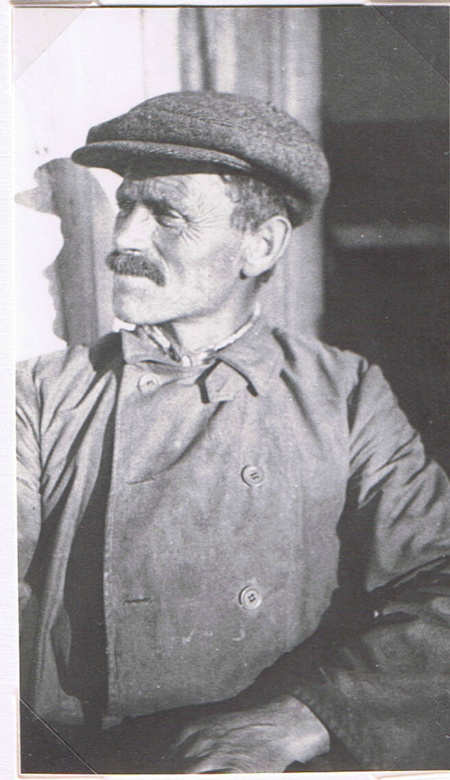
Capt. Helmar Hanssen Expert on sledge-dogs and remarkable traveller, who had been to the South Pole with Amundsen and through the N.W. & N.E. Passages with him. A quiet man. (Photo by an Expedition member 1924).
28 August-5 September 1924. The end of an Expedition. Liefde Bay...
at any moment now. Feel very tired and lazy tonight. “Home John!”. Bed 1 a.m.
31 August. Liefde Bay & departure.
Up 9 a.m. In the morning I helped to clear up the camp & packed etc. Felt very tired in the afternoon, so went to sleep until 4 p.m. spent the rest of the time packing on shore, coming on board for meals. We paid a final visit about midnight, & lit a large bonfire.
The ship weighed anchor 2 a.m. We are now of Quada Hoek (whence the rescuers of the sea-plane came), with a bit of N. wind, but fine skies. The north and centre of Reindeer Peninsula were still snow-covered.
1 September. Slept 18 hours off and on and got up at 8 p.m. for dinner. Feel rather rested, but still lazy. We reached King’s Bay at 7.30 p.m. I talked to Devold, the man from Quada Hoek who rescued Binney & Ellis. He said it had been a very sunless, cold, summer here. The highest temperature was 15 ºC, and this only on one day.
2 September. King’s Bay. Sat up all last night talking with various people, & arguing. Suddenly Montague realised that it was 10 o’clock in the morning and that we had been talking continuously for 14 hours! Had breakfast and spent the morning getting stores up from the hold in order to sell them to the people at King’s Bay; also packing up my collections. Bed 6 p.m.
3 September. Green Harbour, Icefjord. Woke at 6 a.m. The ship left at this time. Got up at 2 p.m. and did nothing all day except argue or read or sit quietly (almost the first time since 3 July, when we reach this same place). Reached Green Harbour at 12 o’clock at night. Bed 3 a.m.
4 September. Green Harbour. Up 1 p.m. Spent the day doing final packing. Bed 12 o’clock.
5 September. Green Harbour. Up 11 a.m. The whole day we lay by the wharf while Binney conducted his selling transactions. Towards evening there was a general air of cheerfulness about our crew. This was not due to their joy at getting nearer home, but because some of them were half tight. Various events have happened which were really serious, but in fact at the time were rather comic. The Captain was more or less happy, & wandered round crooning to himself. He then started ringing the engine telegraph in various ways, and taking the ship for little trips near the wharf. Capt. Hanssen ultimately appeared and firmly took the wheel and brought us back to our original position. Then, owing to the efforts of some half-drunk person, the foc’s’le caught fire and a blaze of paraffin went up. However,

5 September 1924. Green Harbour, Icefjord, Spitsbergen...
three fire extinguishers soon put it out, which was just as well, as there was 150 gallons of paraffin next door. The “foamite” extinguishers made a gorgeous mess of the men’s quarters, which pleases us vastly! Silly idiots! (I can still feel the “panic stations” atmosphere, as the heavy feet of the tall first mate clattered on the deck above me, whereafter I joined in with the nearest extinguisher). Then, when Binney returned, about midnight, we turned all the extra drunks, in various stages of decomposition, off the ship (these had collected during the evening, from neighbouring ships), and tried to set off. Ultimately all was well, the Captain setting off with a merry tolling of his engine telegraph. He began arranging further, and gave a series of cheerful blasts on the hooter, until the first mate rush below, & with my help, turned off its steam supply.
We are now moving out of Icefjord, towards home.
Began to want to go back to Liefde Bay today!
Bed 2 a.m.
(I have thought it worthwhile to lighten a little the catalogues of little auks, brent geese, Saxifraga oppositifolia, polygons etc. by giving this outline of the final risks and hilarious events of the expedition, though they contain no great contributions to natural history. And to those who have read the earlier extracts, the losing battle with sleep is worthy of interest).
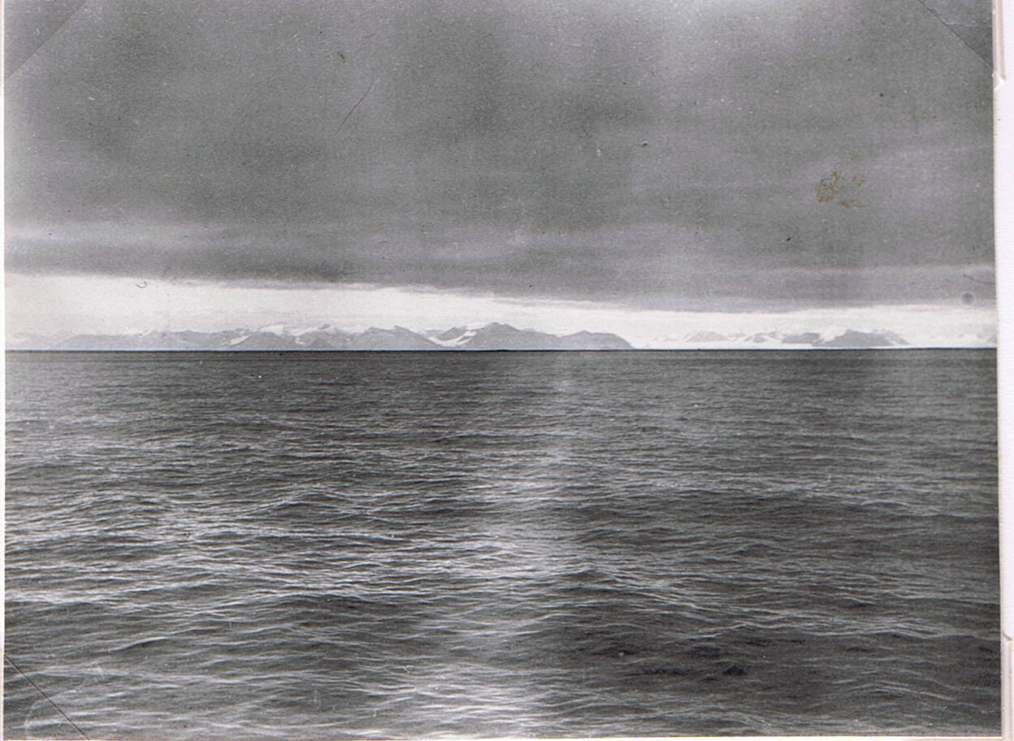
Last view of Spitsbergen – Mountains south of Bell Sound, with two outlets of huge Torell Glacier right. (Just south of this picture i.e. to right, is one of the main barnacle goose breeding areas – the ones that winter at Caerlaverock. 1976). 6 September 1924. (Photo C.S.E. 1924: 56)
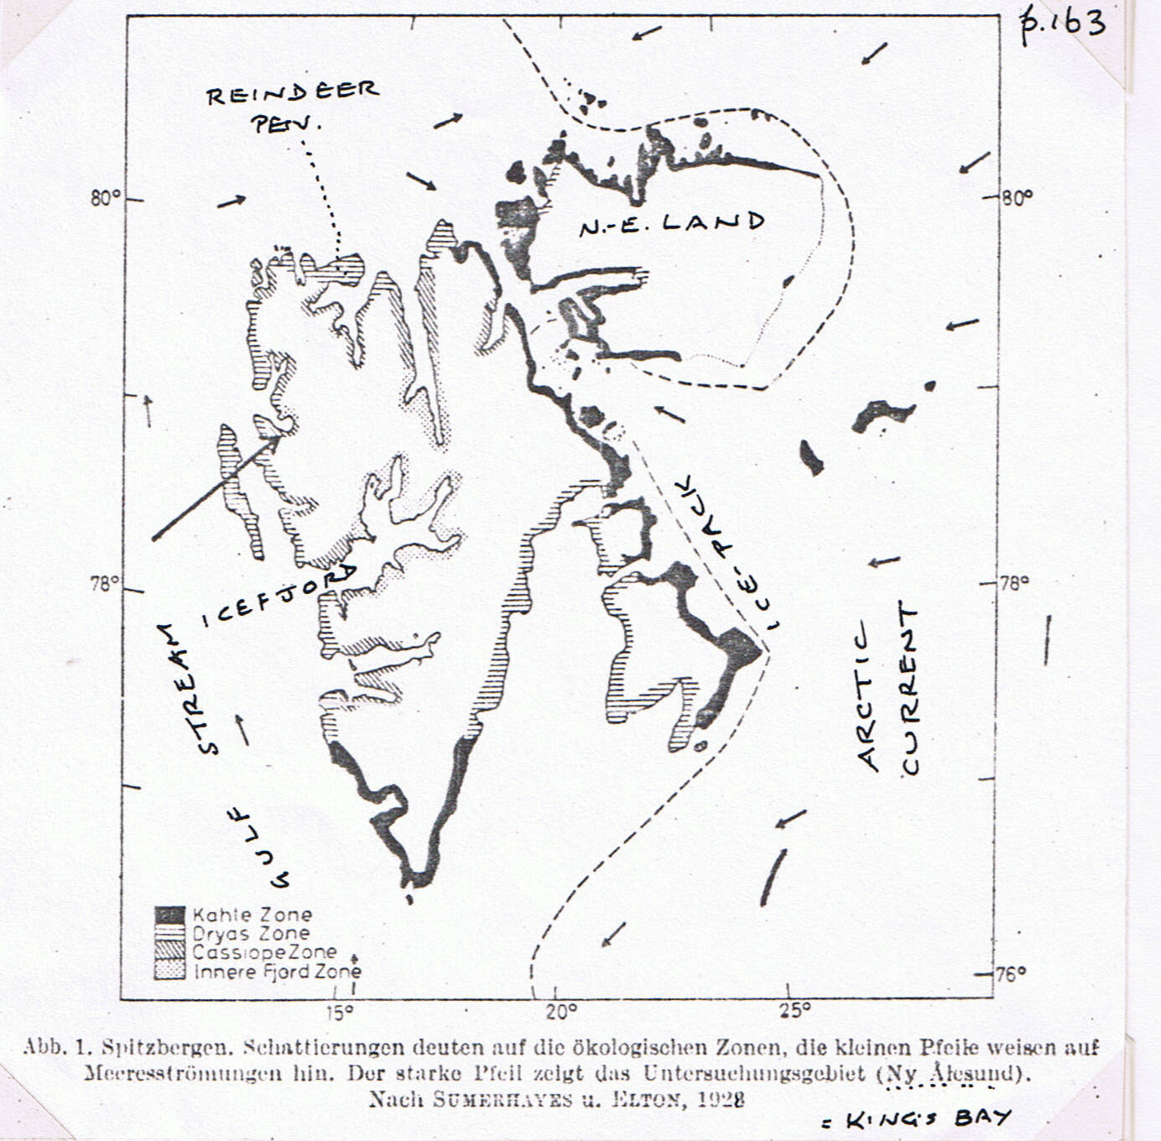
(The culmination perhaps of my work in Spitsbergen was the big map* showing the four Life Zones, which are a combination of the broad effects of the Gulf Stream versus Arctic Current gradients and those found down the long fjords. The latter are caused by air that flows down glaciers and is warmed by pressure to make a more sunny climate there, while the coasts tend to be foggy. The map above is a sign that German and Scandinavian ecologists have accepted this system as an established thing. It is a reduced and simplified map, made by Hermann Remmert (1966) Z. Morph. Ökol. Tiere, Vol. 58, pp. 162-72.
This work gained me the Murchison Award of the Royal Geographical Society. When I turned up to receive it at a London meeting, wearing a lounge suit, I found the other recipients of awards in grey morning dress with tails! The Hon. Secretary, W.F.R. Wollaston, turned up, who was wearing the roughest tweed country clothes. He exclaimed: “Hullo! I see you’ve all got on your Sunday Best!” I think he did this to help people like me. He was a great explorer, who had climbed Mounts Ruwenzori and Santa Marta).
* Published by Victor Summerhayes & myself in the Journal of Ecology (1928), Vol. 16, pp. 193-268.

