THE MERTON COLLEGE ARCTIC EXPEDITION, 1923
notes by C.S. ElTon.

28 July 1923 – 23 August 1923

.
Editor’s notes:
The manuscript was assembled in the 1970s from diaries, field notes and photographs, and typed on unnumbered sheets of loose-leaf quarto. Page numbers are added for ease of reference. Pages that begin or end in mid-sentence are shown as such. Photographic prints, drawings (and early Xeroxes of other documents) are scanned in situ (i.e. with photograph corners and other mounting showing), but to high resolution, so they are shown larger on the page than they were in the original text thus resolving more detail. Those taken by the author are identified e.g.: ‘(C.S.E. photo 1923: No. 17)’. Most of their negatives are still held by Elton’s family to whom application can be made for reproduction.
Species names appear in italics, but other underlining is shown as such. Handwritten additions and corrections are not distinguished from typing. Scored out material is omitted entirely. Abbreviations are shown in full where the meaning is clear. Incomplete or ungrammatical sentences and inconsistent use of upper/lower case, number format, inverted commas etc. are unaltered and only blatant spelling errors are corrected. Editor’s notes and explanations are shown in {}.
M/S = Motor Ship; N.-E.Land = Nordaustlandet.
List of Members of the Merton College (Oxford)
Arctic Expedition, 1923.

Mr. G. Binney (Merton College, Oxford). Leader and organizer of the expedition.
Mr. J.D. Brown (Oriel College, Oxford). Ornithologist; Photographer.
Mr. I.R. Bruce (Cambridge).
Mr. H.M. Clutterbuck (University College, Oxford). Assistant Naturalist.
Mr. C.S. Elton (New College, Oxford). Chief Scientist; Ecologist.
Mr. R.A. Frazer (National Physical Laboratory). Surveyor; Sledging Party.
Mr. W.D. Gundry.
Mr. A.C. Irvine (Merton College, Oxford). Sledging Party.
Dr. T.G. Longstaff (Christ Church, Oxford). Medical Officer; Ornithologist.
Mr. G. Milling (Merton College, Oxford). Sledging Party.
Mr. N.E. Odell (Royal School of Mines). Geologist; Leader of Sledging Party.
Mr. E.R. Relf (National Physical Laboratory). Physicist; Surveyor; Wireless Operator.
Mr. G. Summers (Cambridge). Engineer; Ship’s Carpenter.
Mr. A.T. Wilder (Merton College, Oxford).
Norwegian Members.
Capt. Isak Isaksen. Captain of the Terningen.
Mr. A. Eilertsen. Mate; Physicist.

THE MERTON COLLEGE ARCTIC EXPEDITION, 1923
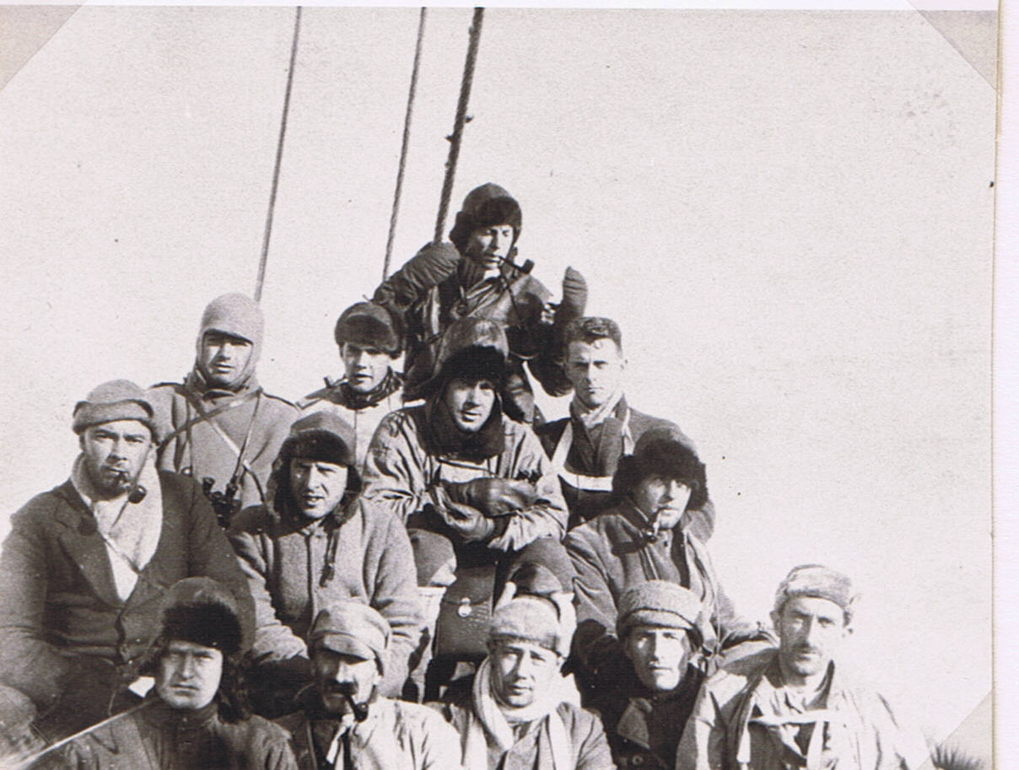
Bottom row (l. to r.): W.D. Gundry, Dr. Tom Longstaff, George Binney (Leader), N.E. Odell (geologist, mountaineer), R.A. Frazer (Mathematician, Surveyor); lower middle row: E. Relf (Physicist, Survey, Wireless), G. Summers, A.T. Wilder (furry hat), H.M. Clutterbuck (assistant naturalist); top row: I.R. Bruce, G. Milling, A.C. Irvine (at top), C.S.E. (Photo J.D. Brown, ornithologist). July 1923.
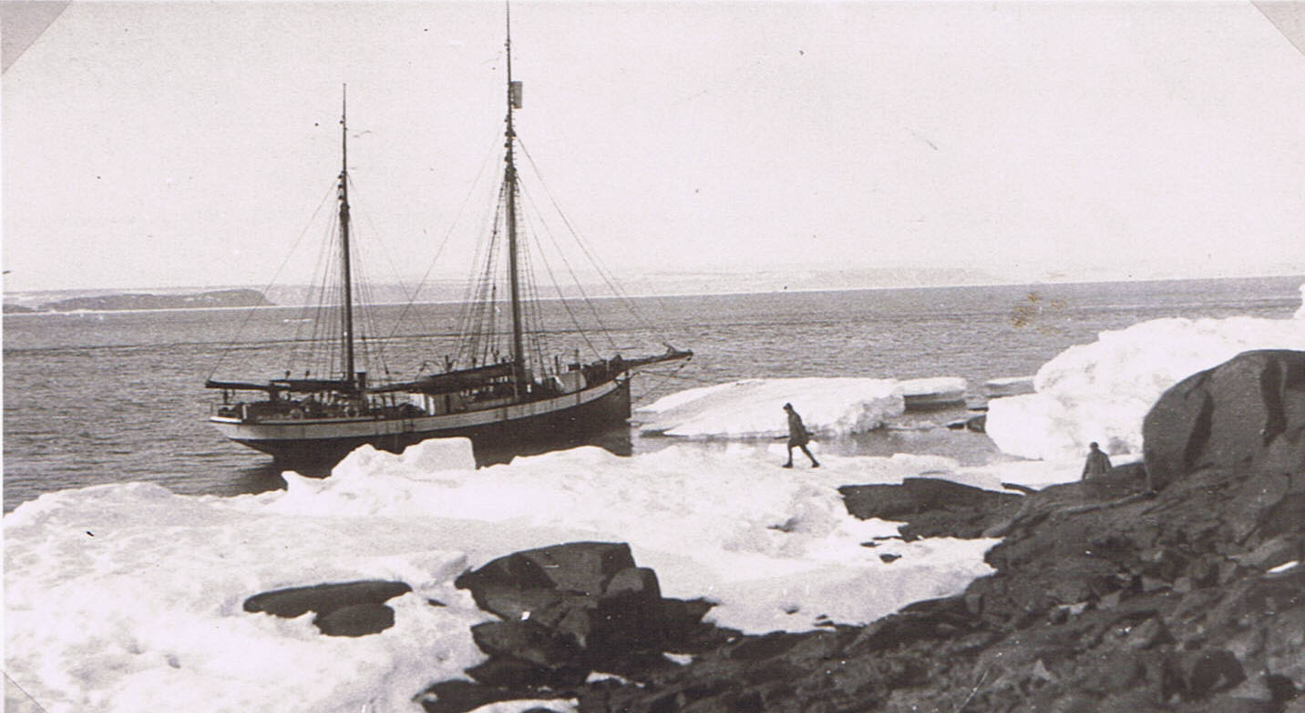
M/S “Terningen” (Capt. Isak Isaksen) moored to the ice-foot (remains of winter ice) at one of the Foster Islands, halfway down Hinlopen Strait. (Photo T.G. Longstaff) N.-E. Land beyond. 29 July 1923.

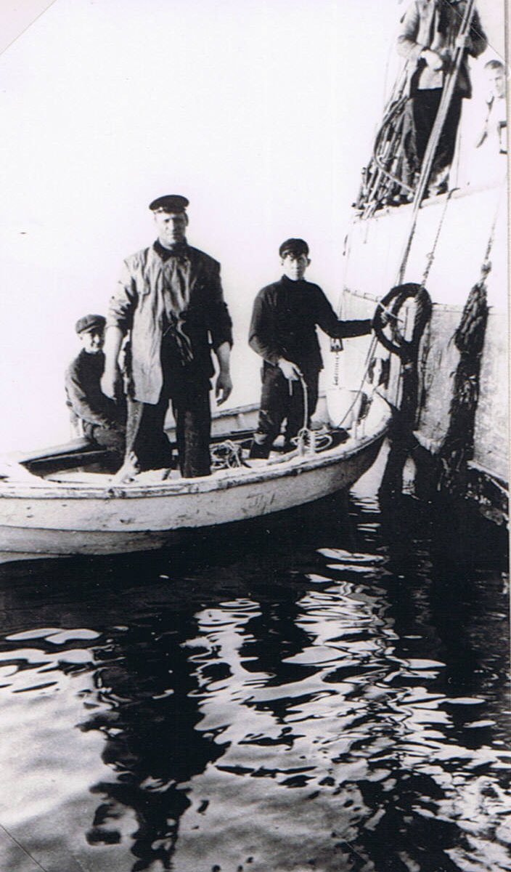
Captain Isak Isaksen and his sons at Jakobson Bay, across from our Liefde Bay camp, 24 August 1923. He was enormously strong and had (in Binney’s words) “unswerving good judgement of ice conditions”, and great daring, and he helped us all he could with our exploration. The most notable sealing captain of his time. Our first mate, Alfred Eilerstsen, from the Tromsø School of Navigation, and the Captain became friends of mine. At the end of the Expedition, the latter went out on his own and brought back for me a heavy sack of fossils from near the top of a mountain in Dickson Land, including some fine ammonites.
28 July 1923. My first day on Reindeer Peninsula, Liefde Bay, Spitsbergen.
“Up at 9.15 a.m. At 11 a.m. we were sailing into Liefde Bay, where we landed this morning. Reindeer Peninsula looks a flat brown slab of land, with small snow patches. There ought to be reindeer, lagoons, etc. At the back of this (to the west) and on the other side of the bay, are ranges of flat-topped mountains. We pass flocks of little auks at intervals. It is a gorgeous calm sunny day, with hardly any glacier ice about and no pack, and clear water.
The sledgers are trying their wireless ashore today. Binney and Brown go up to Bock Bay with some others, to look for the hot springs. Longstaff, Wilder and I go for animals on the Peninsula. The rest (“Binney’s bloodsuckers”) are going after reindeer. Little auks fly exactly like starlings, only they always go low over the water and don’t wheel round in the air. They look dark at a distance, but of course their white tummies show up nearer. There are a great many little black and some long white pteropods in the clear blue water of the bay. The former look like black bumble-bees with flapping black wings but are really molluscs with reduced shells.”
Reindeer Peninsula. [In his book “This my voyage” (1950) Dr Longstaff wrote: “I had many walks over this tundra: the surface of the ground melts in high summer and the foot sinks into the mud at every depression. One day, with Charles Elton I walked for twelve hours, and doubt if we covered twenty-five miles. I found here a nest of the sanderling (Crocethia alba): the hen tried to lure me away, scuffling over the ground with twitching wings. These were the first sanderling eggs obtained in Spitsbergen, the European segment of the Arctic.”]
“The low cliff of red schist seen from the sea rises to 50-100 feet hills behind. There were flocks of eider e.g. 30 ♂♂ and 2 ♀♀ flying about: they originate on the Station Islands where big parties of ♂♂ can be seen standing about. A lagoon of the Richard Lagoon type but more marine, small, over half a mile long, has a permanent channel to the sea about 15 feet wide, and the water tasted strongly salt. There were many Arctic terns and a few eiders on the outer shingle, and great quantities of their white dung on the stones, consisting of the remains of Crustacea (I found legs of amphipods)... A purple sandpiper was feeding on the lagoon shore.”

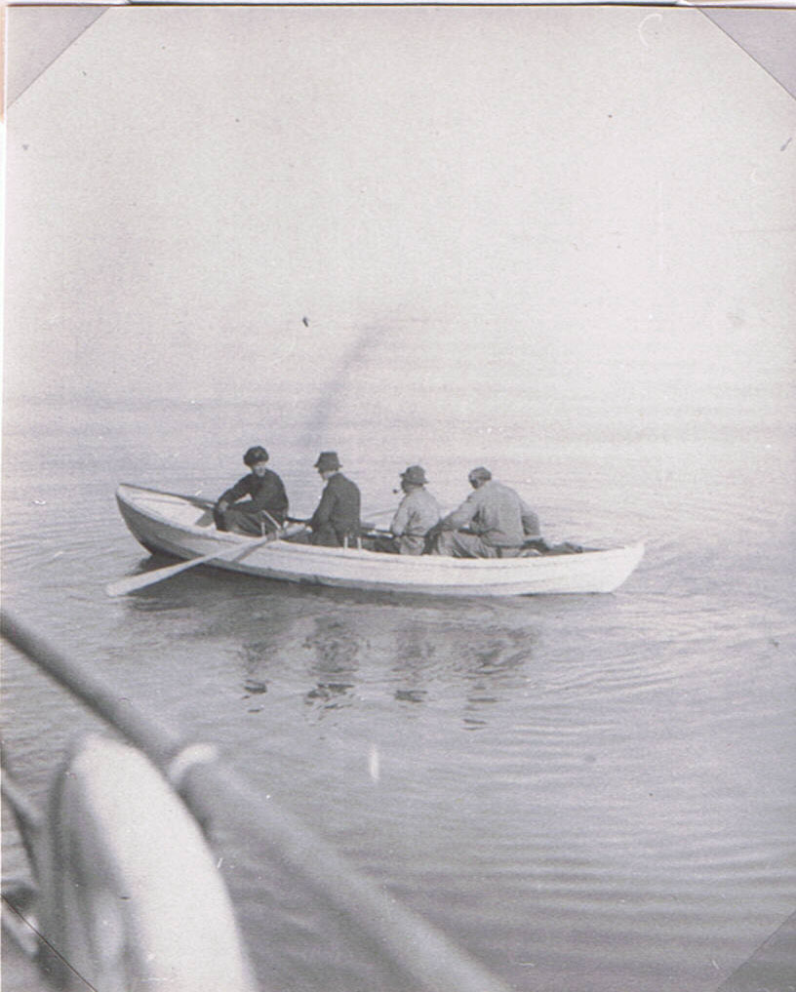
Rowing dinghy to shore of Reindeer Peninsula, – left to right.: Wilder, C.S.E., Longstaff, Frazer. 28 July 1923. (Photo J.D. Brown).
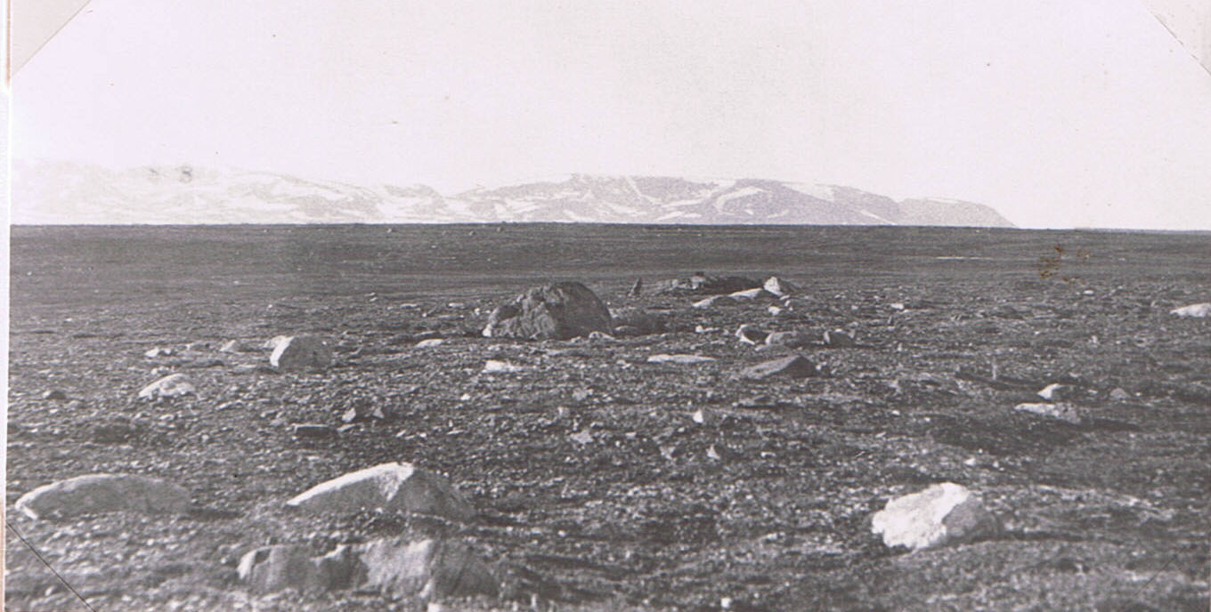
Reindeer Peninsula with its barren tundra and erratic boulders. Sea between “horizon” & mountains. July 1923. (Photo J.D. Brown).

28 July 1923. Reindeer Peninsula, Liefde Bay…
“Terns were fishing much along the shore, and a flock of 4 purple sandpipers was feeding on the tundra and along the shore (chiefly on the ice-foot from last winter, which looked pink in places owing to the red mud on it). Two glaucous gulls. Huge flocks of hundreds of ♂♂ eiders with some hens were sitting in a lump in the still water of the bay. In the distance was a bright purple hill. Then we came on a flock of purple sandpipers and one turnstone (in full plumage) by the shore, and the latter slightly larger than the p.s. and with orange legs. A tern was driving off a Richardson’s skua.
[Along the shore] was much drift-wood, also a fish-net float, spherical, bottle-green, 5-6 inches across, with Nin relief on one end. Also birch-bark etc. [We were near the limit of the Gulf Stream drift]… Then a ♂ sanderling feeding at the water edge and many gnats dancing.
Most of the “dry” tundra seems to be of a fairly uniform nature: old sea-bottom, red mud with small shaly stones forming stone-mud polygons, and containing many sea-shells; and there are erratic blocks scattered over the area. The dominant flowering plants are the purple saxifrage, dwarf willow, with mountain avens (Dryas) sporadic, with no white bell-heather. One reindeer was seen grazing – Longstaff and Wilder tried to shoot it, but it made off and escaped. The Arctic terns are having squabbles among themselves, usually 2 or 3 concerned, and chase each other about.
Watched a pair of purple sandpipers. The ♂ was running around, several times settling on big boulders (on one occasion he stood and sang a quiet rising and falling throaty song – not any of the usual notes). Then he rose and volplaned with the usual curlew note. Later he volplaned near the ♀ with the same note, but the ♀ did not do this ever. Both ran about all over the place, but not in the alarmed way of a bird with young: they have more the air of prospecting for a nesting place!
4 kinds of chironomid flies, large and small, were flying round in the sun. Shaking flowering purple saxifrage, also willow and moss, gave many young black and green-brown spiders of one species, and some adults. They lived in the dry upper part among flowers, where numerous fine threads could be seen spun about. [Most of these flies have aquatic larvae and the adults emerging from ponds formed the chief spider food].
Then Longstaff found the sanderling’s nest, a deep cup full of leaves, on a purple saxifrage/soil polygon region on a hill. The top of this hill and of other hills near (where rock is close to the surface or outcropping) had big clumps of Dryas, and sheets of a white lichen encrusting mosses.”

28 July 1923. Reindeer Peninsula, Liefde Bay…
“We got on board at 11.30 p.m. Huge and sufficing meal. I worked until 3.30 a.m. putting away stuff and preparing for tomorrow’s camp. This has been one of the most gorgeous days of my life. Crawling to bed.”
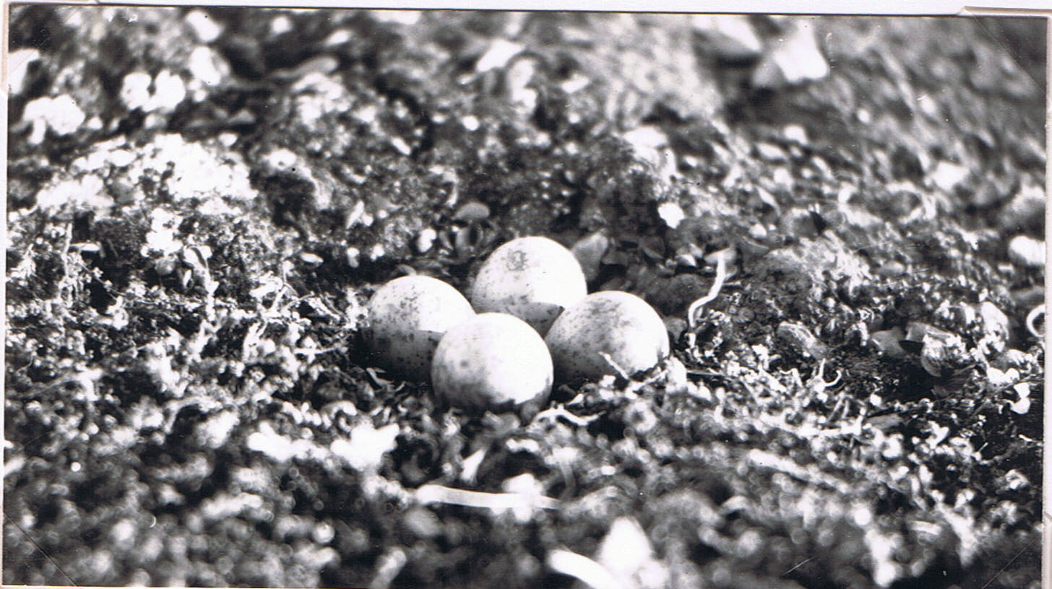
Eggs of sanderling, Reindeer Peninsula, 28 July 1923. (C.S.E. photo 1923: No. 17).
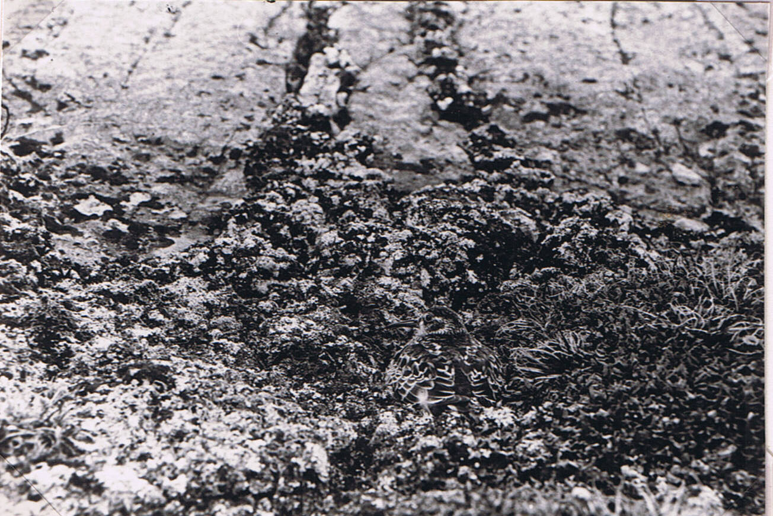
Purple sandpiper (camouflage) on its nest, July 1921. (Photo by Seton Gordon on previous Expedition probably on Reindeer Peninsula).

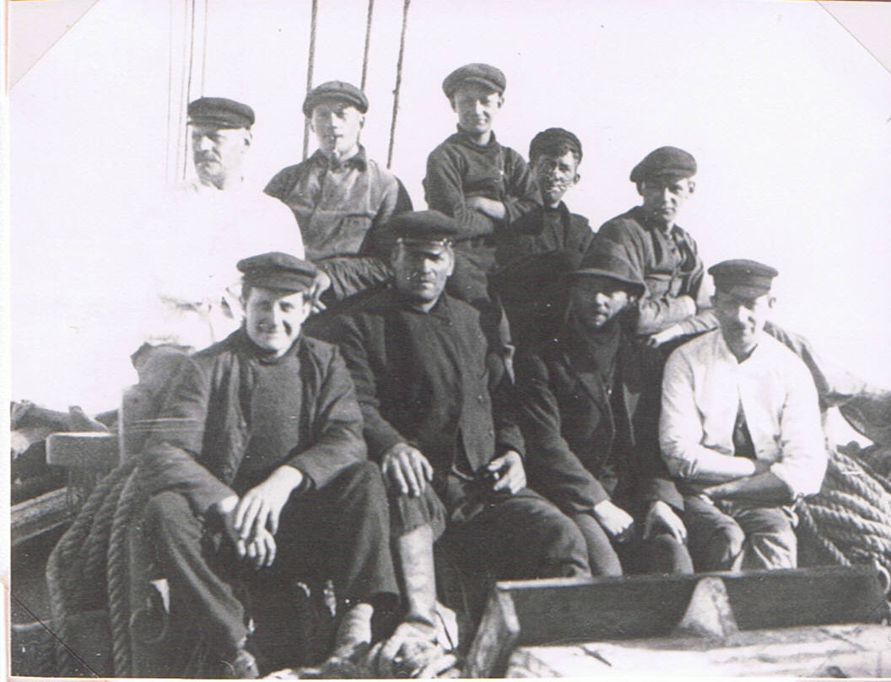
Our Magnificent nine Norwegian crew. Bottom, l. to r.: Engineer, Capt. Isaksen, Alfred Eilertsen (mate). cook. Top: Crew’s cook (Captain’s brother, ret.), crewman, 2 sons of Capt. (– r. hand one engine-room assistant), crewman. (Last 2 not certain order). (Photo J.D. Brown)
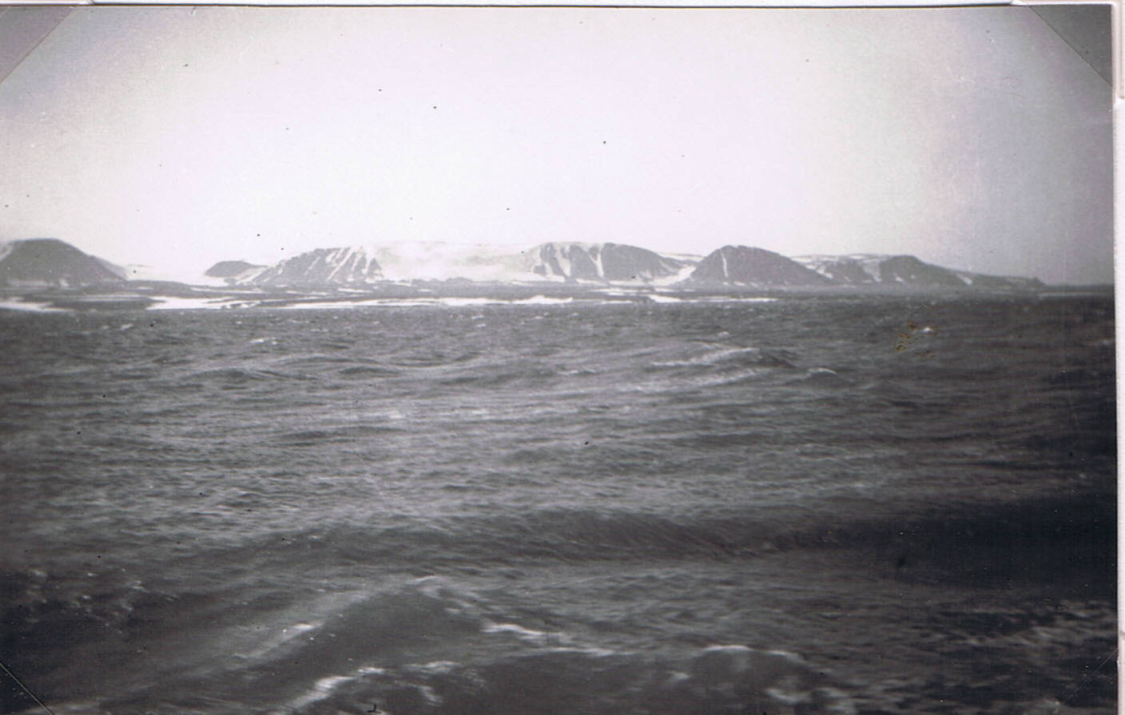
Entering Hinlopen Strait in a choppy sea against a bitter wind. Coast of New Friesland and Mt. Hekla (Treurenberg Bay behind). 29 July 1923. (Photo C.S.E 1923: No. 20).

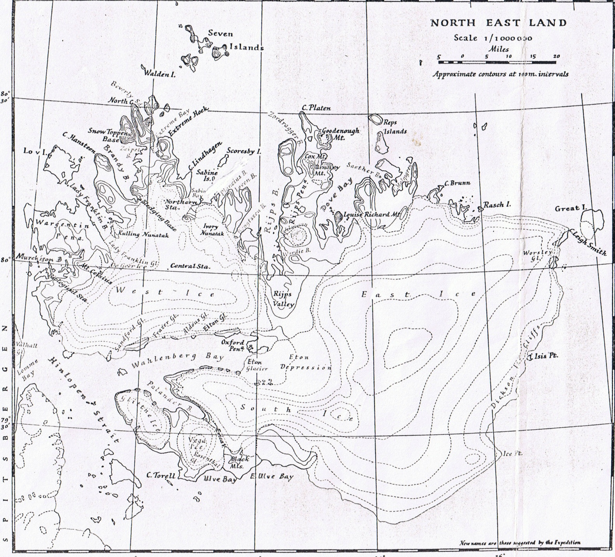
= Mandt’s

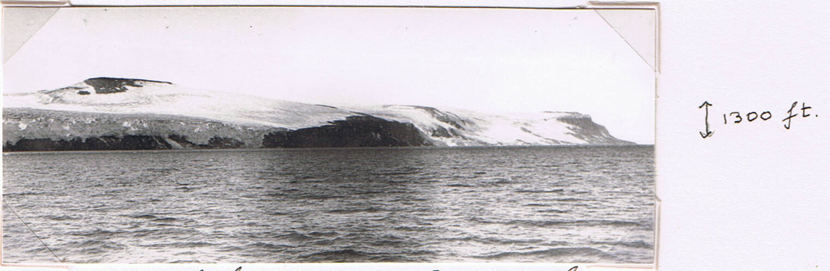
The great Alkrange, a high dolerite cliff and pinnacles with the New Friesland ice-sheet topping it, Hinlopen Strait, c. 30 July 1923. (Photo J.D. Brown). Cape Fanshawe extreme right. (Detail, next page.)
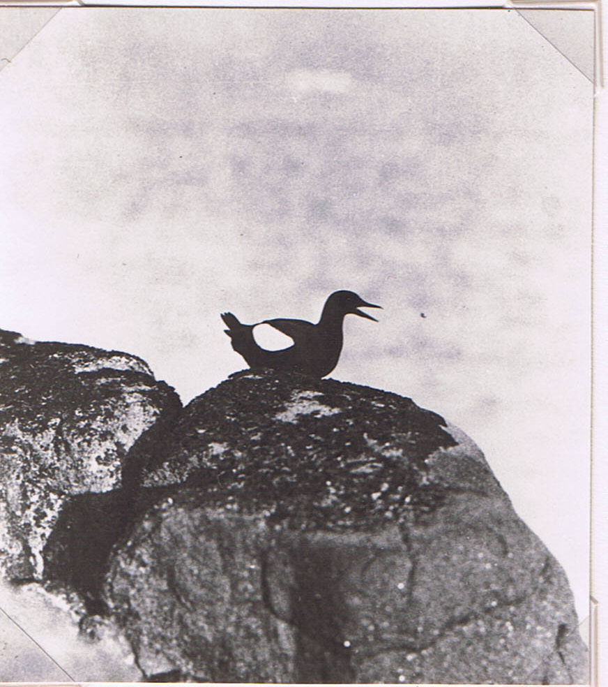
Black Mandt’s guillemot sitting on dolerite rock (with orange lichen from bird manuring) West Foster Island, Hinlopen Strait, 29 July 1923. (Photo J.D. Brown)

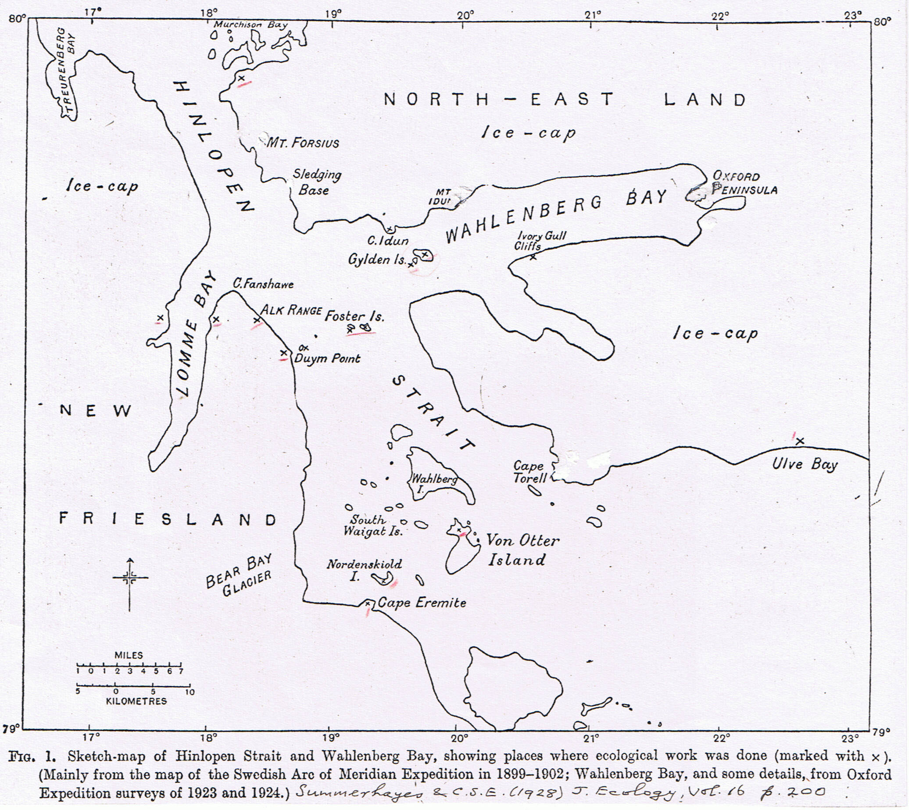

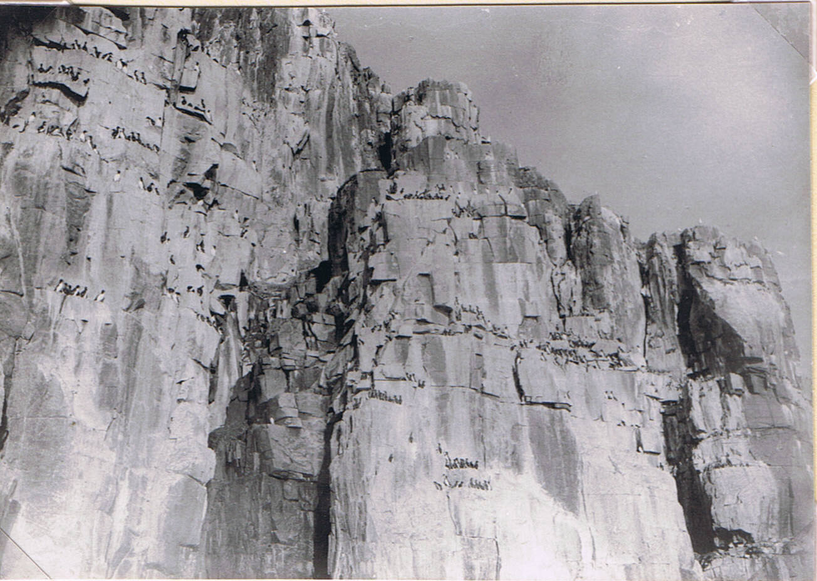
The white shapes of the glaucous gulls can just be seen on the tops, where they probably were nesting. They prey on guillemot eggs and young.
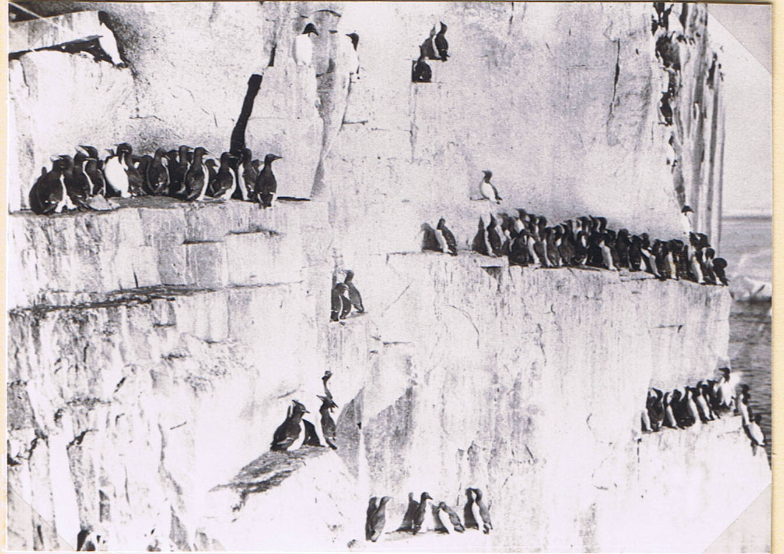
Brünnich’s guillemots on the Alkrange, Hinlopen Strait, 1924 (yes). (Photos A.N.T. Rankin)
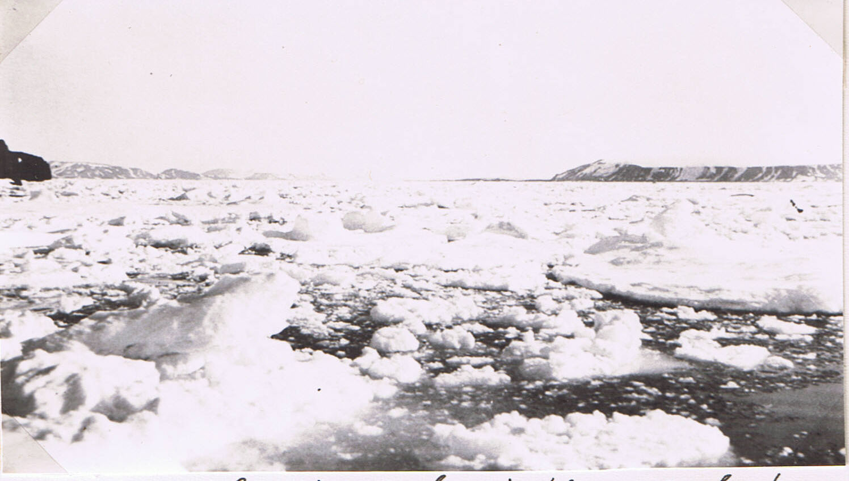
Loose Polar ice-pack in the south-east part of Hinlopen Strait. N.-E. Land on left (with island), Cape Eremite on right. 31 July 1923. (Photo T.G. Longstaff).
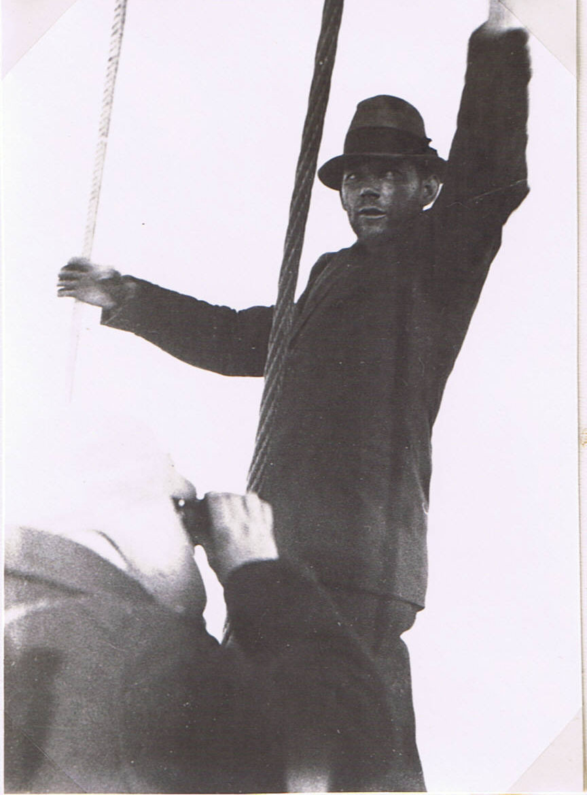
“SHTOP!” The mate, Alfred Eilertsen, signalling from the bows that an ice-floe is too solid to attack. Dr Longstaff left. 31 July 1923. (Photo J.D. Brown).
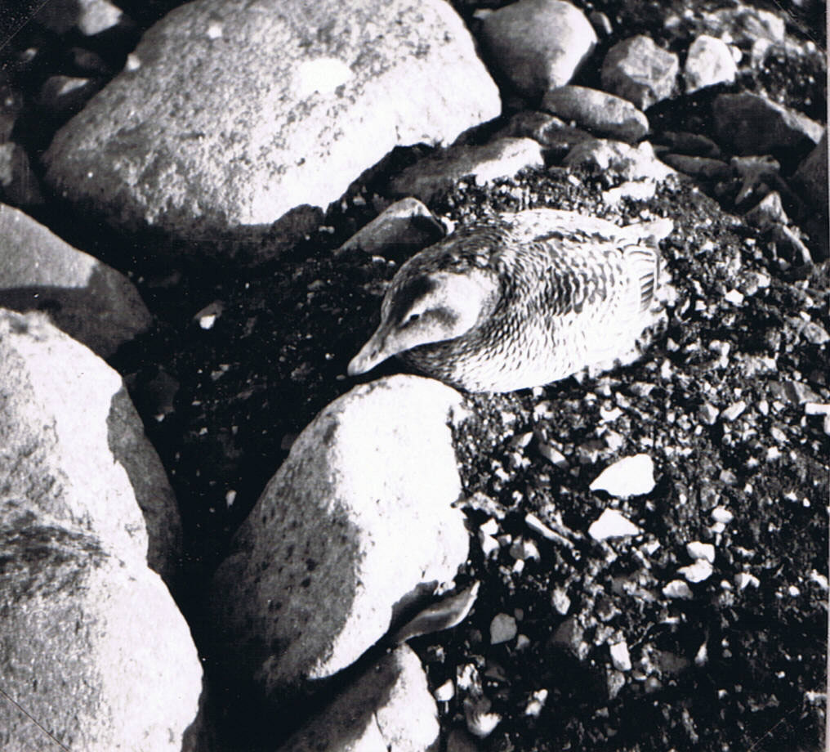
Eider duck on its nest among dolerite rocks, Nordenskiöld Island, Hinlopen Strait. 31 July 1923. (Photo C.S.E. 1923: No. 38).

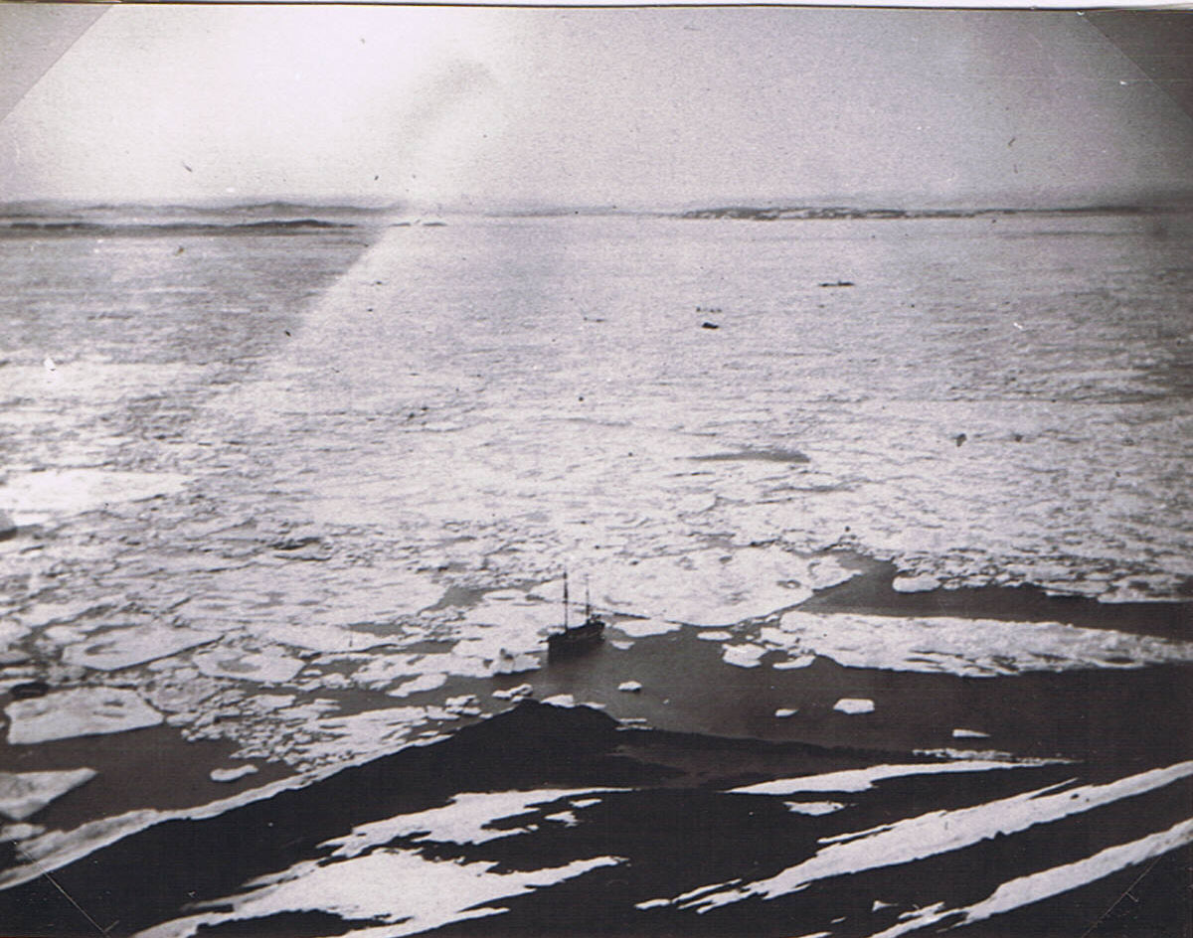
Ship at Cape Eremite, enclosed by ice-pack and partly aground, 1-3 August 1923. Black foreground is tundra. North-East Land in distance, with dolerite islands between. (Photo C.S.E. 1923: No. 46)

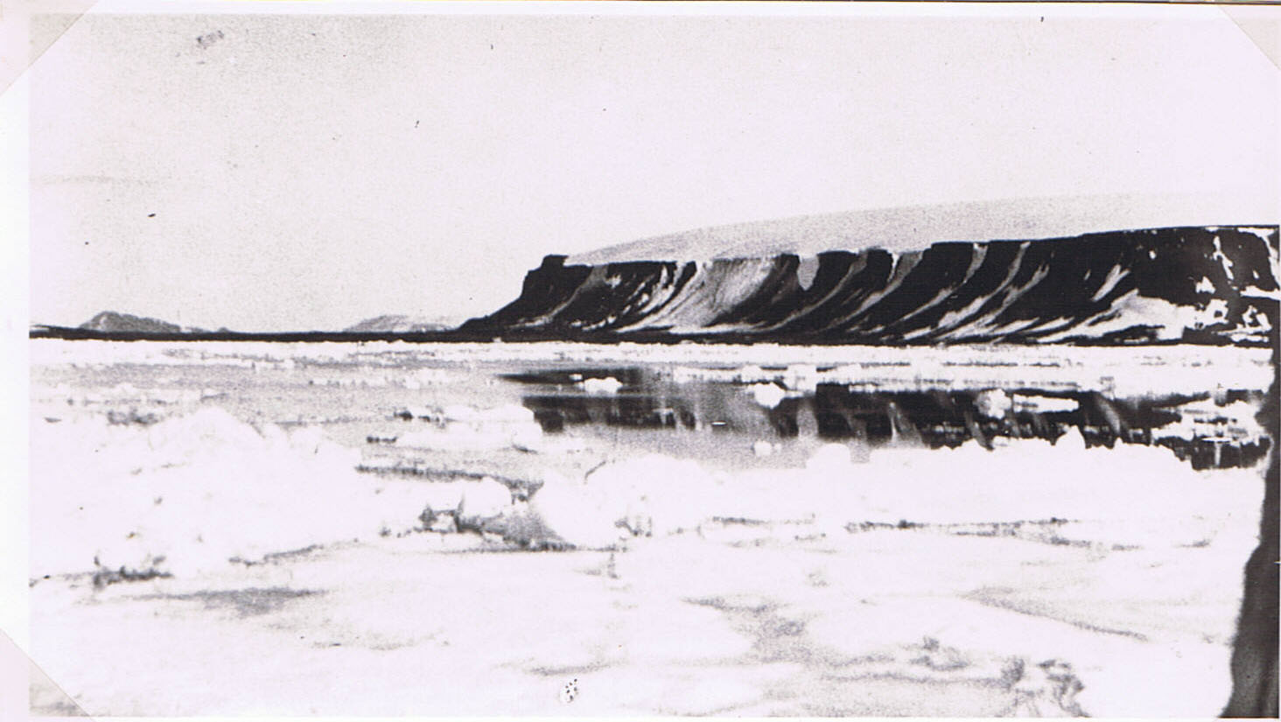
Cape Eremite, Hinlopen Strait, where the drift-ice trapped us in for a few days. 1-3 August 1923. (Photo J.D. Brown).
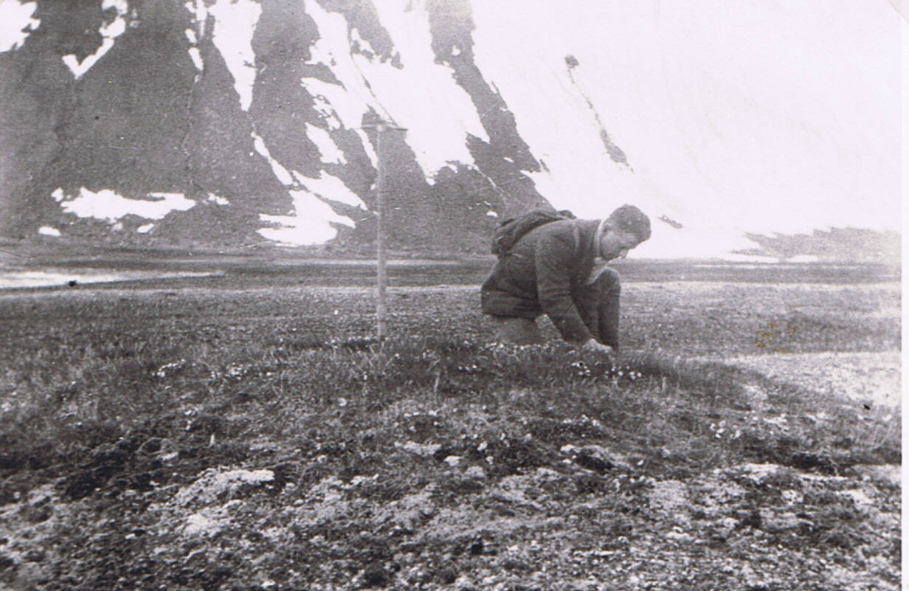
Cape Eremite, dolerite (basalt) cliffs behind. C.S.E. collecting from a “Skua Hummock) – where Richardson’s skuas have nested many years and manured the ground, so that a closed vegetation of grass, flowers, moss and lichens grows. 3 August 1923. (Photo E.R. Relf).
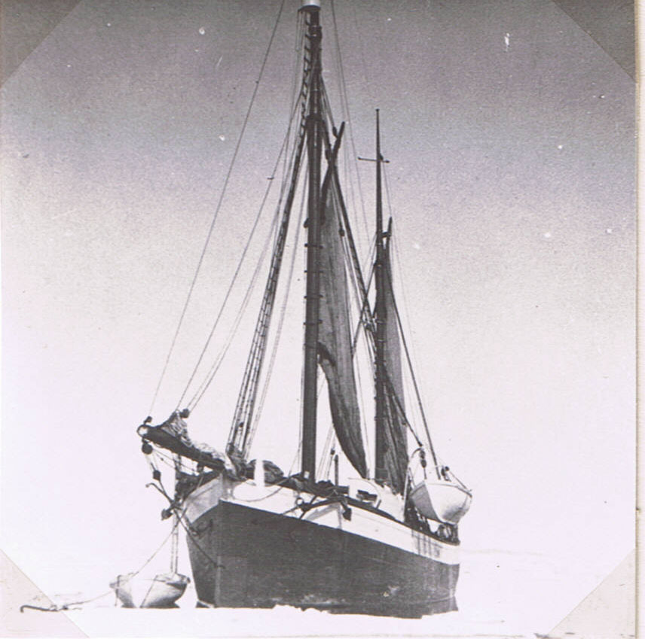
Anchored to a floe among loose pack in south end of Hinlopen Strait. 8-9 August 1923. (Photo J.D. Brown).
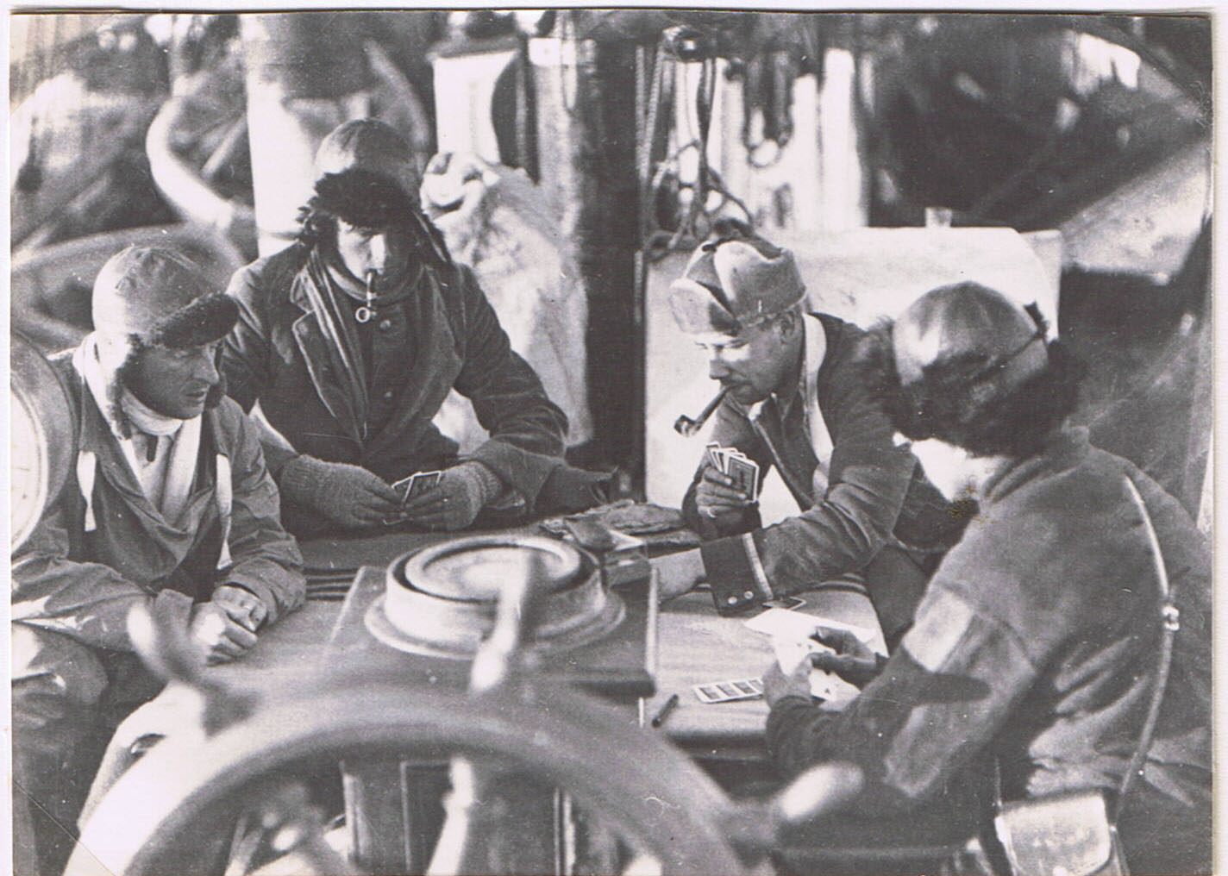
Bridge on deck in the calm sun, in Olga Strait, while ship was in the ice-pack, 8-9 August 1923. Left to right. Geoffrey Summers, Hugh Clutterbuck, George Binney, American Gundry. (Photo J.D. Brown).
They are playing round the binnacle, by ship’s wheel.
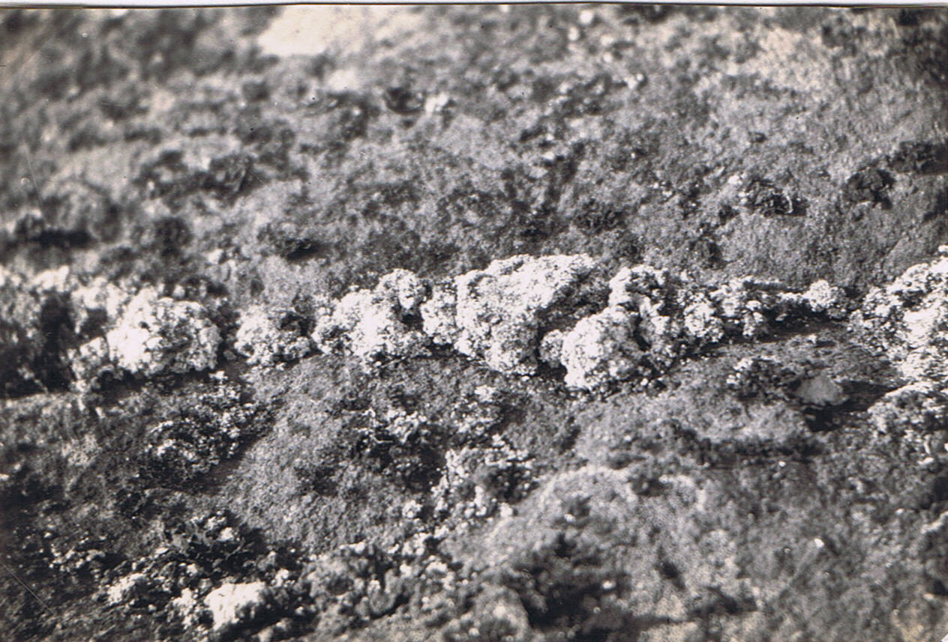
Colonisation of rock crack by lichens (Lecanora etc.) on dolerite island, the Gylden Islands at mouth of Wahlenberg Bay, Hinlopen Strait, 10 August 1923. (Photo C.S.E.1923: No. 71)
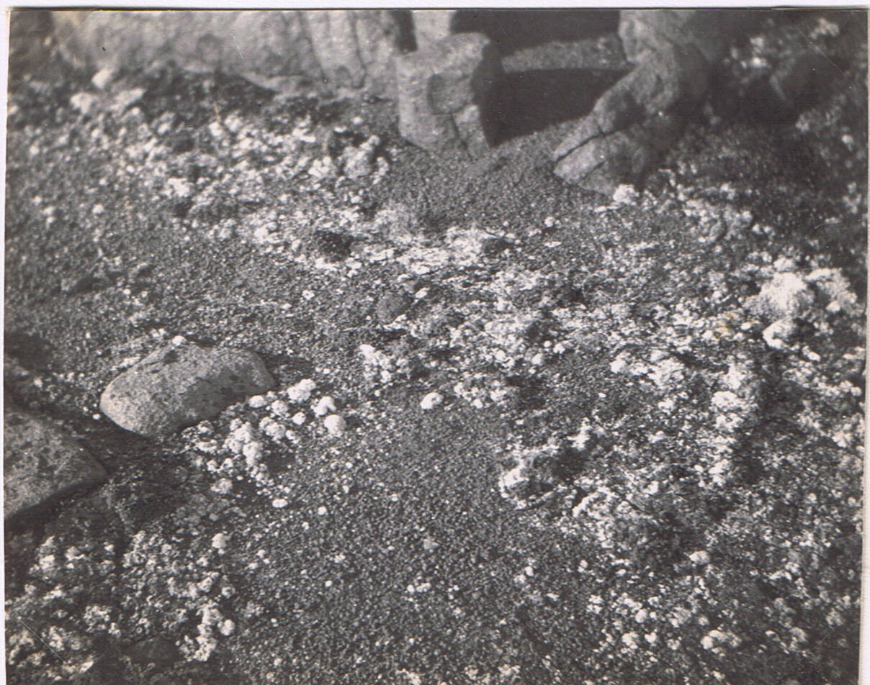
Colonisation of frost-shattered dolerite “soil” by lichens (chiefly Stereocaulon alpinum). As above. (Photo C.S.E.1923: No. 70).
[These photos are in the ecological paper (1928) by Summerhayes & me] also those on next page.
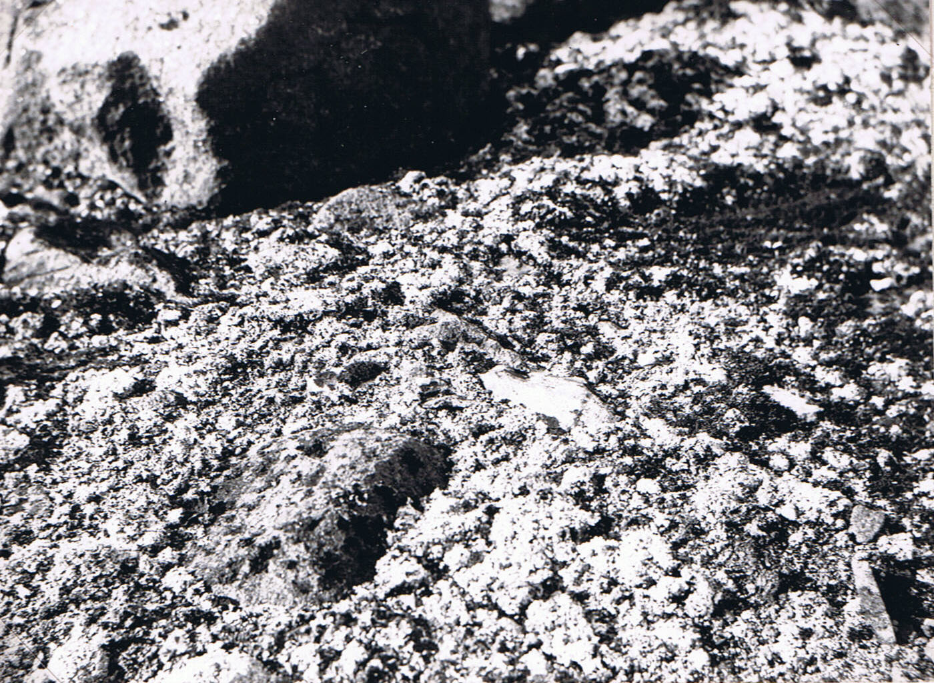
Further succession stage on dolerite soil, closed lichens and some moss, Gylden Islands, mouth of Wahlenberg Bay, 10 August 1923. (Photo C.S.E.1923: No. 53).
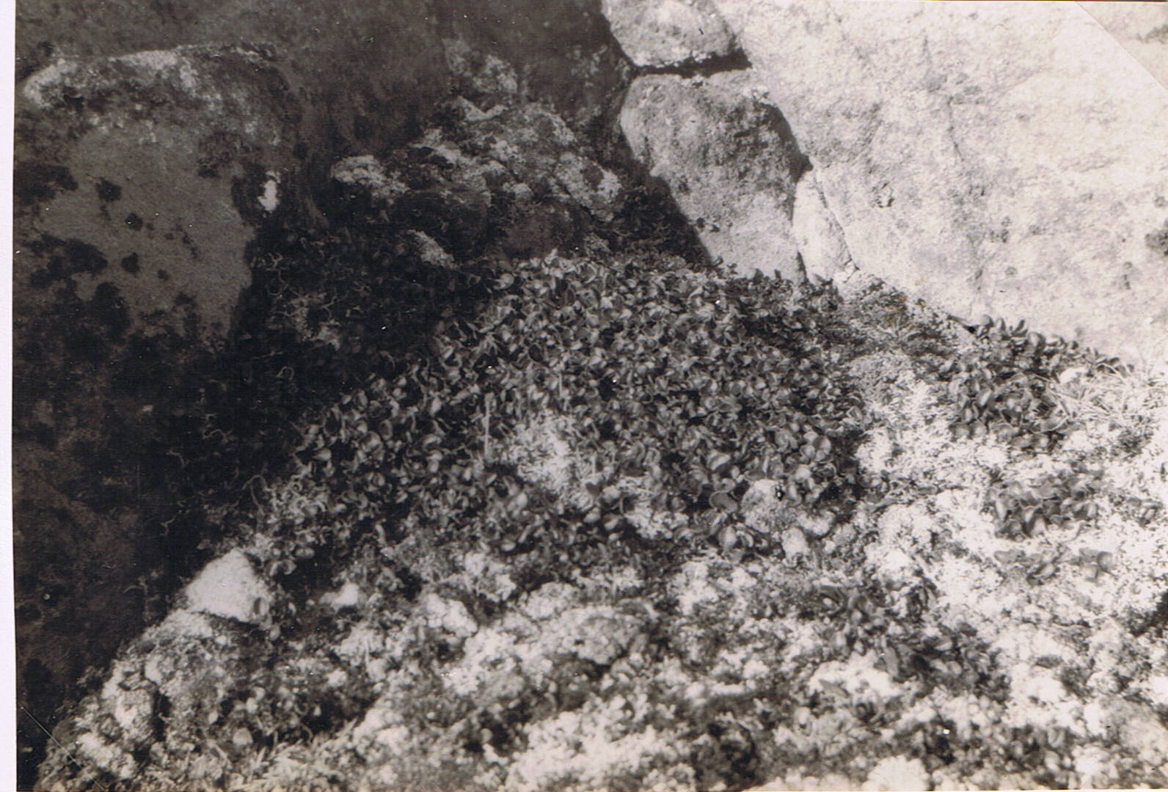
Climax vegetation – the Arctic willow, Salix polaris (1-2 inches) – in this bleak climate, on dolerite. As above. (Photo C.S.E.1923: No. 69).
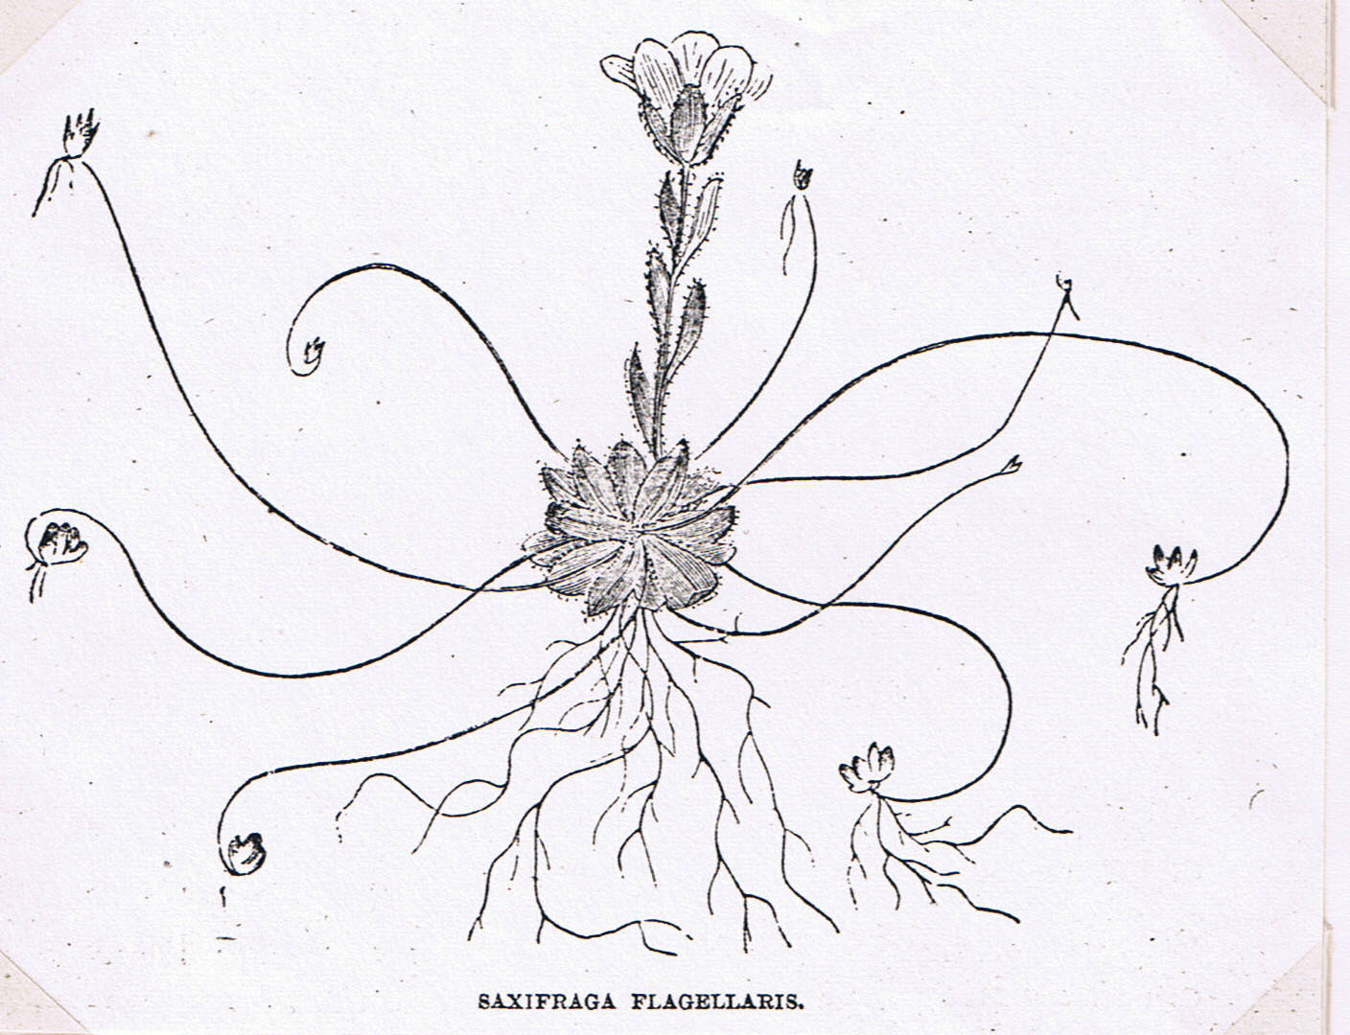

From “The Arctic Voyages of Adolph Erik Nordenskiöld.” Translated & edited by A. Leslie, 1879, page 76.

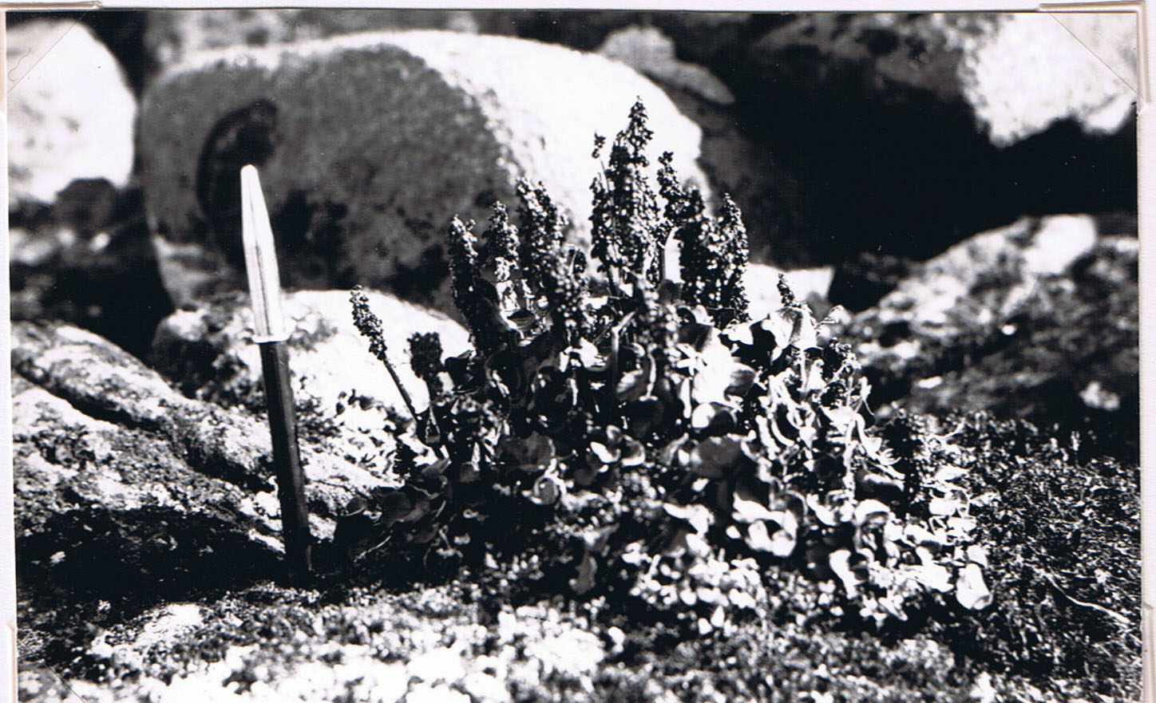
Arctic sorrel (Oxyria digyna), Gylden Islands, mouth of Wahlenberg Bay, 10 August 1923. (Photo C.S.E. 1923: No. 64).
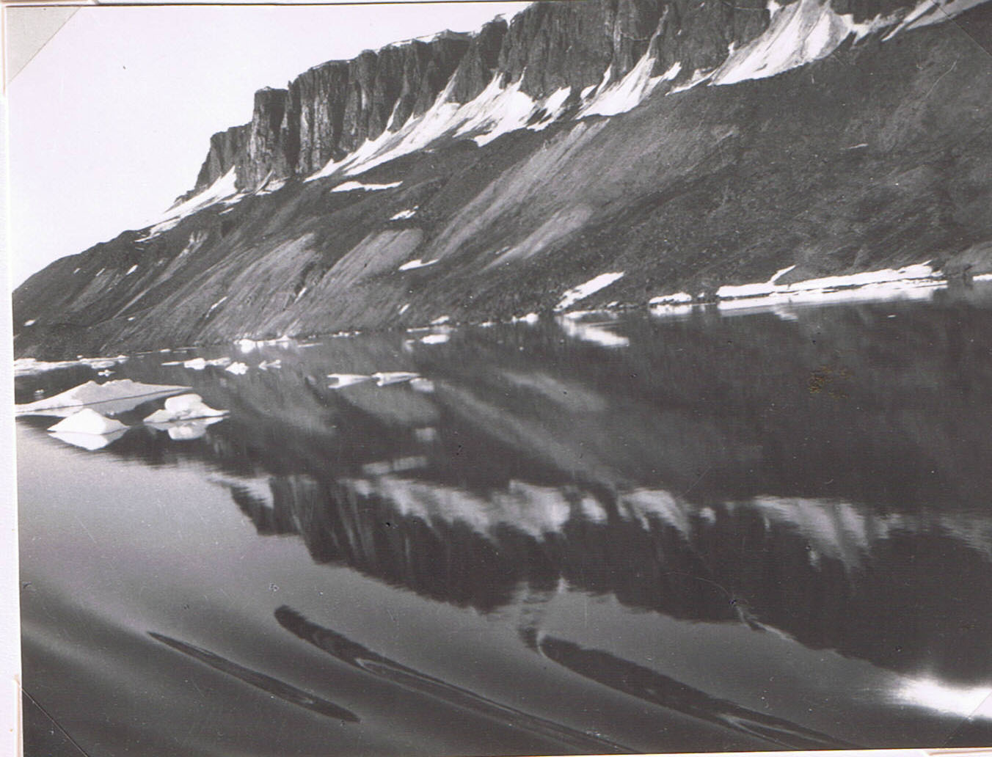
Cape Fanshawe at entrance to Lomme Bay from Hinlopen Strait, south-east corner. Limestone layer overlies dolerite and below is scree. Puffins nested on rock ledges. 11 August 1923. (Photo C.S.E. 1923: No. 68). Darker patches on screes are vegetation made richer by bird-droppings.
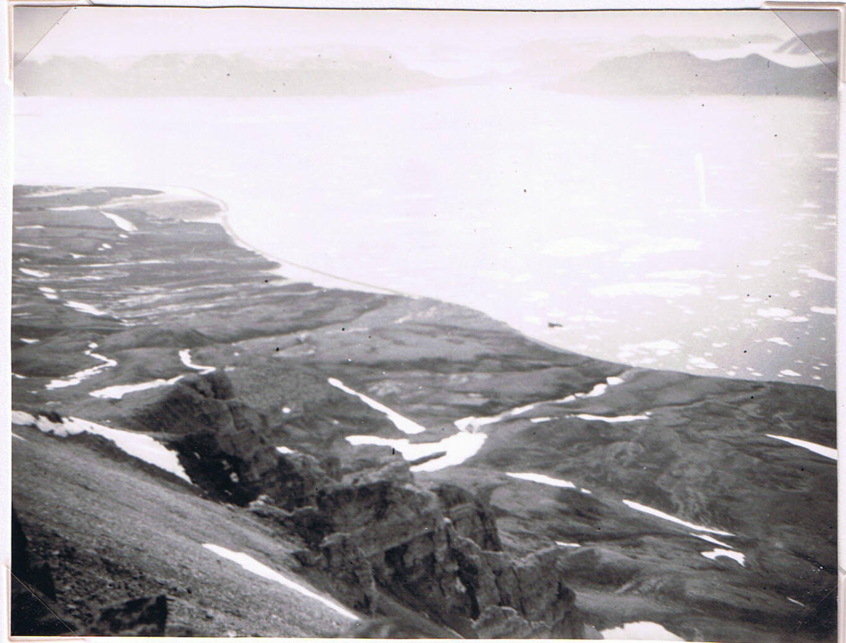
View from cliff-top near Cape Fanshawe, the north-east corner of Hinlopen Strait and Lomme Bay, looking across latter to New Friesland with Faske Bay and Skinfoks Glacier. Rich vegetation under puffin etc. colonies below and lagoons with relict copepod in. Ship (seen from 900-1000 ft.). 11 August 1923. (Photo C.S.E. 1923: No. 66). (Baked limestone just below).
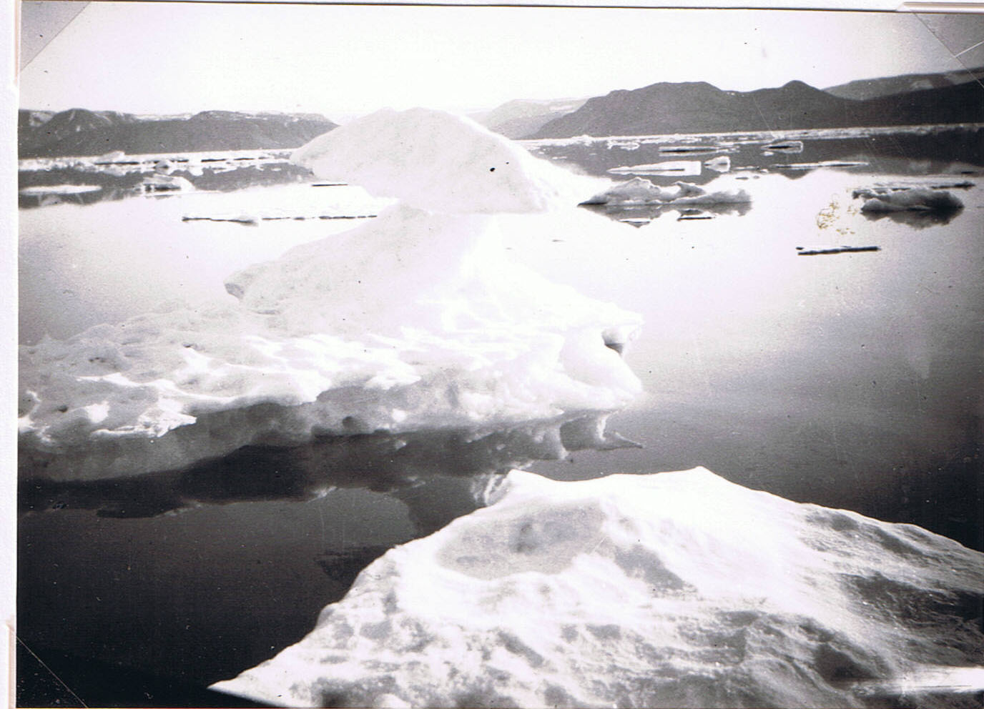
Lomme Bay, as above → (Photo C.S.E. 1923: No. 76)
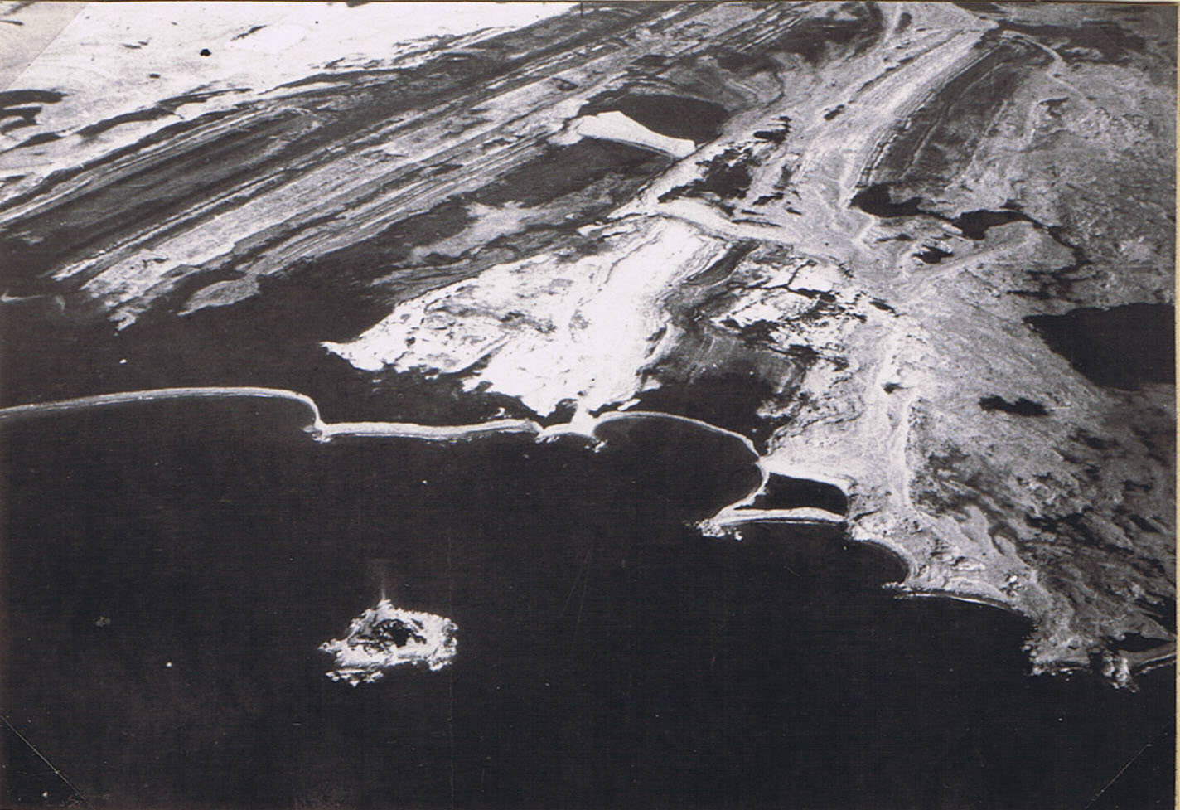
Shoal Point, the south-west corner of North-East Land, air photo by Capt. Tymms. On right are the strike-lines of Hekla. Hoek rock; top left are raised beach terraces; on outer shore the single-bar lagoons. This landscape is very like that of Murchison Bay’s outer part.
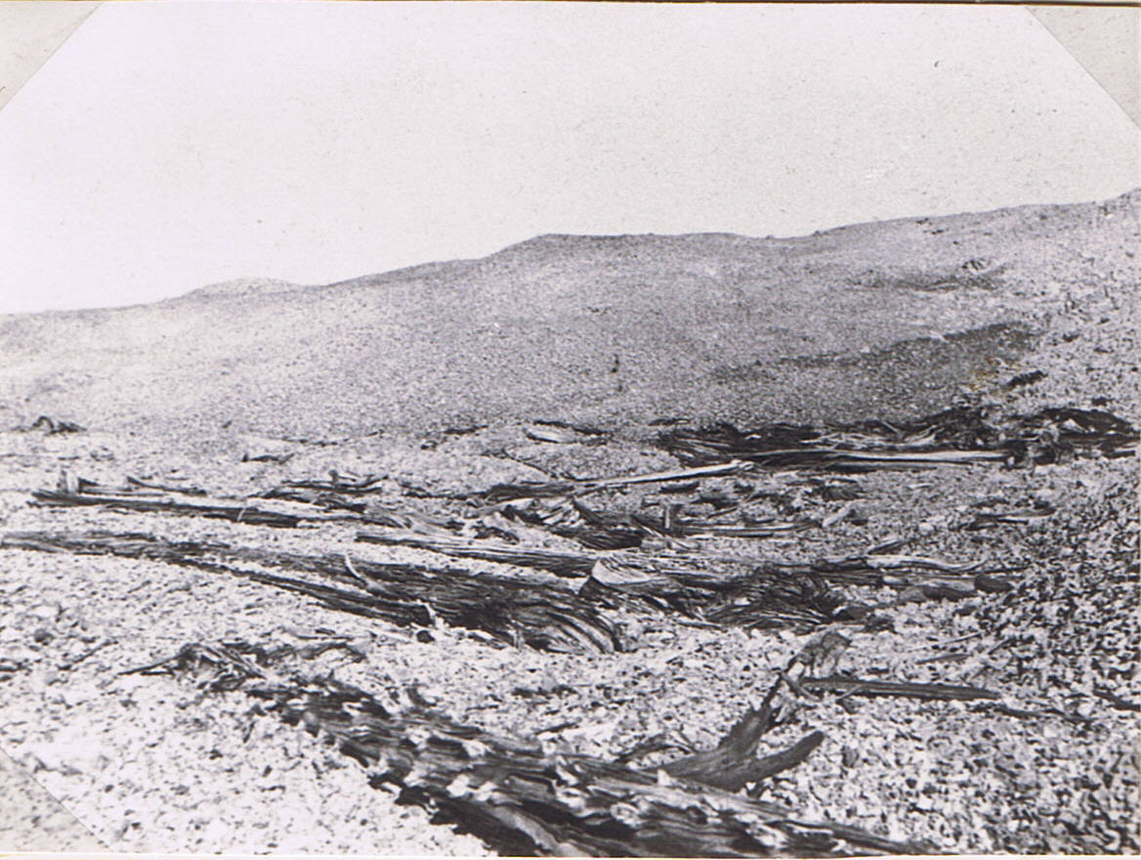
Conifer drift-wood from Siberia on the shore of Cape Sparre, Murchison Bay where also articles brought up by the Gulf Stream’s last tip. 12 August 1923. (Photo J.D. Brown).

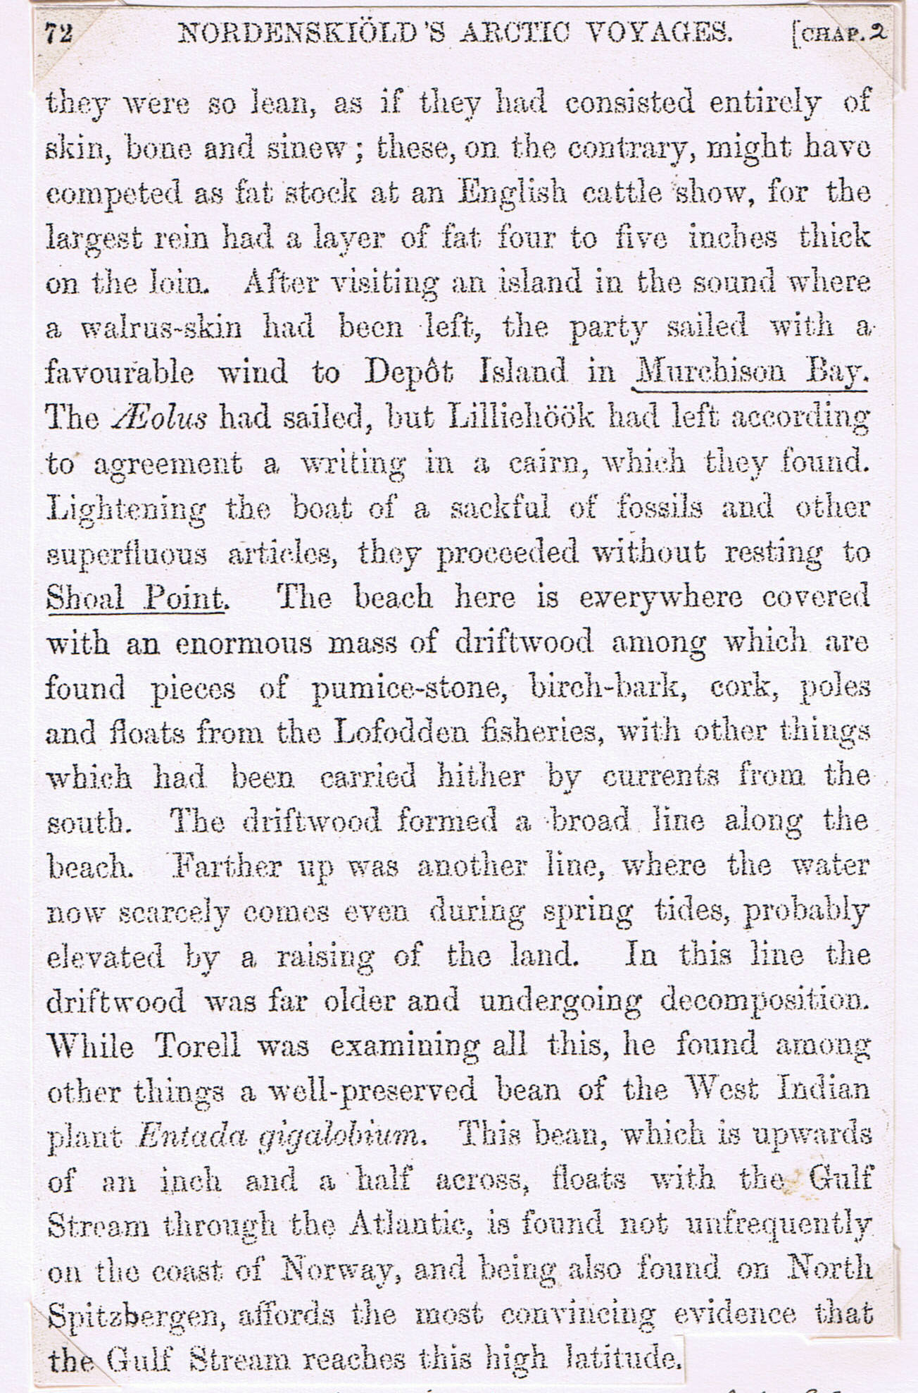
Torell’s expedition in 1861. From “The Arctic Voyages of Adolph Erik Nordenskiöld.” Translated & edited by A. Leslie, 1879. Shoal Point is the North end of Murchison Bay. At Cape Sparre (the south end) I picked up a green Norwegian fishing-float, which I still have. (Collected 12 August 1923). For West Indian beans see next page.
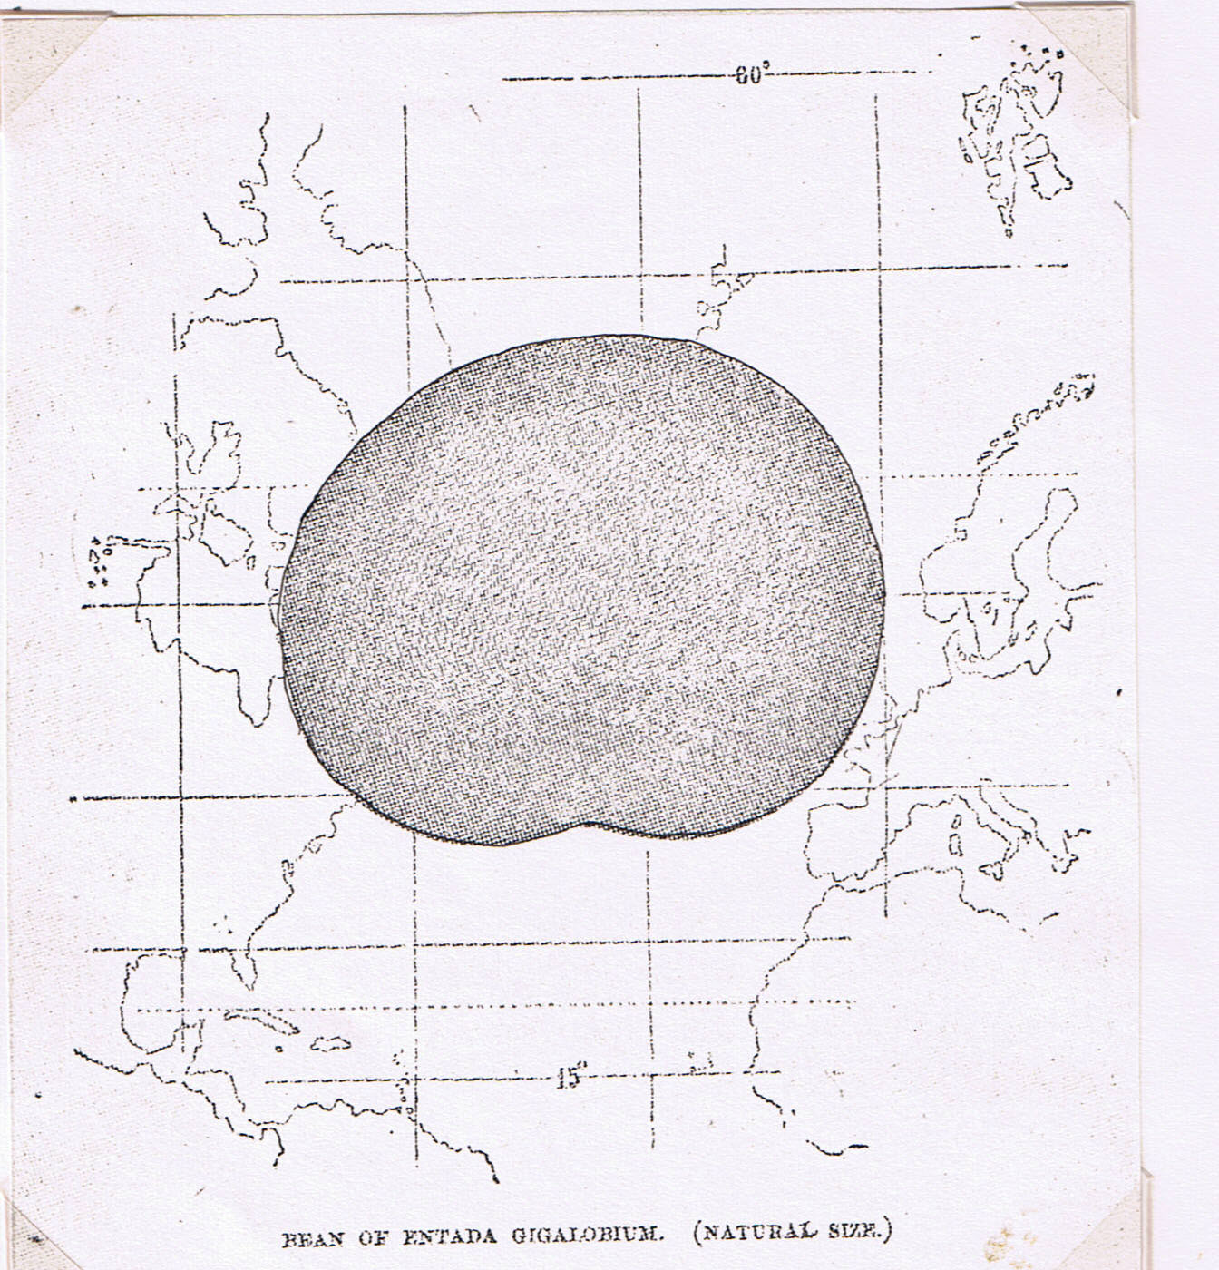
Nordenskiöld’s Arctic Voyages, page 73. (See previous page) Found by Otto Torell at Shoal Point on the north side of Murchison Bay. Similar West Indian beans have often been drifted on the Gulf Stream to Ireland and the Outer Hebrides. I was given one picked up on Pabbay, Harris Sound.

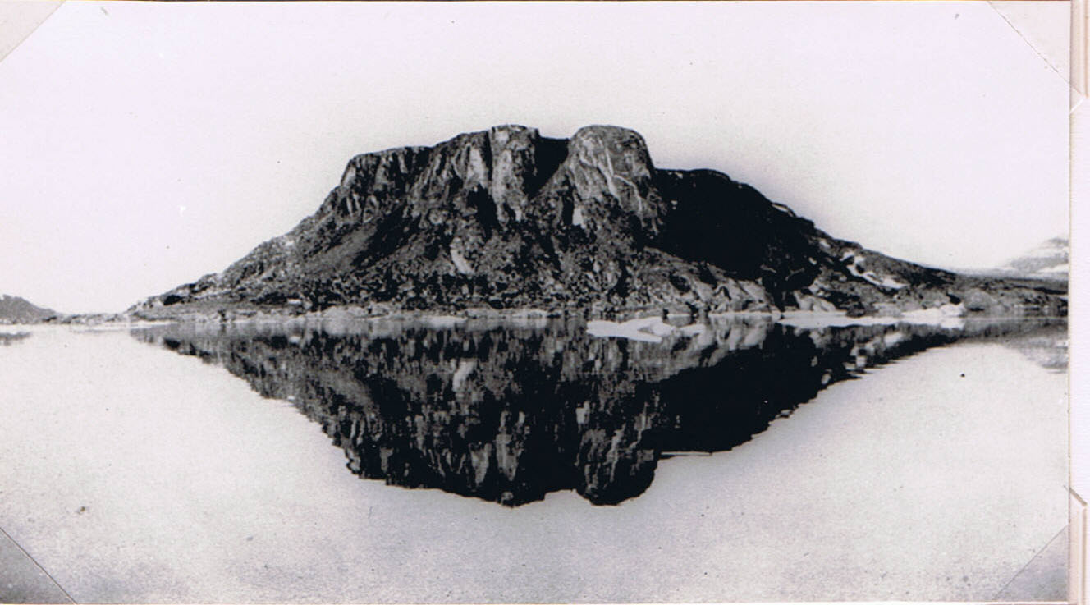
North Cape, Granite Island forming the extreme north-west point of North-East Land. Dark vegetation on the lower slopes of scree below sea-bird colonies (little auks etc.) 12 August 1925. (Photo T.G. Longstaff).
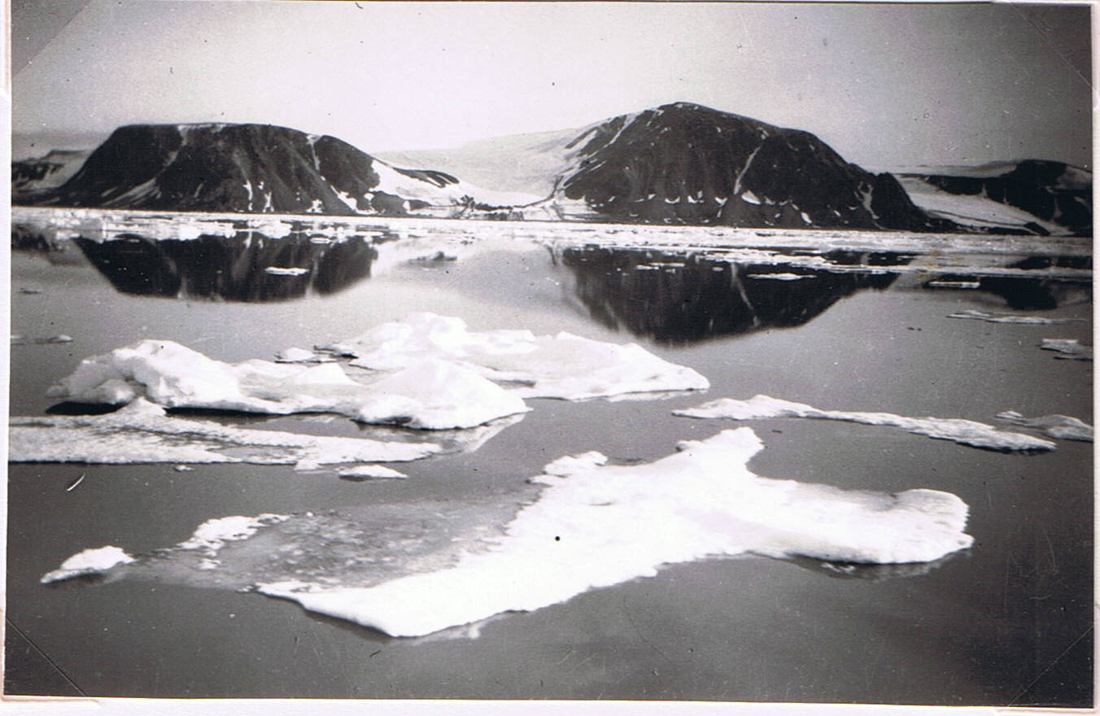
N. coast of North-East Land, E. of Cape Platen 12 August 1923. (Photo C.S.E. 1923: No.67).

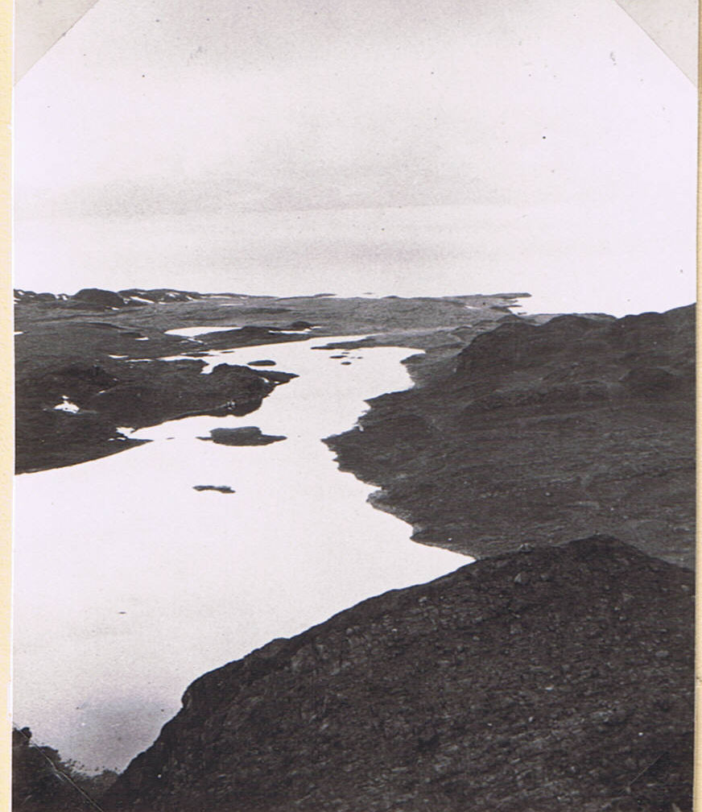
Our Salmon Lake in Wijde Bay, seen from mountain. 17 August 1923. (Photo T.G. Longstaff). Minute ship visible. (West side of Wijde Bay in distance). Tiny group of ‘Tern Islands’ near outlet.
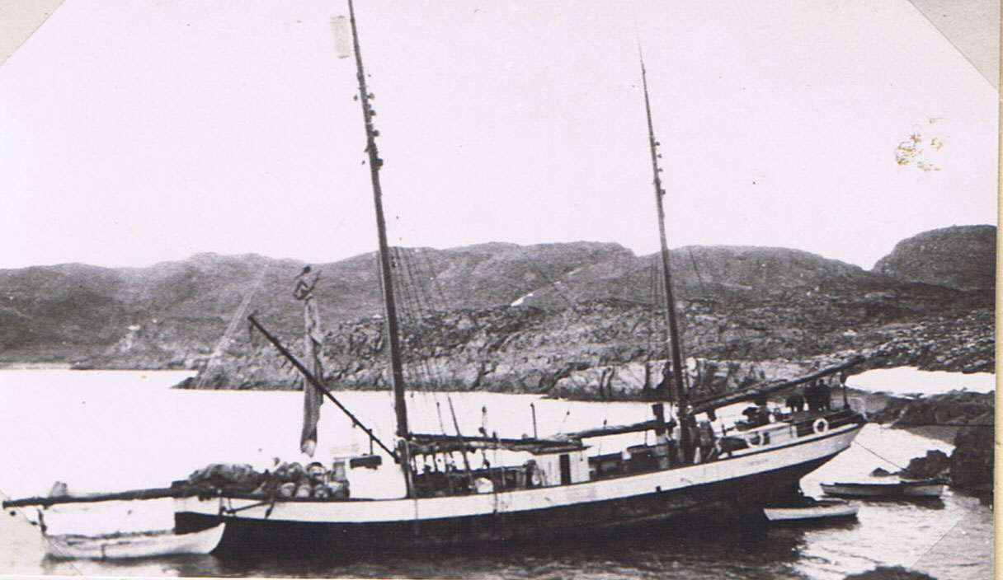
“Terningen” beached (a 4½ ft. tide) in Wijde Bay, to have propeller changed. Note whale-boat full of water weighing down bows, and goods piled forrard. 16 August 1923. (Photo T.G. Longstaff).
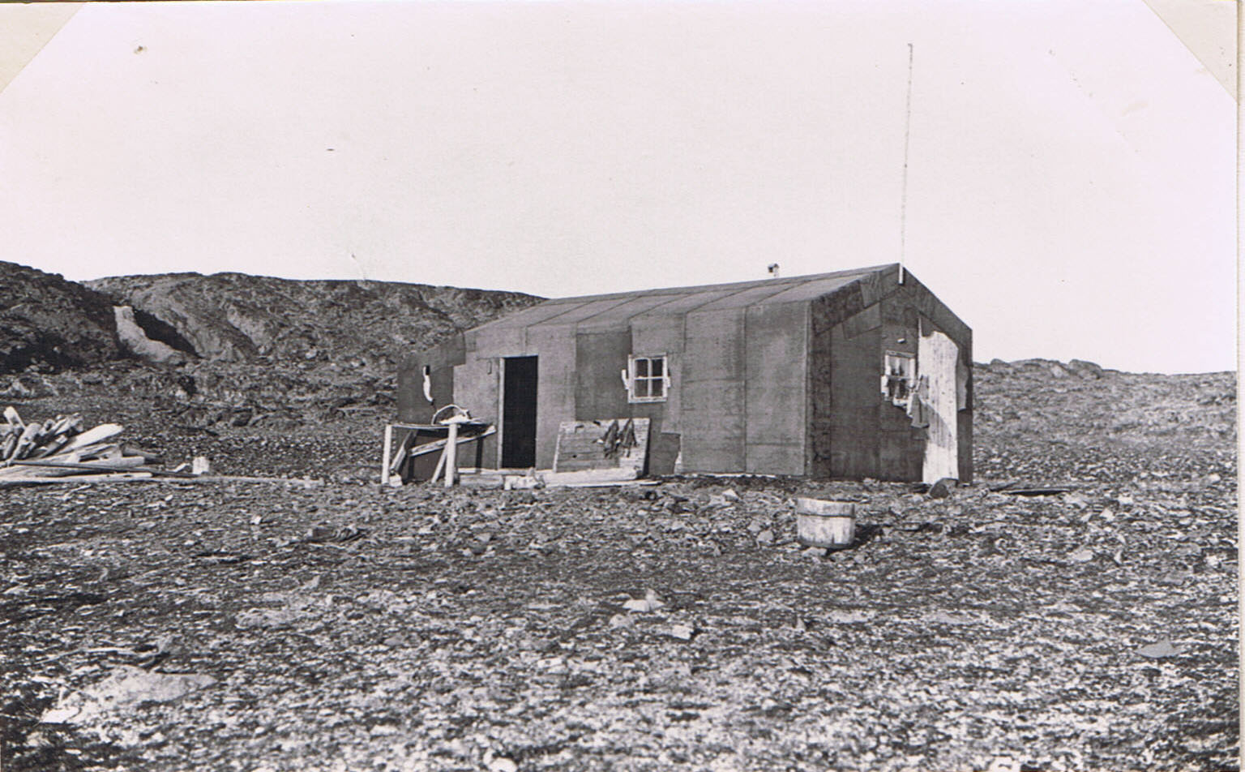
The trappers’ hut used by Douglas Brown and C.S.E. 18-20 August 1923, Wijde Bay.
(Photo by A.N.T. Rankin 1924).
(2 Arctic fox skins drying on the board).

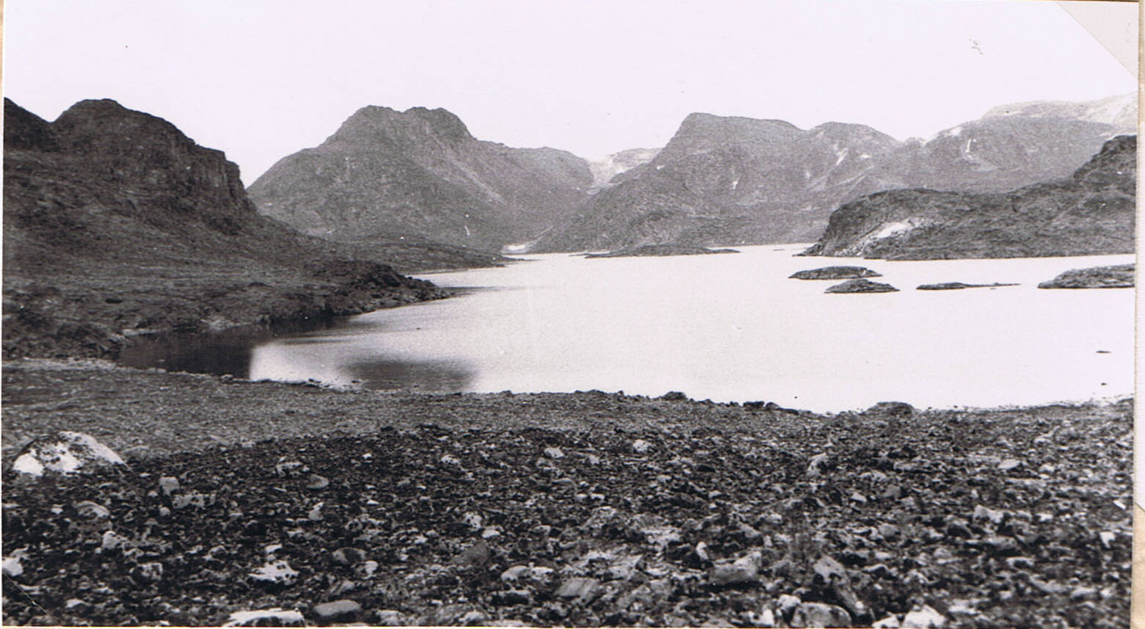
The Salmon Lake in Wijde Bay where Douglas Brown and I went in a collapsible boat. Arctic tern nesting islets in foreground. C. 16-20 August 1923. (Photo G. Summers).
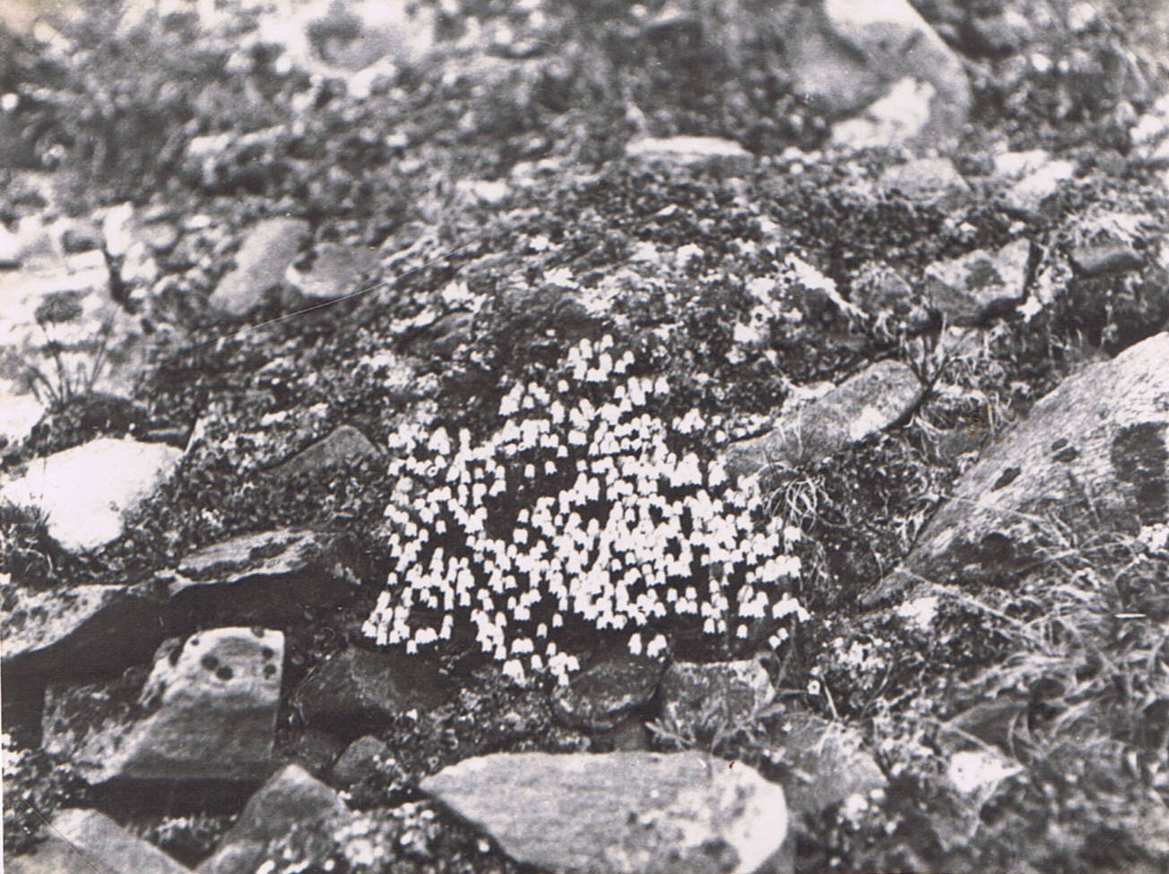
White bell heather (Cassiope tetragona) on Archaean rock debris near Salmon Lake, above. (Photo J.D. Brown 16-20 August 1923).
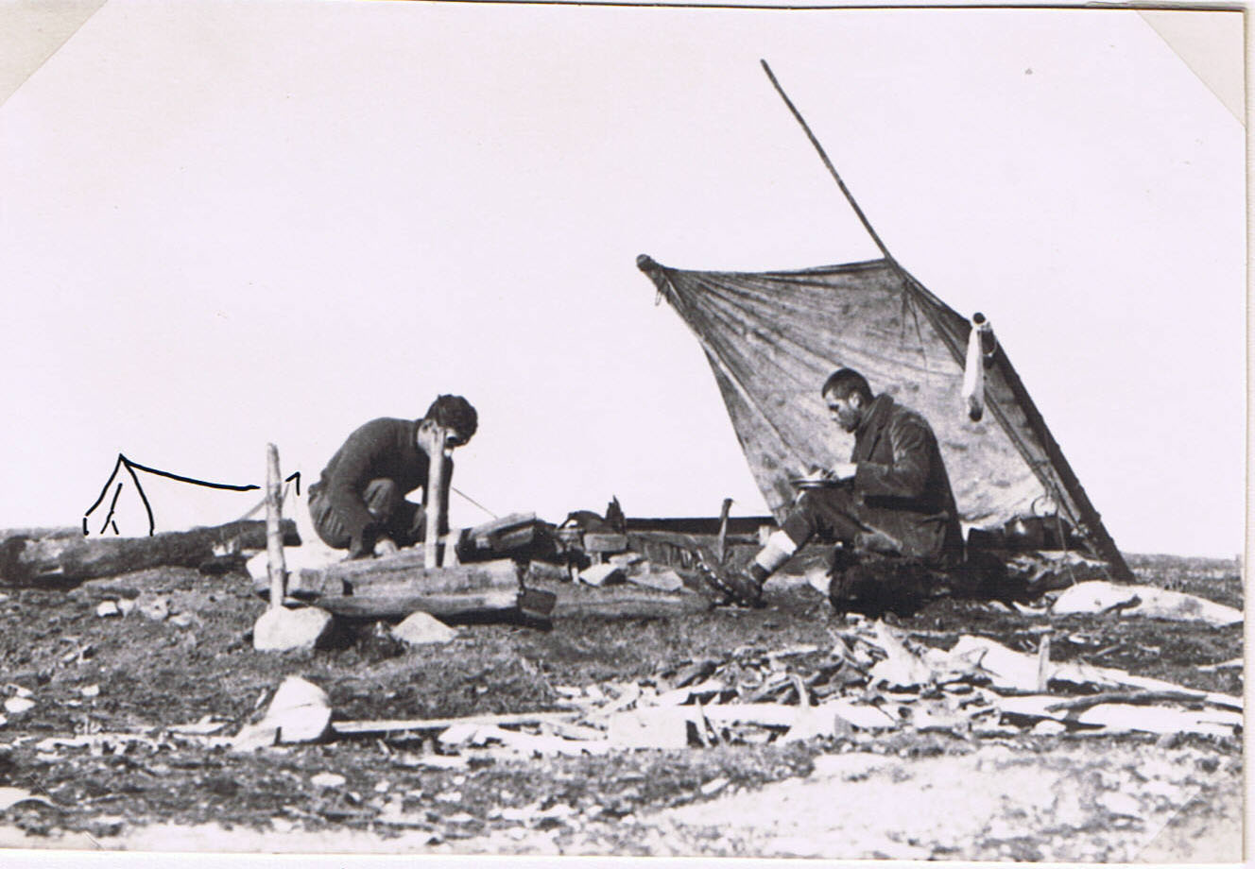
C.S.E. & Hugh Clutterbuck in camp on Reindeer Peninsula, 22 or 23 August 1923. (Photo J.D. Brown).
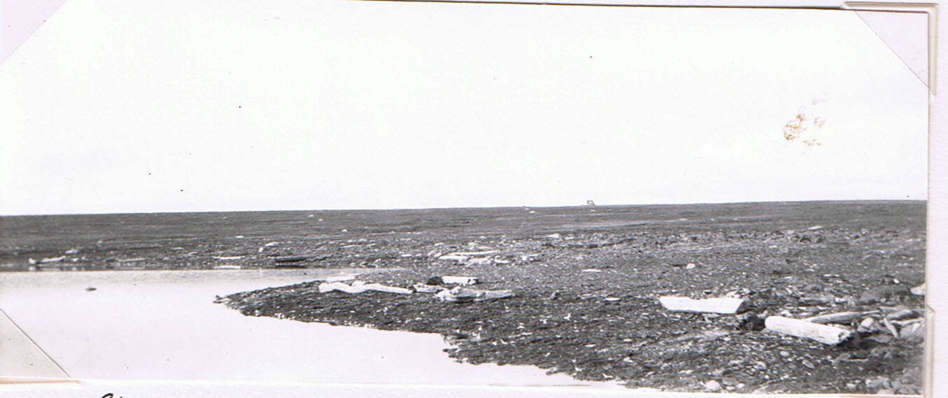
Driftwood on the shore of small lagoon quite recently cut off from the sea. (“Lagoon II”). South shore of Reindeer Peninsula. 23 August 1923. (Photo C.S.E.1923 No. 118).

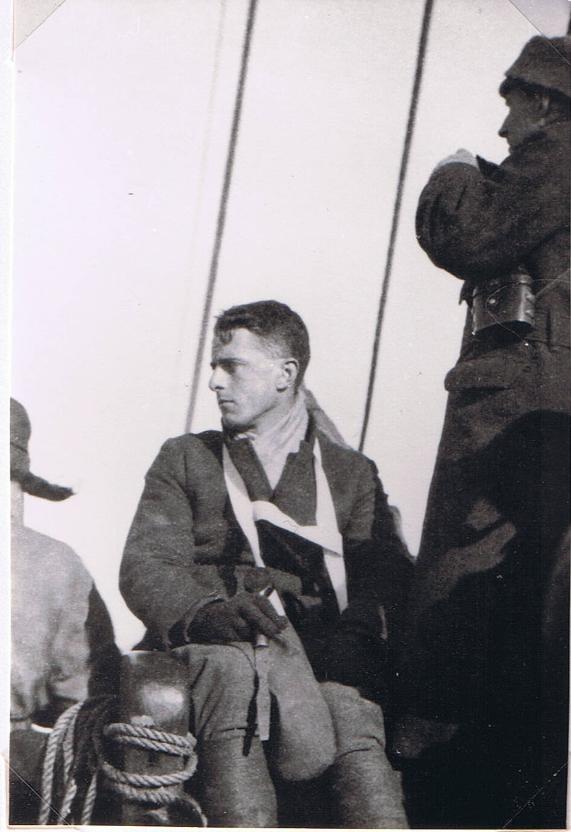
C.S.E. on board at the end of the Expedition. Odell on the right. (Photo by an expedition member). 1923.

