THE OXFORD UNIVERSITY EXPEDITION
TO SPITSBERGEN (1921)

notes by C.S. ElTon.

June 1921 –August 1921

.
Editor’s notes:
The manuscript was entirely handwritten on unnumbered sheets of loose-leaf quarto. Page numbers are added for ease of reference; in places, pairs of sonsecutive sheets without illustrations have been placed on a single electronic ‘page’. Pages that begin or end in mid-sentence are shown as such. Photographic prints, drawings (and early Xeroxes of other documents) are scanned in situ (i.e. with photograph corners and other mounting showing), but to high resolution, so they are shown larger on the page than they were in the original text thus resolving more detail. Those taken by the author are identified e.g.: ‘(C.S.E. photo 1921: No. 17)’. Most of their negatives are still held by Elton’s family to whom application can be made for reproduction. Contact the Editor: C.M.Pond@open.ac.uk.
Species names and proper nouns appear in italics, but other underlining is shown as such. Handwritten text and corrections are not distinguished from typing. Scored out material is omitted entirely. Abbreviations are shown in full where the meaning is clear. Incomplete or ungrammatical sentences and inconsistent use of upper/lower case, number format, inverted commas etc. are unaltered and only blatant spelling errors are corrected. Editor’s notes and explanations are shown in {}.
Art = article
{Preface page}
Three Expeditions to Spitsbergen, 1921-24.
(See Arts. 4, 8, 9, 17, 22. Also, dealt with in other places, Arts. 10, 19, 14).
In the spring of 1921 Huxley told me that I might have a chance of joining the O.U. Spitsbergen Expedition as his field-assistant. In the event, I did go, and the experience had a profound influence upon my ideas in ecology, especially about the structure of animal communities. From records I have kept (but there is no complete diary, such as I wrote in 1923 and 1924), publications and clear memories, I reconstructed a very detailed account of the Expedition as I experienced it myself. It was greatly helped (for dates, etc.) by F.C.R. Jourdain’s diary, kept in the E.G.I. archives. Copies of the MS and photos of my 3-volume typed account are (1) with me (2) in the Scott Polar Research Institute (3) in the Norsk Polarinstitutt, Oslo. The work was briefly reviewed in the Polar Record (January 1984, vol. 22, pp. 83-4) by Colin Bertram.
I have illustrated the present summarised account with photos.
The Expedition was set up by a group of Oxford ornithologists, the actual planning being mainly done by George Binney. There were two phases (1) the First Party consisted chiefly of ornithologists, led by Jourdain, (2) the Second Party was to sledge in New Friesland. Longstaff and I served on both, he being one of the sledgers, as well as a good ornithologist and general naturalist.

THE OXFORD UNIVERSITY EXPEDITION
TO SPITSBERGEN (1921).
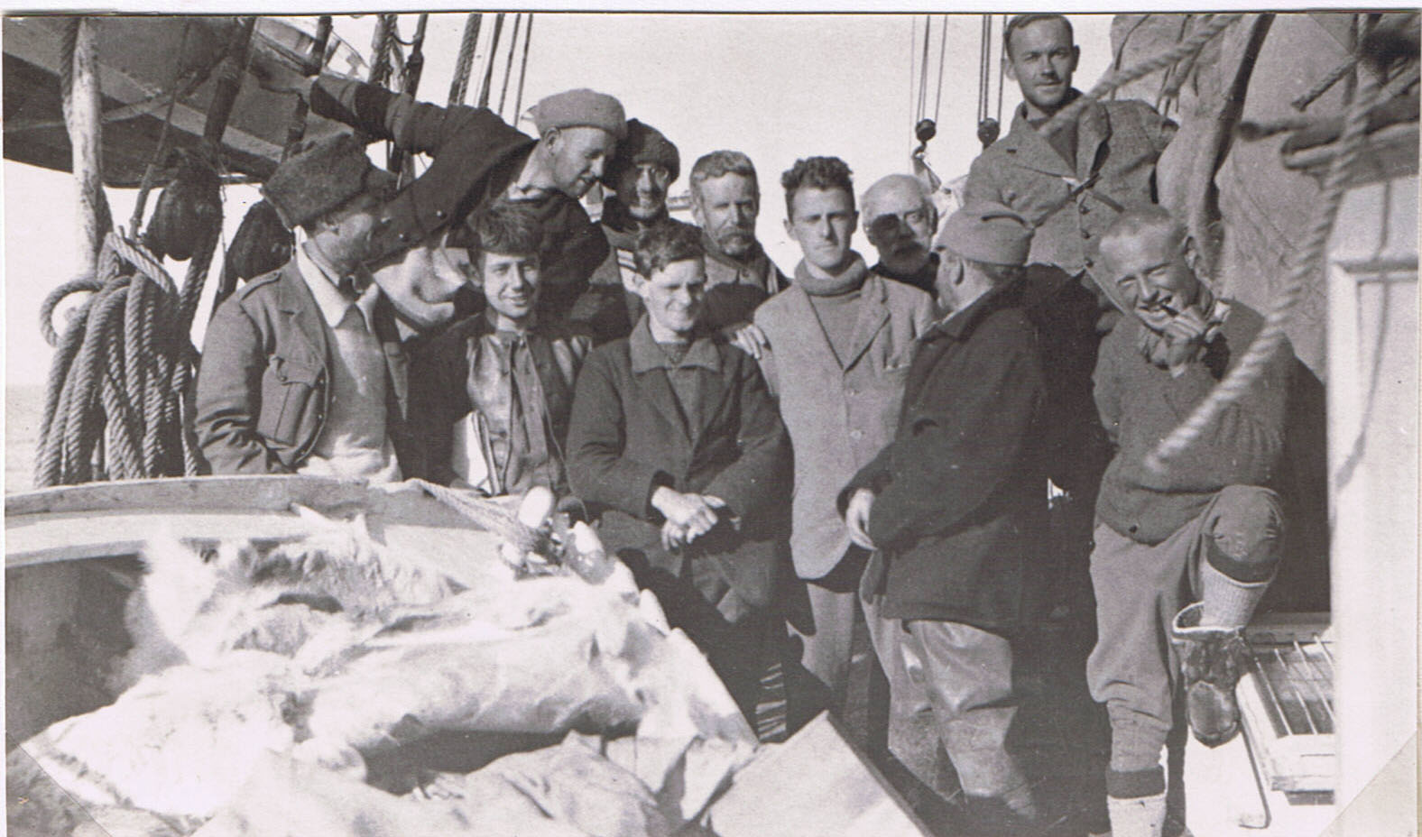
L. to r.: J.S. Huxley (birds); F.G. Binney (Organizer), A.H. Paget-Wilkes (birds); J.D. Brown (birds); V.S. Summerhayes (botanist); F.C.R. Jourdain (Leader, birds & eggs); R. Pocock (cook etc.); Dr. T.G. Longstaff (birds & much else); R.W. Segnit (geologist); H.L. Powell (taxidermist). C.S.E. in roll-neck jersey.
(Photo by Seton Gordon, birds & photographer).
The 2nd party not shown here, came later, to ‘Bruce City’: A.M. Carr-Saunders (zoologist); R.A. Frazer, N.E. Odell as sledgers; R. Stobart in charge of sledge-dogs (not used); G. Slater (glaciologist), J. Walton (botanist).

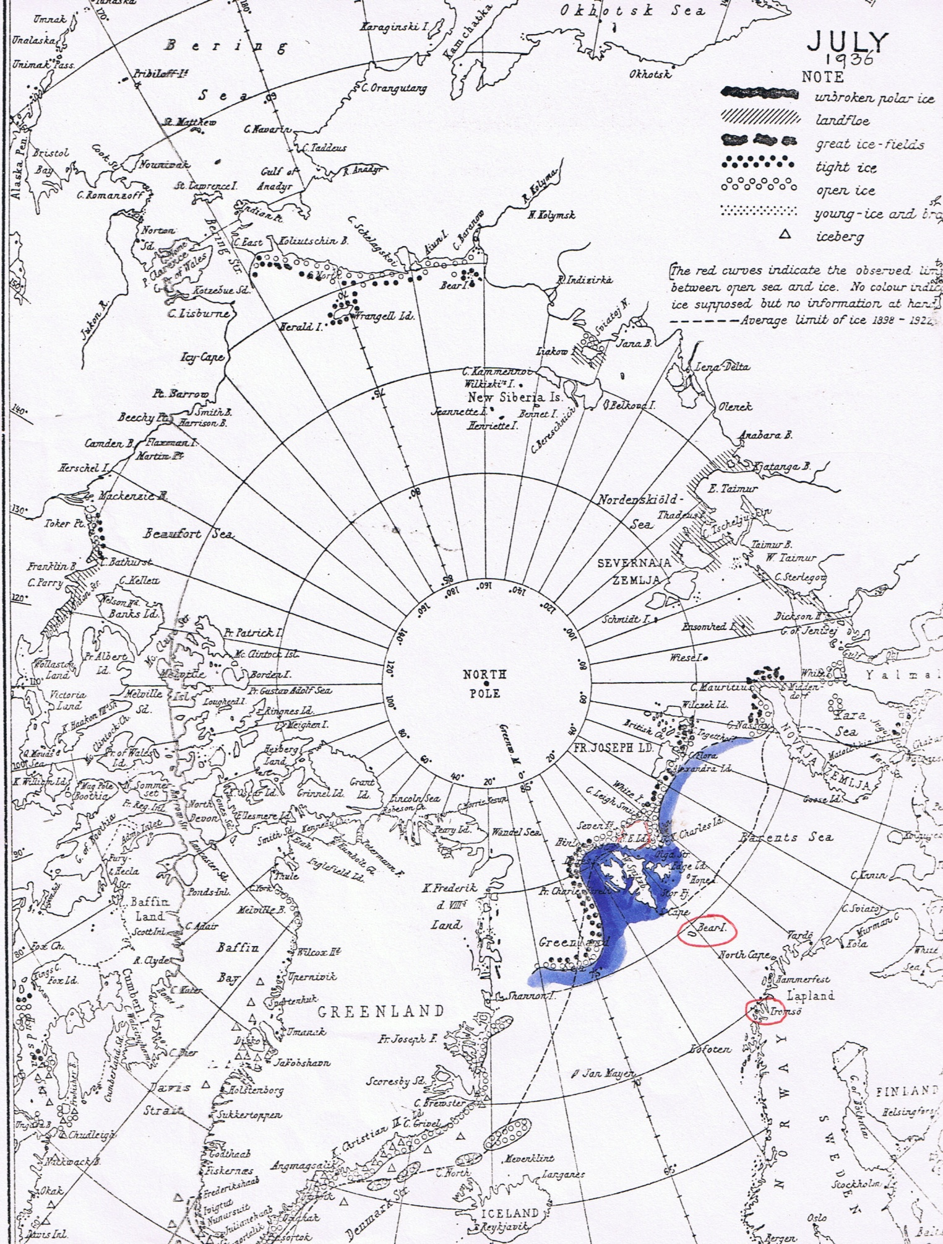

{Printed list tipped in with photograph corners}

List of Members of the Oxford University Expedition
to Spitsbergen, 1921.

Rev. F .C. R. Jourdain (Magdalen), (Leader of the Expedition; Ornithology).
Dr. T. G. Longstaff (Ch. Ch.) (Ornithology; Exploration).
Prof. A. M. Carr-Saunders (Magdalen), (Zoology).
Prof. J. S. Huxley (Balliol and New College), (Zoology).
Mr. F. G. Binney (Merton), (Secretary and Organizer).
Mr. J. D. Brown (Oriel), (Ornithology)
Mr. C. S. Elton (New College), (Animal Ecology).
Mr. Seton Gordon (Exeter), (Photography; Ornithology).
Mr. A. H. Paget-Wilkes (Lincoln), (Ornithology).
Mr. R. W. Segnit (Balliol), (Geology).
Mr. R. A. Frazer (National Physical Laboratory), (Exploration; Surveying).
Mr. N. E. Odell (Imperial College of Science), (Exploration; Geology).
Mr. Roger Pocock (Cook; Artist).
Mr. H. L. Powell (Taxidermist).
Mr. G. Slater (Royal School of Mines), (Glaciology)
Mr. R. Stobart, (Exploration; Surveying)
Mr. V. S. Summerhayes (University College, London), (Botany).
Mr. J. Walton (Cambridge), (Botany).

I shall only give a very broad summary here: my own work, for which Huxley generously gave me complete freedom, was to carry out a complete ecological survey of all habitats except truly marine ones, and all groups of animals. This had never been attempted before, although nineteenth century Swedish expeditions had done much good collecting. I worked closely with V. S. Summerhayes, a young graduate of University College, London, who as botanist on the First Party carried out a fine survey of vegetation, – our main results were published jointly in Art. 4. I collected the freshwater Algae and a few seaweeds, and my own survey included the intertidal marine zone. I should explain here that the aqrchipelago was then a no-man’s land; but in 1925 it became officially under Norway, who re-named it “Svalbard” (this includes also Bear Island). But I had to keep the old names of the Admiralty Chart, the Scottish Spitsbergen Syndicate, etc. because all the records and specimens used them. (In my full account, I have explained cases where the interpretation is needed).
Unlike so many modern young people, I had never been abroad before. Equipped with some war-time things from my brother L.S.E., and taking a very full assortment of collecting gear, including various special chemicals for preservation of specimens, I travelled to Tromsø via Bergen. Here I joined our sealing ship, the “Terningen” (in which I was to travel much more extensively in 1923).
Our first stop was for 10 days on the barren island of Bear Island, where, however, there was an enormous population of sea-birds, especially guillemots – these seas are as rich as the land of frost-shattered rocks is poor. We camped in the ruins of a whaling station, and were remarkably fortunate in having only two really bad days, one of which I shall describe; and the other yielded a fine crop of marine animals washed up by the storm, which went to the British Museum.
Here I studied, among other habitats, some of the numerous tarns, and in particular the deep Ella Lake in the south of the island, where I found the only water-mite* to be recorded from Svalbard (it occurs also in the mountains of Norway). Also here was a small caddis-fly, once previously recorded there, but also the only species known in Svalbard.
Also the published results of this Expedition were collected together in a 200-volume edition of bound-up reprints, “Spitsbergen Papers”, and also some in “S.P. 2” {= Spitsbergen Papers 2}, one also in the later Exploration Club volume, “Greenland and Spitsbergen Papers”, all of which are available in Oxford and some other main libraries such as the R. G. S. {= Royal Geographical Society}.
* Sperchon lineatus

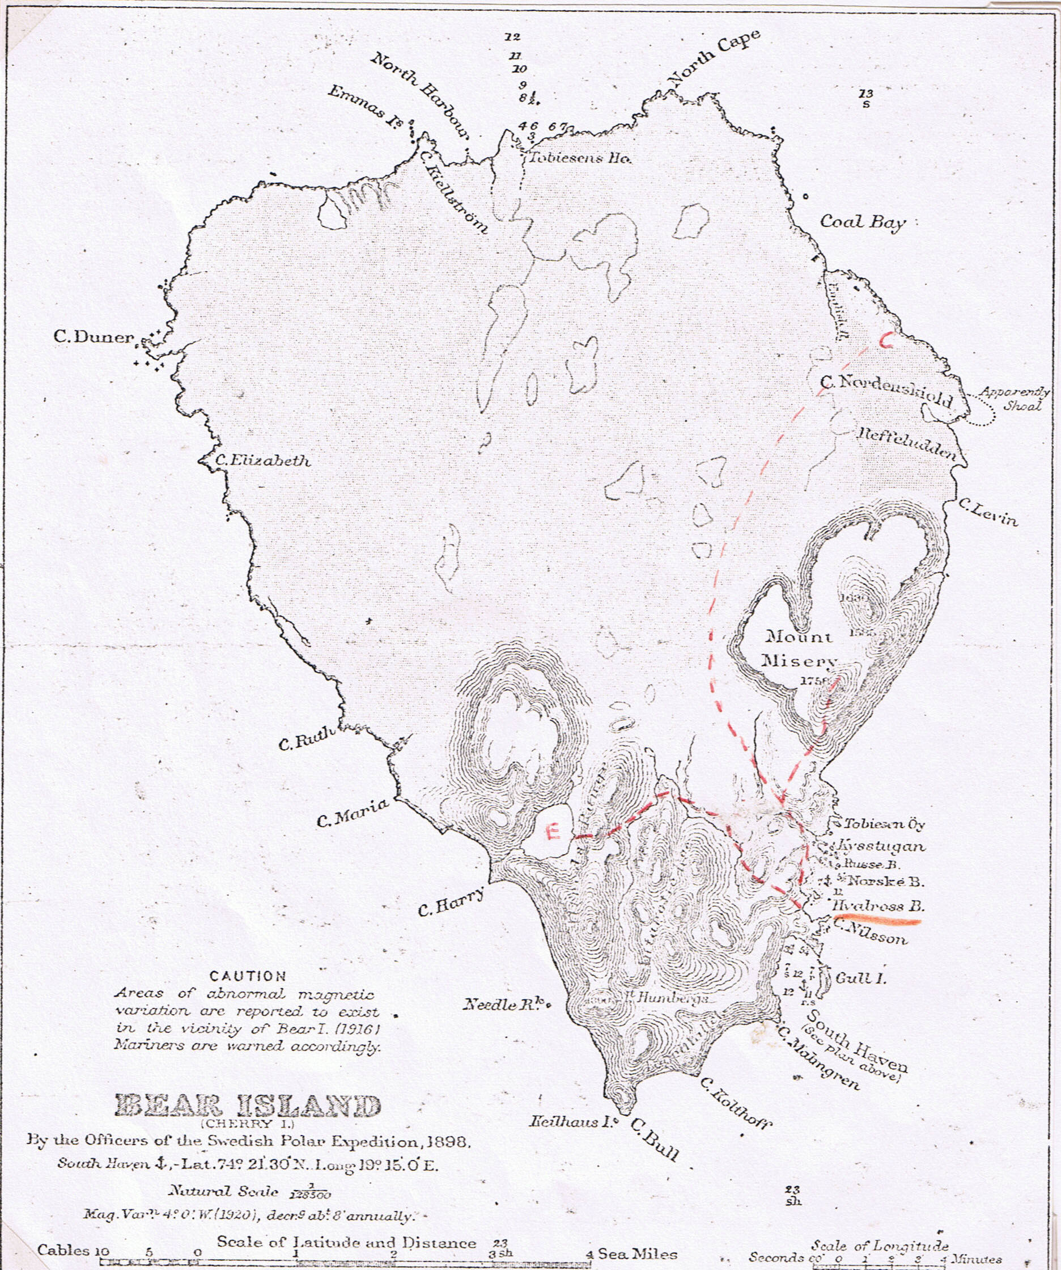
Xerox of piece of chart found in F.C.R. Jourdain’s diary. E = Ella Lake. ‘Hvalross B.’= Walrus Bay. Red routes of my walks with Dr. Longstaff very approximate. C = Coal Station.

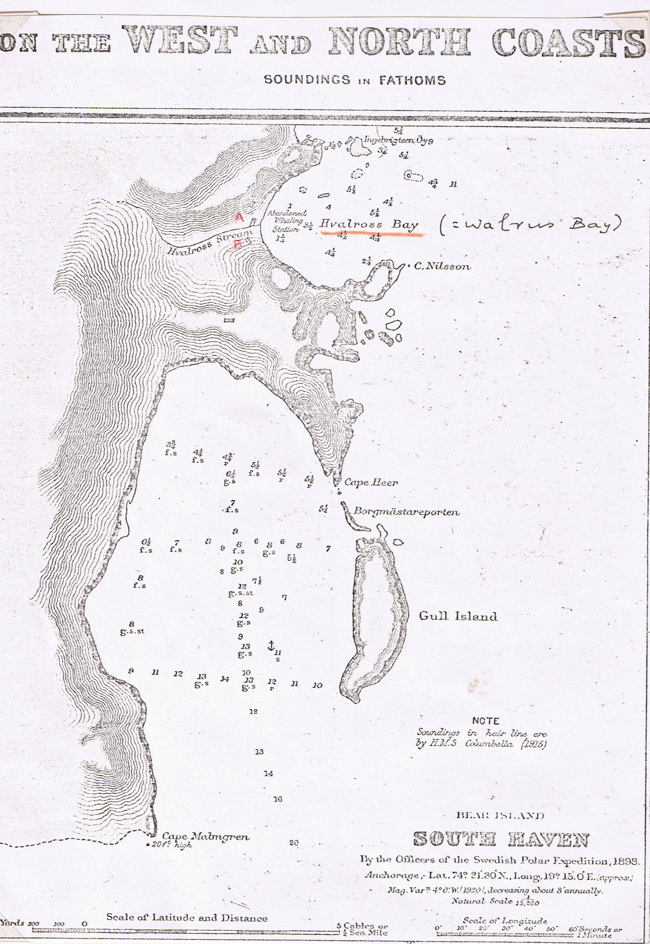
As last chart, more detail. A = old forge. B = “Haddock Villa”.
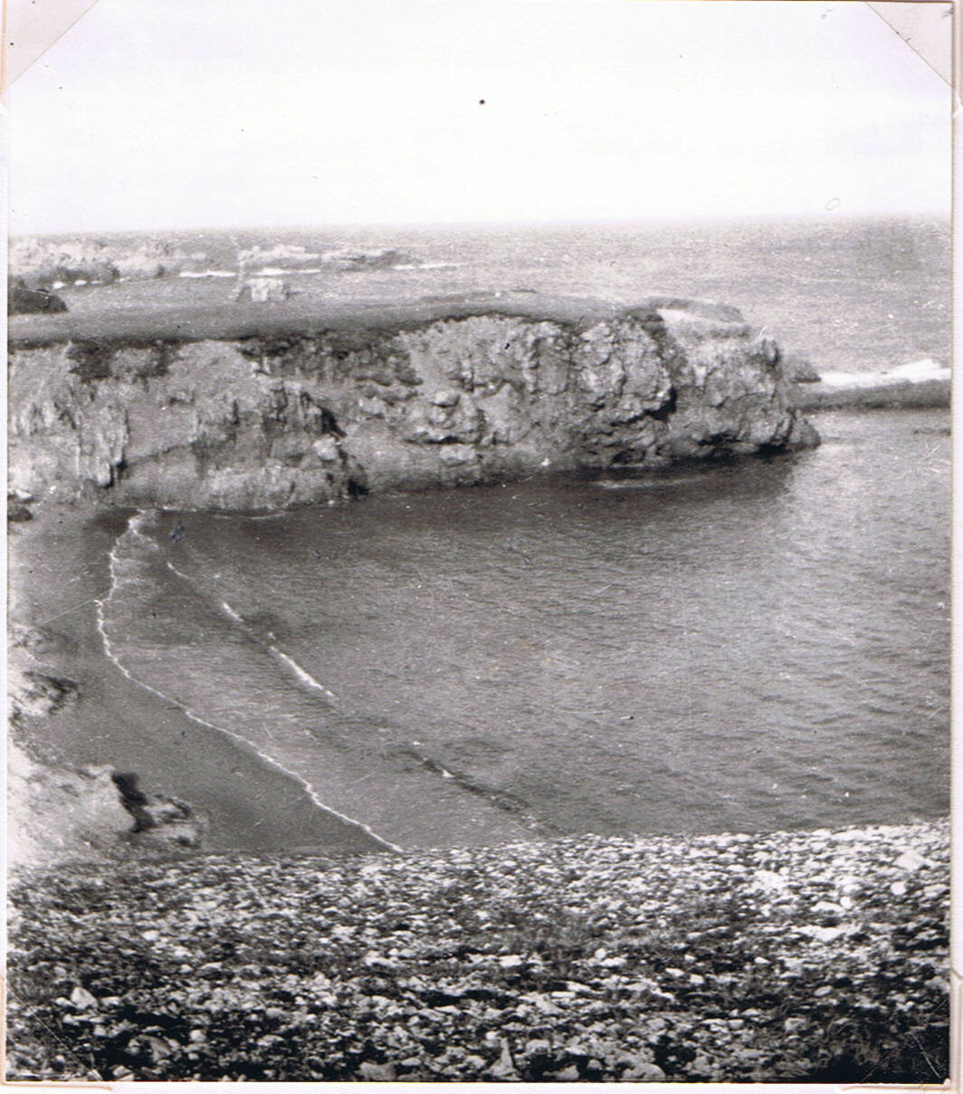

Walrus Bay, Bear Island. (Photo C.S.E. 1921: No. 904).

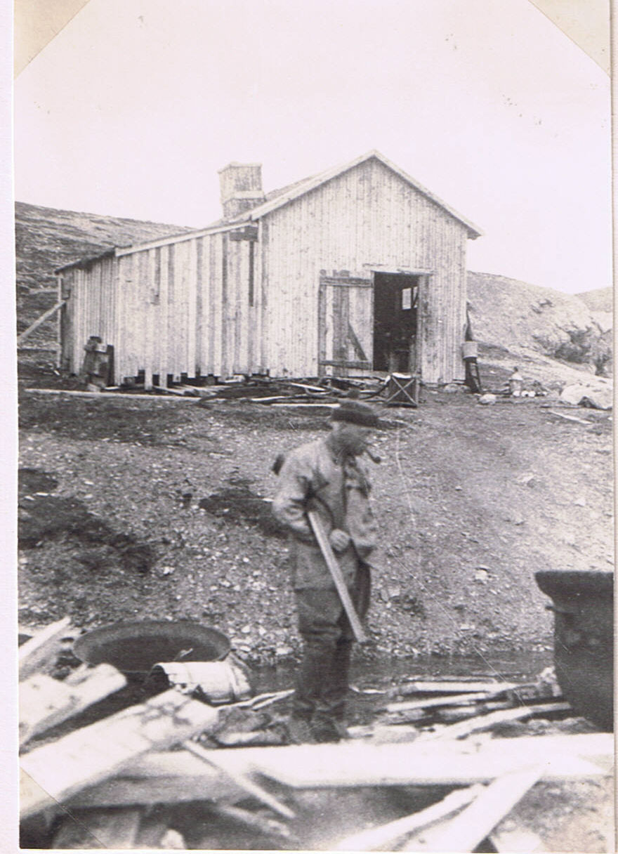
Our habitation on Bear Island in June 1921. H.L. Powell, our taxidermist. (Photo J.D. Brown)

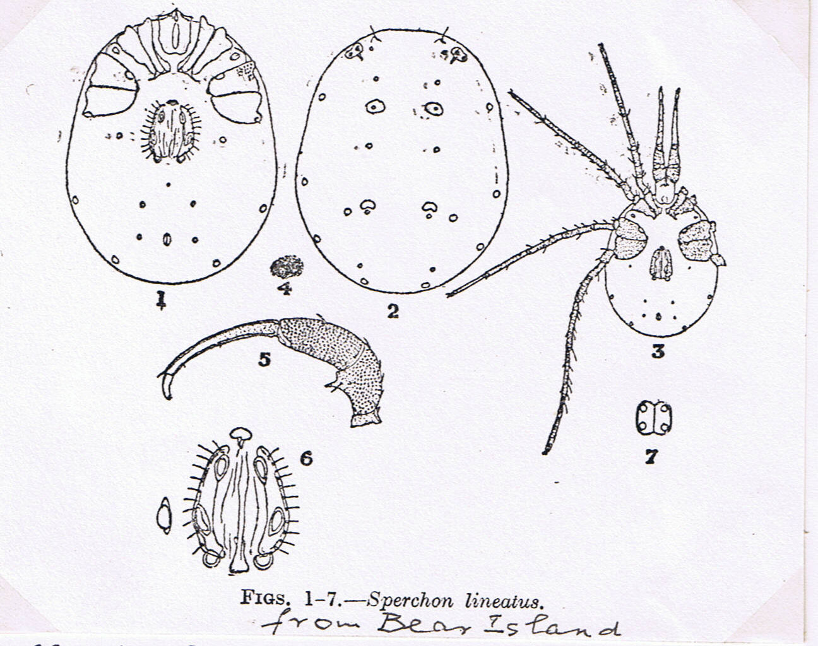
Charles Soar, 1922, J. Queckett Microscopical Club, Ser. 2 vol 14, p. 103.

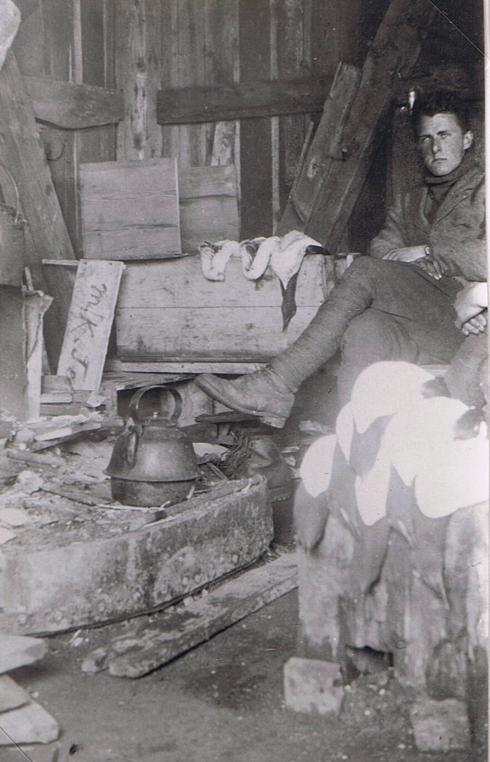
C.S.E. by cooking hearth + guillemots. Walrus Bay, Bear Island, June 1921.
(Photo T.G. Longstaff)

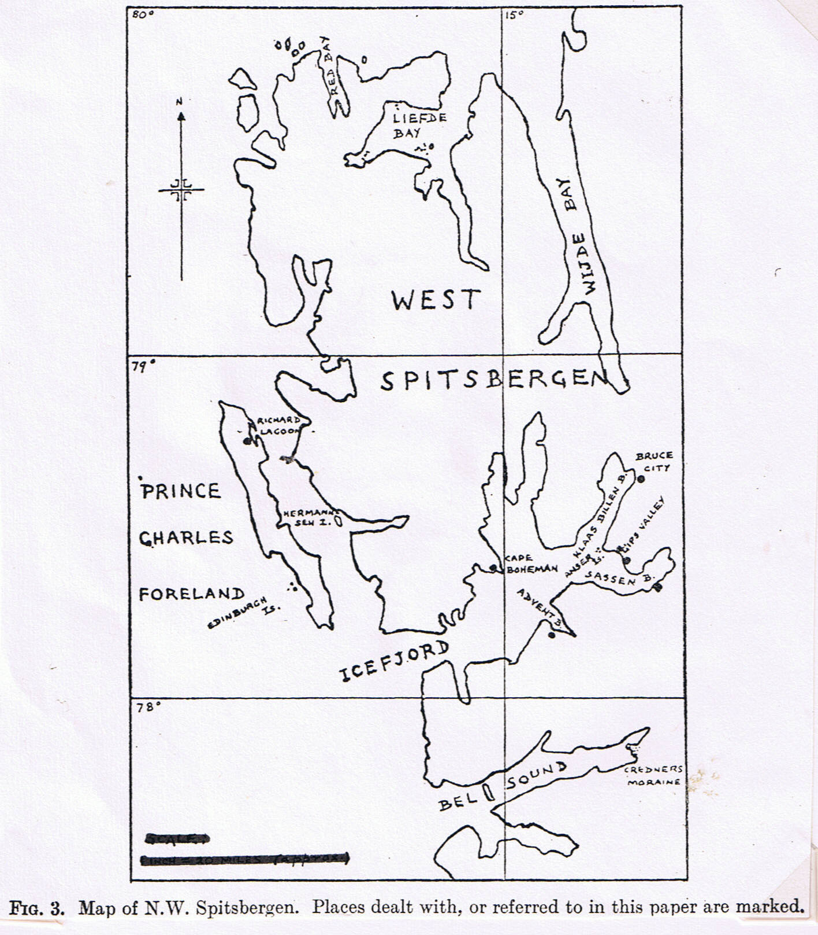
From V.S.S. & C.S.E. (1923), page 234.
(Sketch-map by C.S.E.)
(Scale given on published map is wrong, because of reduction printing: treat as rough locations derived from old inaccurate chart)

There are also some good notes on this expedition in Dr. Tom G. Longstaff’s remarkable autobiography of mountaineering and exploration, “This is my voyage” (1950). We were camped at the S.E. of the island, and he describes a walk that he and I made in a whole day of blizzard, to the Norwegian mine in the N.E.: “A wet blizzard raged the whole day and the going was atrocious. Although the distance was only seven miles we took four hours each way, always over unstable spiky rocks with swamps of mud in every hollow. It was our introduction to the bad footing of the Arctic, which causes two miles an hour to be reckoned good going.”
My later work was mainly to places around IceFjord, the great inlet on the West Coast of main Spitsbergen, with its coal-mine settlement at Advent Bay. (At the latter Jourdain obtained eggs of the barnacle goose). But I also had an interesting visit to the N.E. part of Prince Charles Foreland, where Huxley, Summerhayes, Sergit (our geologist) and I camped by the large Richard Lagoon. The Lagoon, though tidal, was still partly ice-covered, and we arrived during the violent snow-melt of the Arctic spring. We camped in small tents and were pretty cold. I shared one with Huxley, and clearly remember that, as we lay in our sleeping bags, he asked: “Tell me, Elton, what as a matter of fact is Ecology?” This rather defines
{new page}
the state of zoological thinking at that time. After our return home, I remember that Professor Poulton remarked: “Are not ecologists an obscure sect of the followers of Lamarck?” Perhaps if I had used the term “bionomics” it would have been clearer to them. “Ecology”, to most people, I think still meant the study of plant associations.
While at P.C.F. {= Prince Charles Foreland} I nearly lost my life, by forgetting Longstaff’s injunction not to cross a particular bit of winter ice. I fell through up to my neck, but was saved by wearing a rucksack, and by Segnit whose shout checked me, then blinded by water on my goggles, from stepping back into the hole – I would have drowned in the snow-melt torrent that had weakened the ice there.
The choice of places to camp during this Expedition was quite out of my own control; but it happened to include (if one counts Bear Island also) the four ecological zones of increasing fertility into which we were later to divide Svalbard – “Barren”, “Dryas”, (mountain avens) Cassiope” (white heath), and “Inner Fjord” (see maps etc. in Art. 17).
My longest stay was at Base Camp

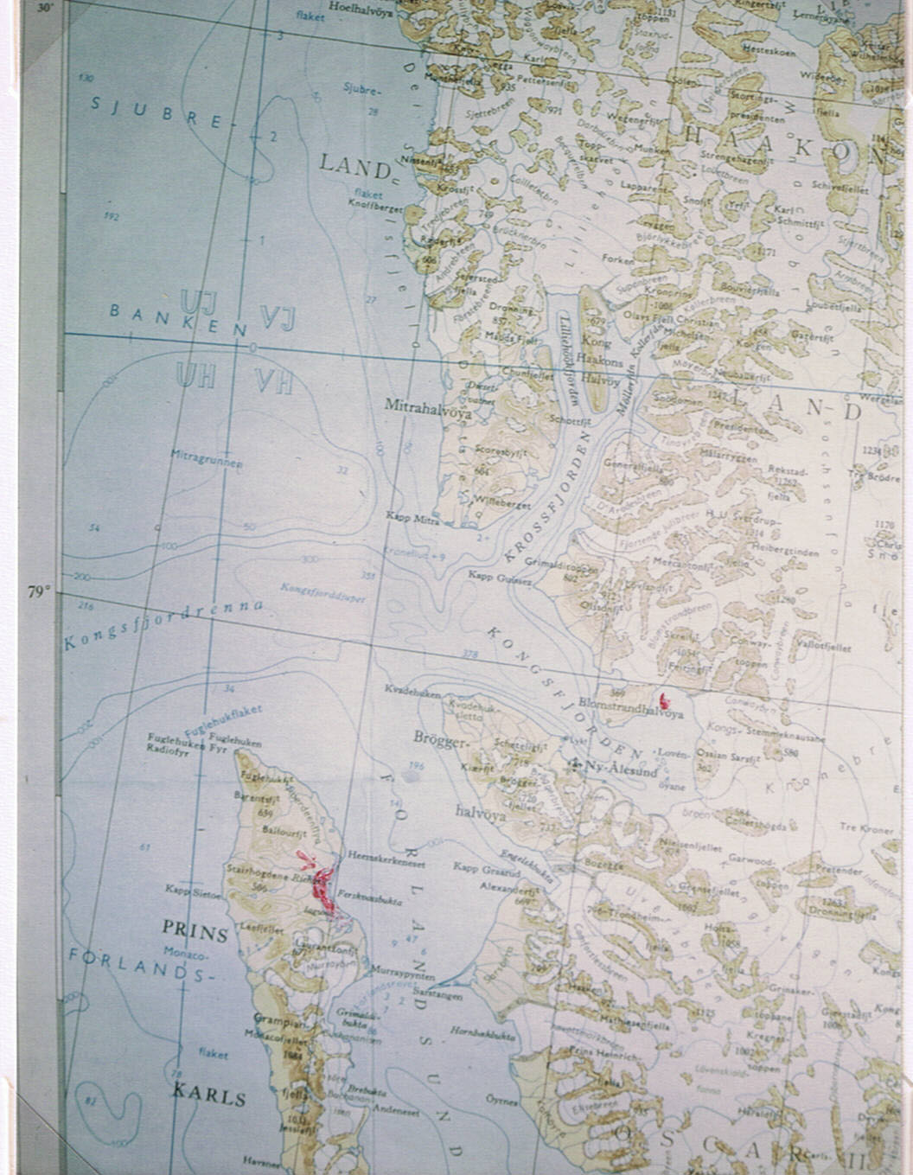
Richard Lagoon, arrow Prince Charles Foreland camp, in red. Deer Bay Island, King’s Bay, red dot r. (see 7 July 1924). The scale is 1 mm = 1 kilometre. (Colour photocopy by C.S.E. from Norsk Polarinstitutt map 1968 x ½)
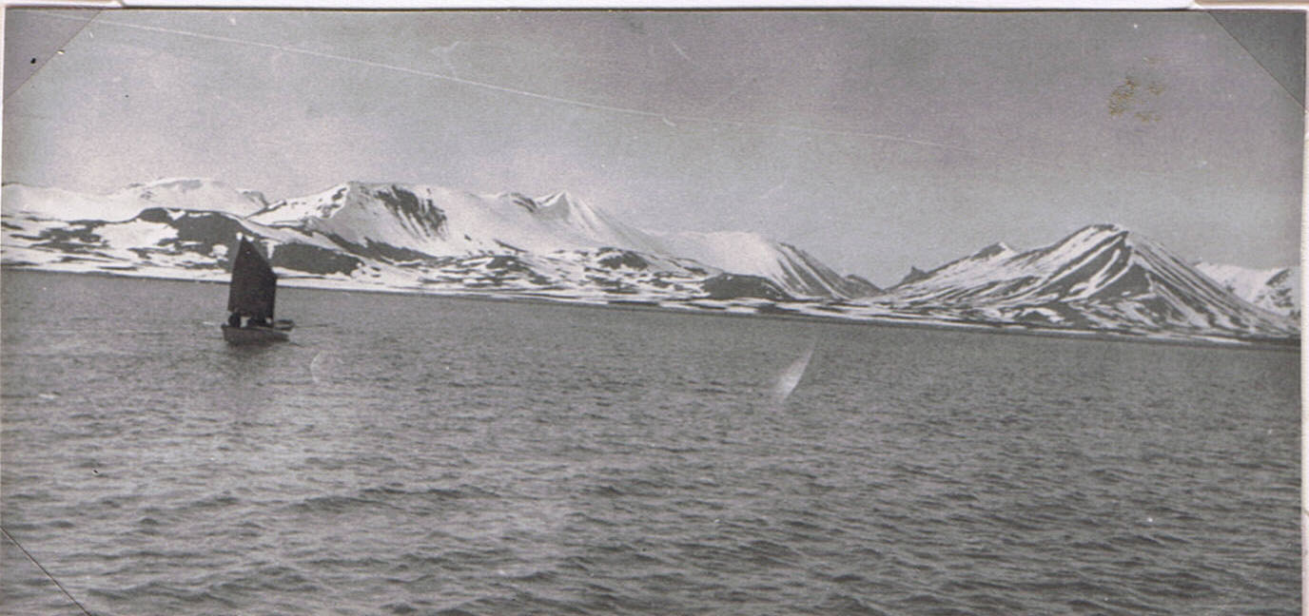
Landing opposite Glen Mackenzie, P.C.F. {= Prince Charles Foreland} where camp was (Photo J.D.Brown). 30 June 1921
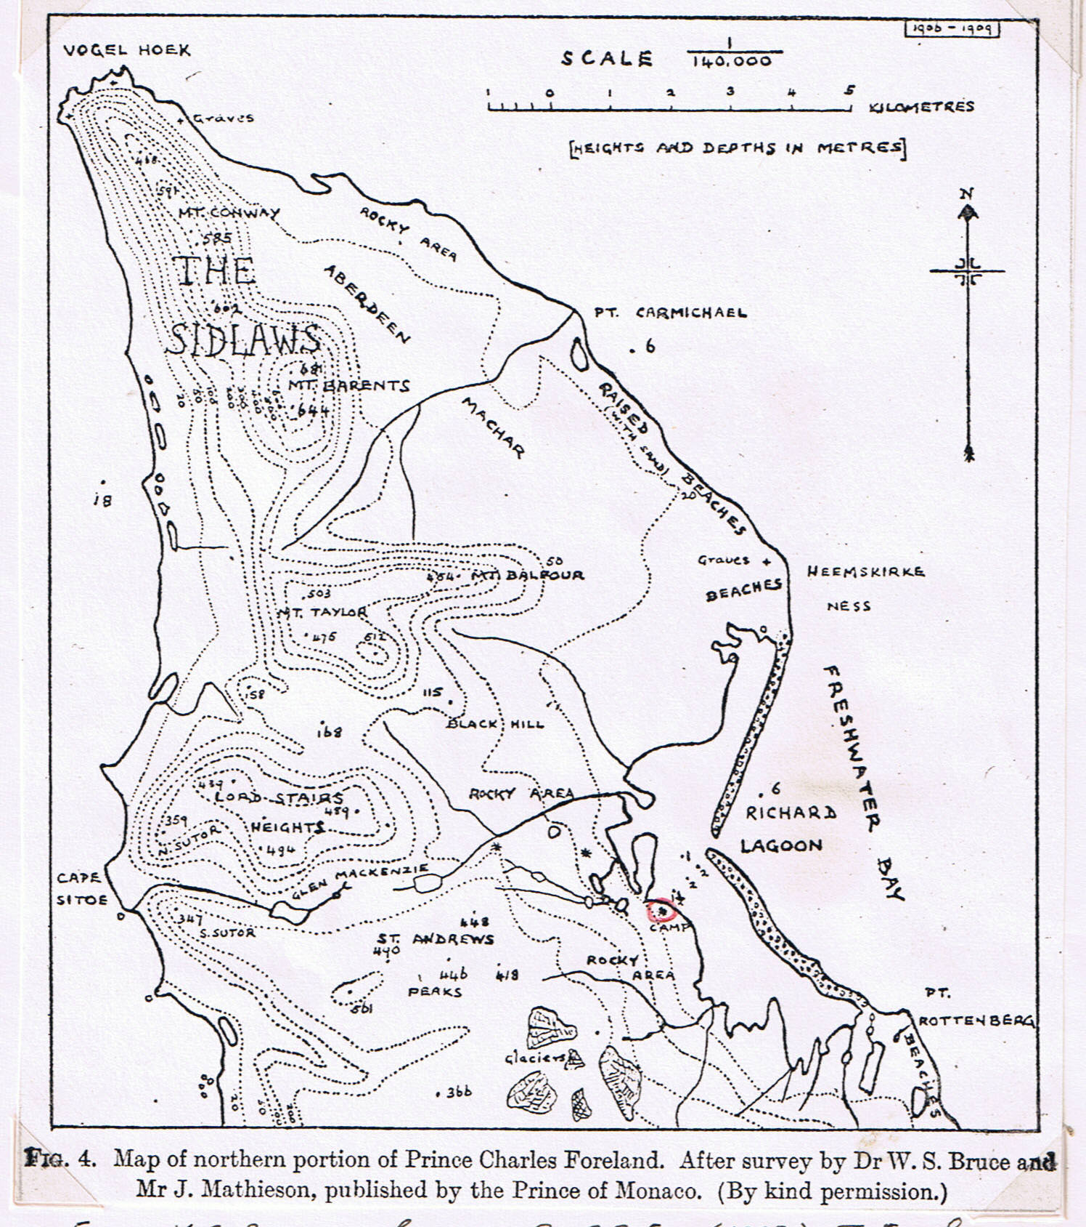
From V.S. Summerhayes & C.S.E. (1923) J. Ecology, vol. 11, P. 236. The Norsk Polarinstitutt of 1968, shows that the lagoon entrance in the centre has closed up, and there is one at the N. and another at the S. end.
(This map was copied by C.S.E.)

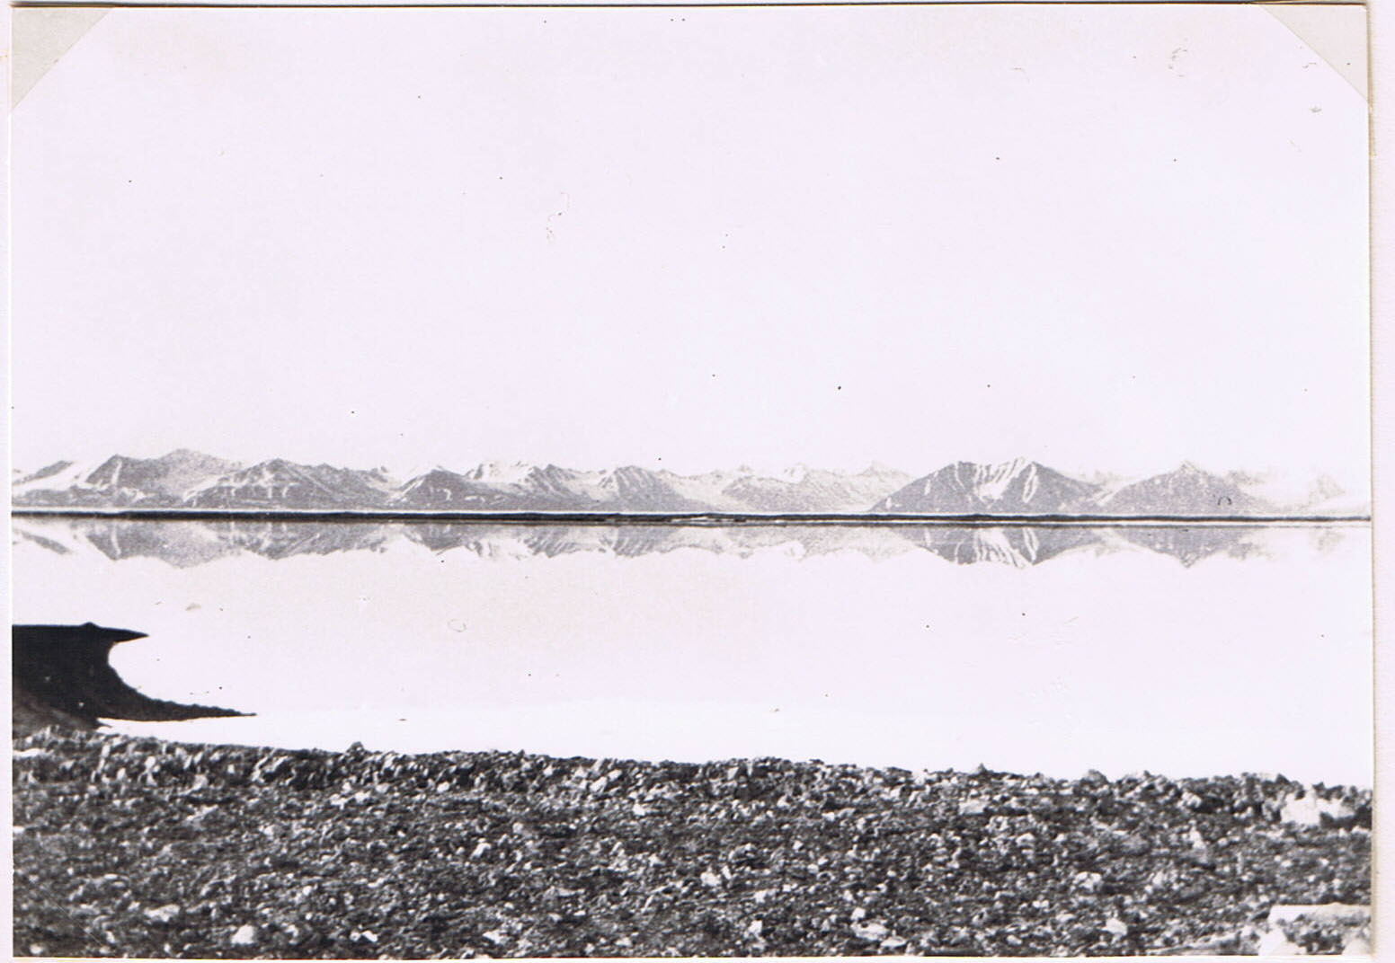
Mountains of West Spitsbergen seen across Richard Lagoon from our camp – they are around 3000 ft. and the level marks an ancient surface cut up by erosion. Foreland Sound lies outside the shingle bar and is not visible. (Photo C.S.E. 1921: No. 901).
(Printed in Dr Longstaff’s autobiography “This my voyage” 1950).
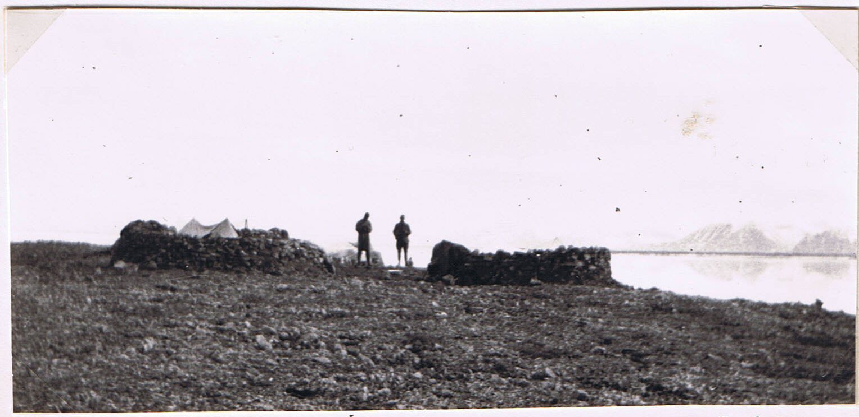
Huxley and Segrit by our camp on P.C.F. We built dry-stone walls as protection from the wind. (Photo C.S.E. 1921: No. 901B).
(Photos early July 1921).
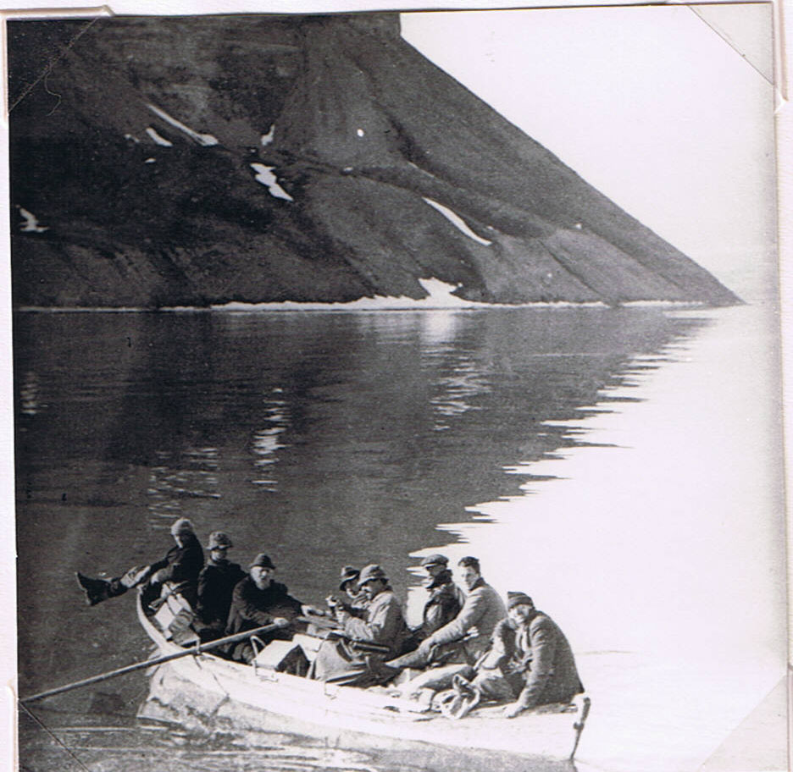
Boat party going to Gips Valley, Icefjord, 26 June 1921. L. to r. Paget-Wilkes, Summerhayes, old Ice Pilot, Binney, Seton Gordon, Jourdain, C.S.E. (no hat), Brown. (Photographer unknown)
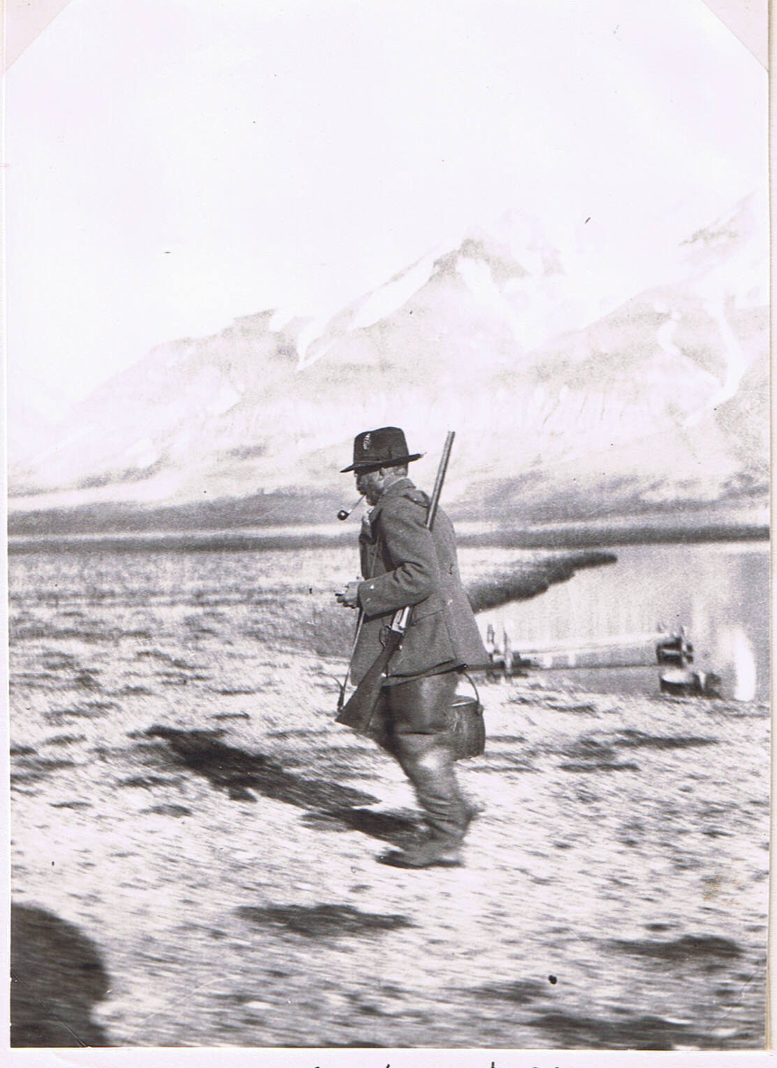
Dr. Tom Longstaff
(Photo July 1921, at “Bruce City” Klaas Billen Bay, Spitsbergen.
He was on his way to feed the sledge-dogs). (1921: No. 9)

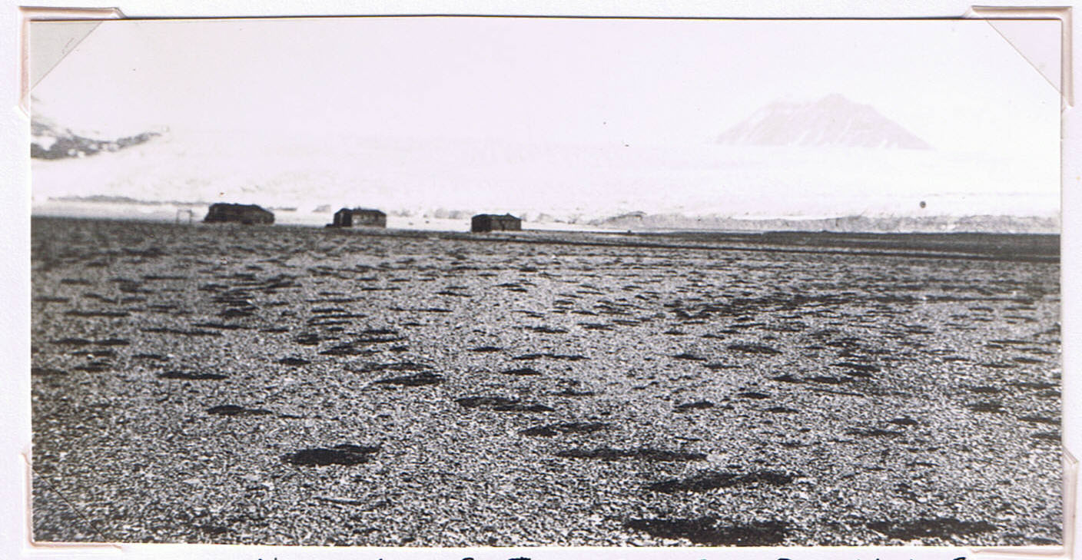
“Bruce City” (4 huts of the Scottish Spitsbergen Syndicate), with the Nordenskjold Glacier and Mount Terrier behind. Raised beach with spaced clumps of Dryas octopetala.
(Photo A.M. Carr-Saunders).
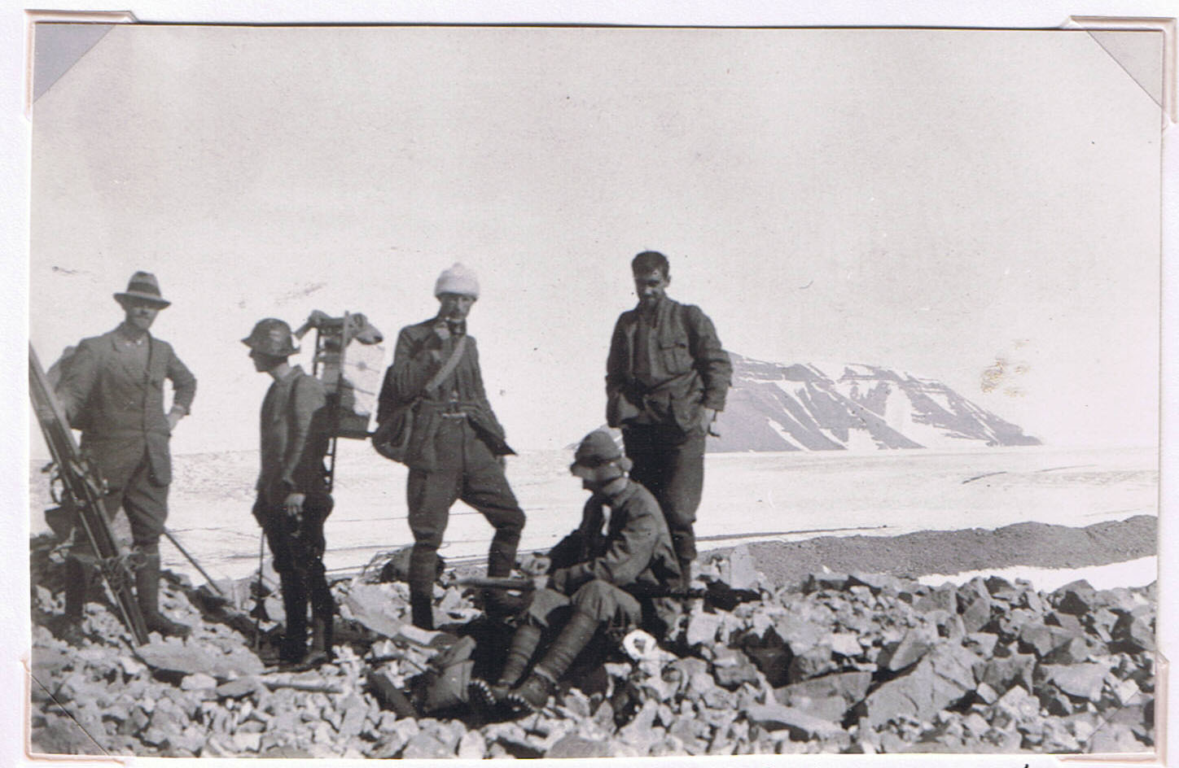
Party carrying part of sledgers’ stuff up the Nordenskjold Glacier. L. to r.: Segrit, C.S.E. (60 lb of chocolate on an Everest rack), Carr-Saunders, Odell, Walton.
(Photo T.G. Longstaff). (We are on the left-side moraine).
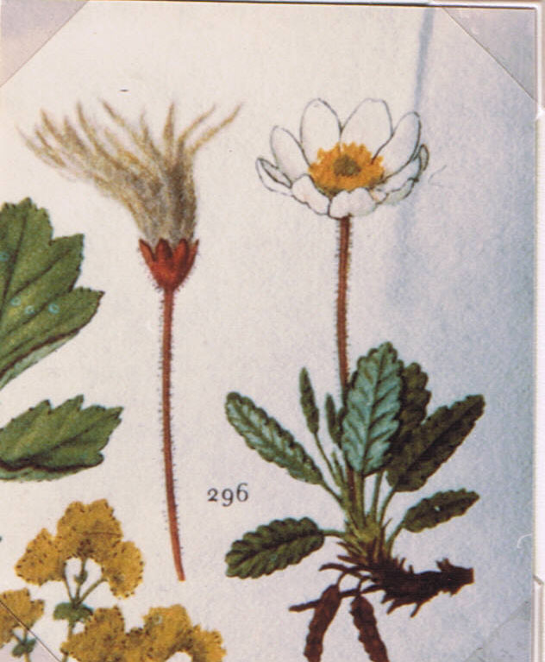
Mountain avens (Dryas octopetala)
(From M. Slytte Christiansen, 1962, ‘Flora i Farver’ Copenhagen. Photocopy by C.S.E.)

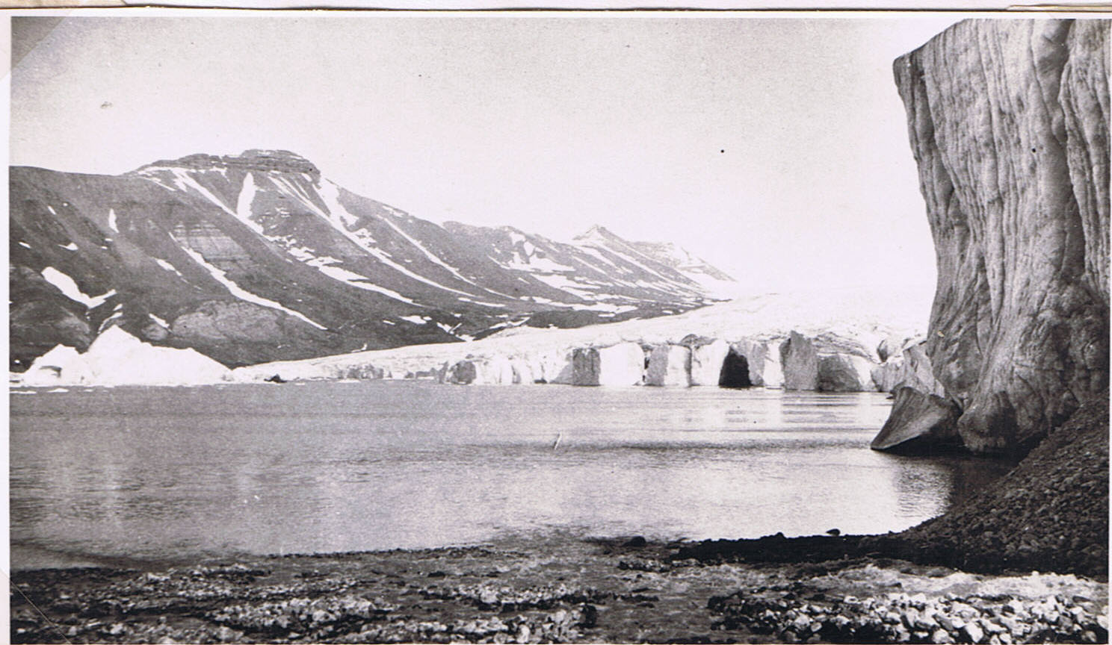
Face of the Nordenskjold Glacier at the head of Klaas Billen Bay, with large iceberg (? 100 ft. above water) just broken off. Mt. DeGeer behind. August 1921. (Photo T.G. Longstaff).

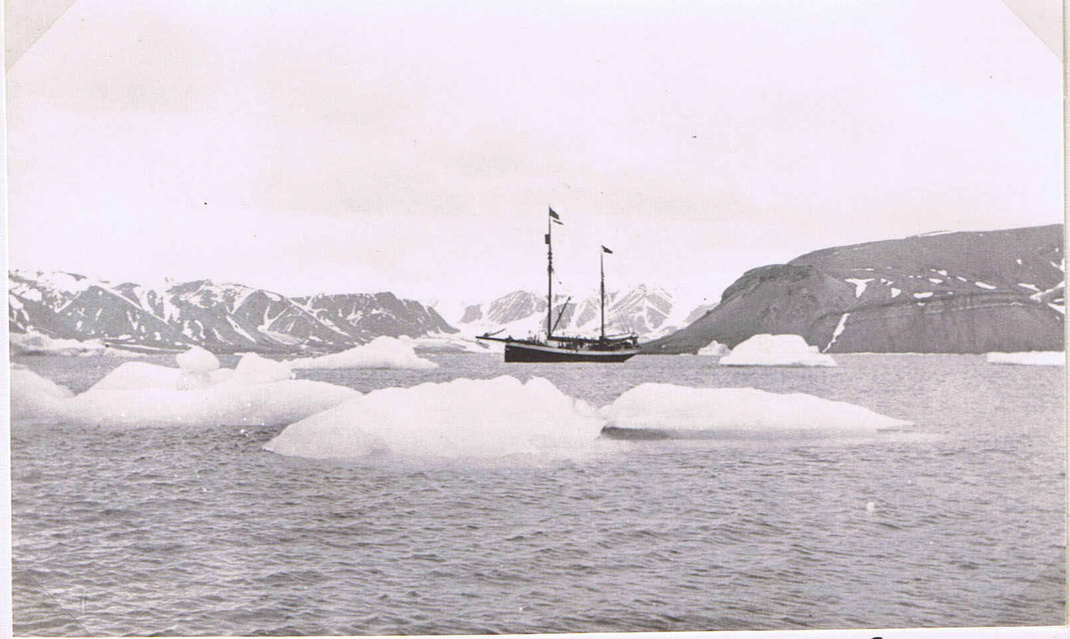
The “Terningen” of “Bruce City”, Klaas Billen Bay, Icefjord, among ice-Bergs calved off the Nordenskjold Glacier (off r.) Petunia Bay beyond. July 1921. (Photo Seton Gordon)
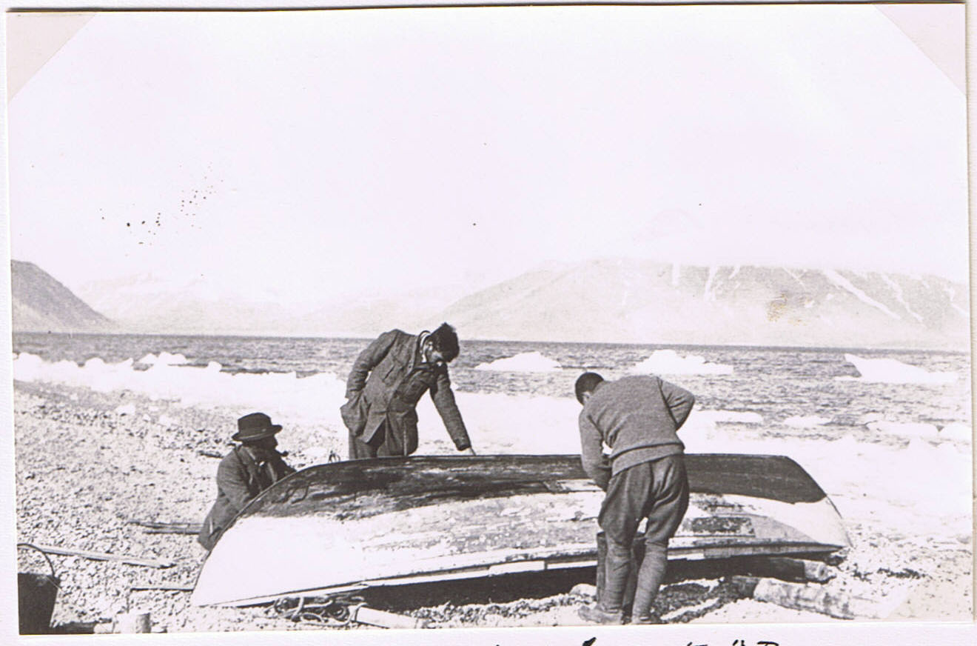
Caulking the dinghy at “Bruce City”. L. to r. Dr Longstaff, John Walton, C.S.E. Pyramid Mountain and Mimerdal behind. Brash ice from Glacier. August 1921.
(Photo A.M. Carr-Saunders).
{Page placed here, but text clearly continues from page 13.}
for sledgers, – several wooden huts belonging to the Scottish Spitsbergen Syndicate (mining), who lent the Expedition two of them. So, at “Bruce City”, as these hutments {sic} were called, a mile from the great Nordenskjold Glacier at the head of Klaas Billen Bay, I was able to have a bench and use my monocular microscope to look at aquatic animals. The unique series of lagoons on successive shelves of raised beach here, is described under FRESH-WATER STUDIES. In them I found relict or nearly relict Crustacea; also a very abundant colonial flagellate, Uroglena volvox, that I had studied not long before in Oxford’s Botanic Garden!
Summerhayes returned home with the First Party. On the Second was A.M. Carr-Saunders with whom I dredged some marine animals that went to the British Museum. He had to return early, owing to illness. John Walton had come as botanist, and worked partly with me e.g. we did a plane-table survey of a small tidal estuary and salt-marsh that he published. My own survey covered all the habitats from intertidal to dry tundra – much of the latter covered with polygon soil markings, the rest being shingle beach with Dryas clumps. The best flower places were on the margins of the lagoons.
Most of the intertidal zone was very barren, because of the floating fragments of glacier ice. But on our side of Nordenskjold Glacier, which had been in
{new page}
retreat for some years, there was a moraine in the form of a long line of heavy boulders, that gave some protection for small pools and an extensive mud-flat. By the boulders I discovered a small tunicate Rhizomolgula globularis, described by R. Kirkpatrick of the British Museum, but already known from elsewhere: this record filled a gap in its known circumpolar distribution. There were also Amphipods, such as Gammaracanthus loricatus, which I had already found in Richard Lagoon. (It is a fresh-water relict in some N. European lakes).
I will not try to repeat the extensive account that we gave, of various other habitats, but must pay tribute to the various specialists who dealt with our collections. Among these I specifically mentioned Dr J. Stephenson, who unravelled the different taxonomy of the Enchytraeid worms – a group of small white worms that are the only native land oligocheates here, and very laborious to collect and preserve. Also Dr. F.W. Edwards, who tackled the very difficult group of Diptera Nematocera; or “Chironomid flies”, which form the bulk of the winged insect fauna up there. They in turn are preyed on by very small spiders, which Dr. A.R. Jackson studied. He named a new species caught (by Segrit) across from Bruce City, on a flower slope, as Micaria eltonii, a very local species of inner fjord habitats.
These three groups of invertebrates,

together with mites and springtails (Collembola), form the main species, all of them very small, of the tundra habitats. Most of the gnats have aquatic larvae, so that spiders tend to concentrate near water. But one species is confined to unstable ground such as scree slopes which are a very important element in this landscape, and may be seen in Britain as “fossil” remnants of the Ice Age.
An additional collection was made, of Rotifera, by drying samples of moss from various places. These revive in water. They were studied by D. Bryce, who found in some of them a very curious Protozoan parasite. We also took home some soil samples in sterile tins, that were searched for Protozoa etc. by H. Sandon, at Rothamsted.
Finally I did some work on Holocene fossils at these raised beaches. The lower series, by the sea, was about 40 ft. at its highest level. This was a large ancient lagoon site, and must once have been an open bay, because on its inner shore were the skeletal remains of a large whale. I spent my last night at Bruce City without sleep (I had become extremely fit), digging up these bones and making scale drawings of them (included in my full survey volumes). But I had also found a very good Holocene section in a stream gully near the shore, the fossils of which were described by Donald F. Baden-Powell (in Art. 22). They included Mollusca and Foraminifera. Among
{new page}
former was the common intertidal mussel Mytilus edulis, extinct in Spitsbergen and indicator of a warmer climate then. Scandinavian work has since dated this section in terms of thousands of years. (Therefore there has been a long period for the fresh-water relicts to spread).
I went back to Norway with Walton, and some 30 cases of expedition stuff, sleeping in some empty bunkers of a coal steamer. The sledgers returned and had a valuable journey to recount. Altogether, I think the Expedition accomplished an enormous amount; and it was the start of a series of later expeditions that were continued after the formation of the Oxford University Exploration Club in 1927.
My collections were handled by the British Museum and, above all, at the Hope Department, where Prof. E.B. Poulton’s energetic organization of various taxonomists throughout the country, was vital and remarkably effective. The insects that I brought back were dealt with by his assistant Mr A.H. Hamm, a field observer of genius, and most remarkable technician e.g. in mounting the very delicate Diptera I brought home.

